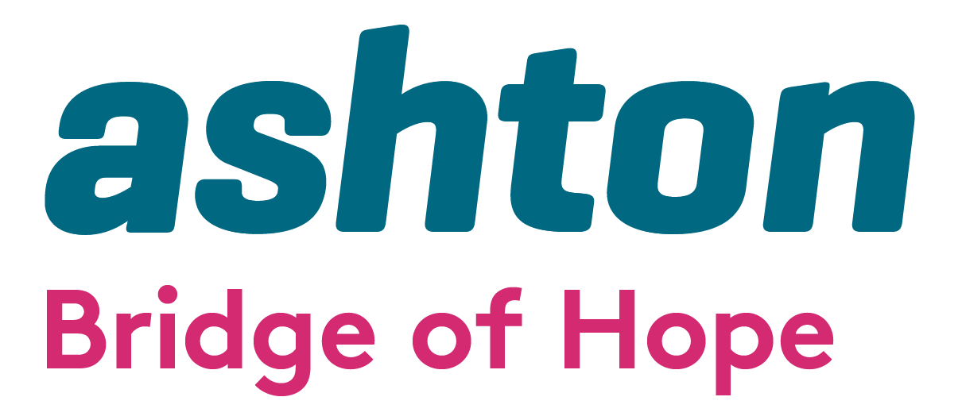

Invitation to Tender for the role of Internal Quality Assurance/IQA/Internal Verifier 2025-2026

Bridge of Hope, a project of Ashton’s Health and Wellbeing Department, is inviting tender applications from competent, experienced and appropriately qualified facilitators to deliver VTCT training on a sessional basis.

Bridge of Hope Overview

Bridge of Hope is a health and well-being service that supports individuals affected by the conflict and those experiencing poor physical and emotional health. Our mission is “To empower and promote positive change for victims and survivors through the delivery of quality health and wellbeing services.”

Ashton Bridge of Hope holds organisational membership and is an accredited service with the British Association for Counselling and Psychotherapy (BACP), Membership Number: 211323. We operate in accordance with the BACP Ethical Framework for the Counselling Professions and ensure that all stakeholders/service users are aware of this professional code of conduct.

Our services are person-centred and based on the theory that no single approach will suit everyone. All services are monitored, and outcomes are recorded. We support people through a range of funding streams made possible by the Victims & Survivors Service, Belfast Health & Social Care Trust (BHSCT) and Public Health Agency. We are a Primary Care Talking Therapies Hub provider delivering services across the city of Belfast to meet the needs of individuals who are experiencing common mental health problems.

Holistic support services include complementary therapies: life coaching; counselling and psychological services; accredited VTCT training; personal development courses, and provide support to those applying for the Troubles Pension (TPDPS). We also provide support through our Health and Wellbeing Caseworkers. All of these services are designed to help manage and reduce stress and encourage the development of positive, healthy and resilient lives.

More details here: www.ashtoncentre.com and www.bridgeofhope.support

Ashton’s Bridge of Hope project is a VTCT approved training centre. We currently deliver 3 accredited VTCT courses. These are:

- Certificate in Thermal Auricular Therapy Level 2
- Diploma in Reflexology Level 3
- Certificate in Swedish Body Massage Level 3

Role description

We see this role to have a range of priorities:

- To interact with individuals on a one-to-one and group basis.
- To ensure the standard of teaching and support for students is to a level required by VTCT in order to ensure qualification upon completion for all students.
- Ensure all requirements of VTCT are met at all times and standards are maintained.
- To provide relevant information and updates to Bridge of Hope’s Training Coordinator and Head of Health & Wellbeing.
- To work collaboratively with the Training Coordinator and sub-contracted tutors for Ashton, Bridge of Hope in relation to all aspects of programme delivery and to ensure that all appropriate procedures and processes are followed, including regular one-to-one meetings.
- Liaise with Bridge of Hope’s Head of Health & Wellbeing immediately should a problem arise relating to the well-being of Victims and Survivors and/or if identified that an individual requires any other support or referral pathway.
- Inform Bridge of Hope’s Head of Health & Wellbeing immediately should any issue relating to the programme arise.
- Attend regular one-to-one meetings with the Training Coordinator.
- To provide relevant support prior to any visit from the VTCT External Verifier and be in attendance during all visits from the External Verifier.
.
The tender format is as follows:

- Applicants must demonstrate how they meet all elements of the essential criteria.
- A breakdown of costs for delivery of this service demonstrating value for money. A cost per hour inclusive of travel, subsistence and VAT should be provided.
- Applicants must be able to demonstrate a flexible approach to working.
- Applicants must include a full and up to date CV including recent examples of similar work with victims/survivors.
- Applicants must include a copy of all relevant certificates.
- Applicants must include evidence of Professional Liability Insurance to a minimum of £5 million.
- Tender applications must include a completed Declaration of Employment Status form.

Copies of tender proposals should be forwarded via email clearly marked “VTCT Facilitator” to:

Lindsay Whitten
Operations Manager
Bridge of Hope
Ashton Community Trust

Lindsay.whitten@ashtoncentre.com

Any tender applications not including all information above will be discounted as incomplete and will not move to scoring. All tenders must be received no later than 12.00 pm on 18th April 2025. No late tenders will be accepted.

Bridge of Hope will use the information supplied to score all tender applications. Please take note of weighting criteria as this will be used to total scores, and only applicants who score over 80 will be added to our Approved Sub Contractors List. Although a score of 80 or more will allow enable an applicant’s details to be added to our Approved Sub Contractors List, this does not constitute any guarantee of hours. Please note any successful tender will only be valid for a period up to the 31st March 2026.

Ashton’s Bridge of Hope operates in line with the General Data Protection Regulations 2018. This means we will treat the information you provide to us with strict confidentiality. At times we may need to share some of your information with other staff, funders and other stakeholders.

Award Criteria | Score out of 100
Be qualified to Level 3 or above in the specific programme to be taught. | 15
A Minimum of 3 years’ experience in delivering VTCT accredited programmes. | 20
Hold a Level 3 VTCT Assessor Award | 20
Have experience of working with individuals who have experienced conflict related trauma including a qualification in Trauma Training. | 10
Demonstrate a commitment to continuing professional development. | 5
Demonstration of value for money/breakdown of costs | 5
Commitment to External Supervision and continued Professional Development | 5
A flexible approach to delivery of these training programmes. | 5
Mental Health First Aid Qualification | 2
Emergency First Aid at Work Qualification | 2
Keeping Adults Safe Training Qualification | 2
Hold Professional Liability Insurance to a minimum of £5 million. | 5
CV included | 4

Contact Details: If you require further information, wish to clarify any points or have difficulty relating to the tender documentation before the submission of your proposal, the contact point is Lindsay Whitten (Operation Manager).

Email: lindsay.whitten@ashtoncentre.com Tel: 028 9074 2255

START AND COMPLETION DATES

It is anticipated that funding for this service delivery will be from 1st April 2025 to 31st March 2026



Invitation to Tender for the role of VTCT Facilitator 2025/2026

NAME: _________________________ TELEPHONE: __________________

EMAIL: ________________________________________DATE: _____________

Essential Criteria
1. Please list all relevant qualifications in the specific VTCT programmes being delivered by Bridge of Hope.

2. Please outline your experience of working with individuals who have experienced conflict-related trauma.

3. Please demonstrate a minimum of 3 years of experience in delivering VTCT-accredited programmes.

4. Please demonstrate how you have a flexible approach to supporting the delivery of VTCT programmes within Bridge of Hope.

5. Have you completed First Aid at Work Training? If so, please detail the dates of completion and include a copy of your certificate with your tender.

6. Have you completed Trauma Training? If so, please detail the dates of completion and include a copy of your certificate with your tender.

7. Have you completed Mental Health First Aid (or equivalent)? If so, please detail the dates of completion and include a copy of your certificate with your tender.

8. Please demonstrate a commitment to continuing professional development, including external supervision. This should relate to the period from 1st Apr 2024 and 31st Mar 2025.

9. Please give details of working with individuals who have experienced conflict-related trauma.

10. Please state your cost per hour inclusive of travel, subsistence and VAT

