
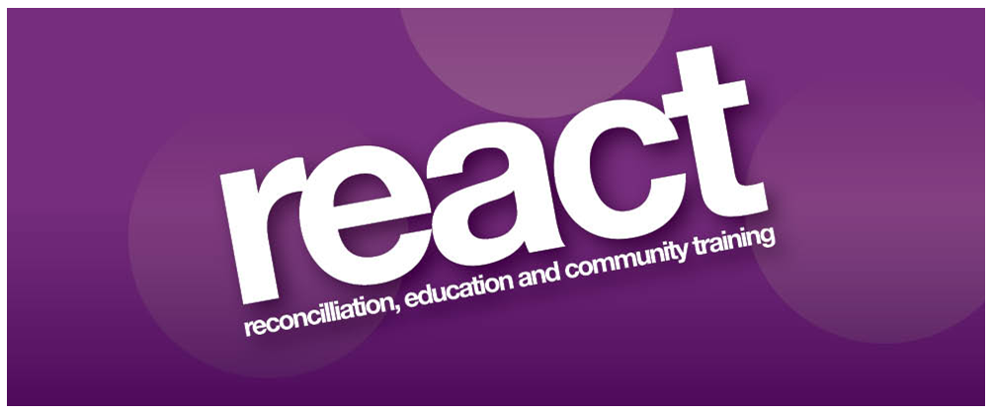

Invitation to Tender

Sessional Complementary Therapists

1st April 2025

Tender Closing Date: 3pm on 14th April 2025
Introduction
REACT is seeking to recruit reputable, experienced and qualified sessional therapists to deliver a variety of complementary therapies.

Background
REACT Victims and Survivors Project offers health and well being and social support services to individuals directly affected by the Northern Ireland Conflict, their families, and carers in the Armagh area.

Role and Responsibilities
- To work directly with victims of the NI Conflict to provide individual reflexology, accupuncture and massage sessions
- Complete MYMOP assessments and provide written records of the work as required
- Maintain confidentiality and work within the boundaries of the data protection act and safeguarding legislation
- Comply with REACT policies and procedures
- Work autonomously and take responsibility for managing own work
- Evaluate own work and contribute to the evaluation of the overall effectiveness of the service
- Liaise as required with other members of staff about the management of programme
- REACT will provide towels, therapist chair and bed. It will be the responsibility of the therapist to maintain clean towels.

Eligibility Criteria
All applicants will be required to meet the Eligibility Criteria stated. Candidates’ that meet the Eligibility Criteria will then be assessed and scored against the Tender Evaluation Criteria as outlined in this document.

- A recognised qualification in reflexology, acupuncture and massage therapy (Minimum Diploma Level).
- Three years paid experience working as a therapist
- Valid Personal Indemnity and Professional Indemnity Insurance.
- Membership of a relevant recognised professional body
- Experience of working with complex trauma related symptoms

Desirable Criteria: Experience of working with victims and survivors of the NI Troubles
Tender Evaluation Criteria
Tenders will be evaluated and scored to ascertain the most economical and advantageous proposal using the tender evaluation criteria.

Tender Evaluation Criteria | Marks Available
1. Experience of working with victims and survivors of the NI Troubles | 20%
2. Knowledge and skills in the field of complementary therapies | 40%
3. A working knowledge of completing an initial health assessment | 10%
4. A clear understanding of working with clients with complex trauma related health issues | 20%
5. Availability/Flexibility (Evening work compulsory) | 10%

Duration of contract
The contract expires on the 31st March 2026 with the option to extend for a further two one year periods dependent on receipt of funding.

Pricing
£30 per one hour session.
Pricing includes delivery and supplying of complementary therapy materials. REACT will provide towels, therapist chair and bed.

Format of Tenders
Tenders must strictly adhere to the format and requirements stipulated in this document and include a copy of a CV, all relevant qualifications, current professional insurance and current membership of relevant professional bodies. Tenders must clearly reference and demonstrate how they meet the eligibility criteria and tender evaluation criteria. Failure to comply will render the tender proposal invalid.

Proposals
The tender proposal and relevant documents should be submitted by email to:
info@reactni.org To arrive no later than 3pm on the 14th April 2025. Proposals that are received late will not be considered.

Termination of Contract
REACT reserves the right to terminate the contract at any time following one month’s notice to do so. However, any breaches of contract may result in immediate termination. The contract may be cancelled by the successful tenderer provided one months’ notice in writing has been given.

Contractually binding information
All information supplied by tenderers will be treated as contractually binding. However, REACT reserves the right to seek clarification or verification of any such information.

Conflicts of Interest
Any conflicts of interest involving a tenderer must be fully disclosed to REACT, particularly where there is a conflict of interest in relation to the aims of the project.

Insurance Requirements
Tenderers must produce all Insurance for Employers and Public Liability and Professional Indemnity and any other required insurances. The successful tenderer will be required to produce valid certificates for the duration of the contract.

Commencement of Contract
The successful tenderer will be required to certify that they are in a position to commence the contract within four (4) weeks from date of award.

Queries relating to this document and any of the requirements stated herein should be directed in writing or email to:

REACT
14/14a Armagh Shopping Centre
Armagh
BT617AE
Tel: 028 37526869
Email: info@reactni.org

REACT promotes equal opportunities. Registered Charity Number: XR 33610
The above project is funded under the Victims Support Programme for Groups Working with Victims and Survivors, which is administered by the Victims and Survivors Service on behalf of the Northern Ireland Executive Office.


