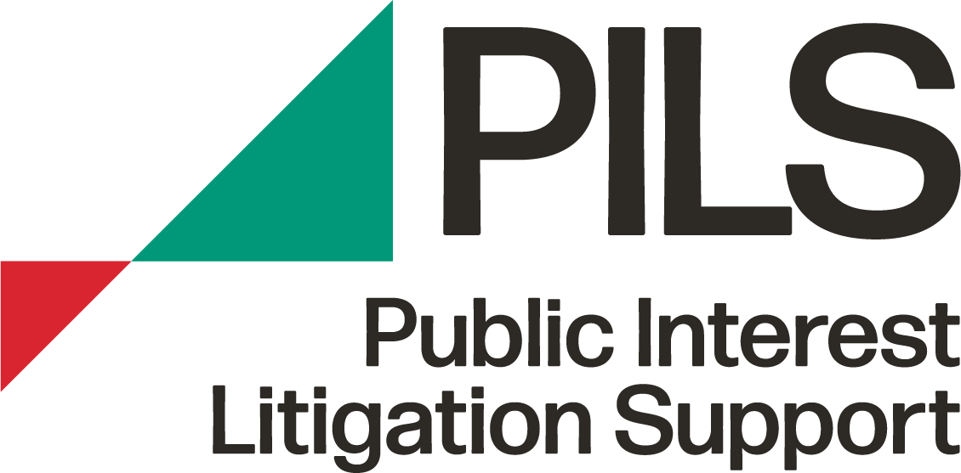

# **Monitoring Form**

PILS seeks to be an equal opportunities employer and to actively promote equality in its recruitment and employment practices. We are obliged by law in Northern Ireland to monitor for community background, but – in conformity with good practice - we have chosen to extend this monitoring to categories mentioned in section 75 of the Northern Ireland Act.

We would greatly appreciate if job applicants would assist us in our monitoring work by completing and returning the form below.

When you submit your job application, this monitoring form will be detached from the rest of your application immediately. To protect your privacy, **please do not write your name** on the monitoring form.

Your answers will be treated in the strictest confidence and the monitoring form will not be seen by the interview panel.

## Gender

Male

Female

Other

**Age Band**

Under 30

30 - 45

Over 45

## Perceived Religious Affiliation/Community Background

Regardless of whether you actually practice a particular religion, please tick the box that most applies to you:

I am perceived to be a member of the **Protestant** community

I am perceived to be a member of the **Catholic** community

I am **not perceived** to be of either the

Protestant or Catholic community

## Marital Status

Single

Married/Civil Partnership/Co-habiting

Separated/Divorced

Widowed

## Disability

Under the Disability Discrimination Act 1995, a person is considered to have a disability if they have a physical or mental impairment which has a substantial and long-term effect on their ability to carry out normal day-to-day activities.

Do you consider that you meet this definition of disability?YES NO

Are there any changes to the organisation’s policies, procedures or practices that would enable you to enjoy equality of opportunity and fair participation in getting a job/working with PILS?

## Cultural/Ethnic Origin

Chinese

Indian

Pakistani

Bangladeshi

Afro-Caribbean

Irish Traveller

African

White

Other

**Political Opinion**

My political opinion is unionist/loyalist

My political opinion is nationalist/republican

Other

## Sexual Orientation

Bisexual

Gay

Heterosexual/Straight

Lesbian

Other