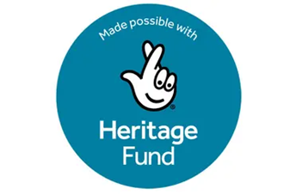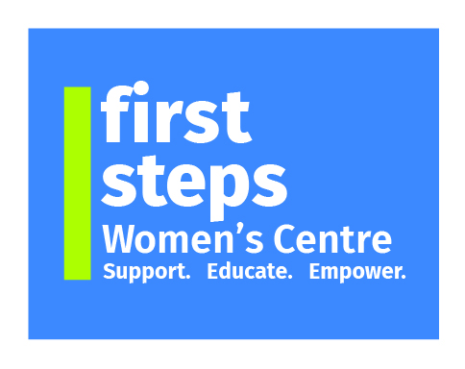

**"Heritage Journeys: Voices of Migrant Women**

**in Mid Ulster"**

**The Vision**

First Steps Women's Centre (FSWC) wants to provide a legacy of the Intangible Heritage from BME women who have travelled and settled in Mid Ulster, between 2000 and 2024. FSWC seeks to preserve the information in numerous formats for posterity. FSWC will use these records as a way to educate and challenge racism. FSWC will undertake to work with a 100 migrant women & refugees who came to Mid Ulster within last 20 years.

**About the Heritage Focus**

FSWC wants to provide a heritage project that focuses on the Intangible Cultural Heritage of BME (migrant) women who reside in the Mid Ulster area and in particular who have attended First Steps Women’s Centre. FSWC has hosted over 100 BME women per year since early 2000's.

This project will capture and record their stories, their lives, their history and therefore their heritage including: their oral history, food practices, religion, social practices, arts & music.

The project will also investigate and record how these have been retained, lost or diminished since arriving in Mid Ulster. It will reflect how these traditions have evolved in a new environment. FSWC wants to record what they left behind, what brought them to NI. We will focus on their homeland culture and seek to record their experiences and their journey to Mid Ulster. FSWC seeks to help these women preserve their heritage before it is lost. There is the danger that their heritage could disappear and be forgotten as they assimilate into being an integrated part of the Mid Ulster community. This heritage and this project are important for many reasons. It can and will be used as an educational tool to inform people and communities who have limited or no knowledge of the heritage of other nationalities.

This project will showcase who these people really are and to highlight the difficulties in their journeys, in settling into a new life. Racism is very much alive and will continue to thrive unless it is tackled using projects like this proposal

One of the best ways of tackling racism is to showcase the lives of people here, to humanise the stories and to counter attitudes through the presentation of journeys that highlight real struggles, resilience and determination. FSWC will take the results of this project to the communities of Mid Ulster and further afield.