RECRUITMENT PACK

Project Officer, NWCN

Contents

Introduction 3

About NWCN 4

Aims & Objectives 4

Core Values 6

Additional projects 7

About the role 8

How to apply 8

Introduction

Dear Candidate

Thank you for your interest in the Project Officer role with North West Community Network (NWCN).

This is a full-time position (37 hours per week). The hours for this position are outlined below:

* 25 hours per week as Project Officer on our new **Supporting BAME Communities** project
* 12 hours supporting the **overall work of NWCN**.

The main purpose of the **Supporting BAME Communities project** is to develop capacity and resilience with minority ethnic communities in partnership with the African Caribbean Community Network (ACCN) and the Filipino Community (Kabalikat).

The following information provides more detail on the purpose and work of NWCN, as well as a job description, person specification and details of how to apply.

Thank you for your interest and we look forward to receiving your application.

About NWCN

NWCN was established in 1995 and is an organisation that works to develop and support community development activity within the Community & Voluntary sector in the north west. We are a network organisation and provide support and information to each of our member organisations. We provide training, advice and a weekly e-bulletin to the wider community sector. We strongly believe in working together with communities and partners within and across sectors. We work together to address what matters and to bring positive change.

Our Vision

A community and voluntary sector that is vibrant, inclusive, resilient, sustainable and actively engaged in key decision-making.

Our Mission

To support and strengthen our members and the community and voluntary sector in the north west.

Aims & Objectives

**Objective 1: *Influence, Advocacy & Leadership* - To be a representative voice of the Community and Voluntary sector in the North West**

* Lead on responses to relevant policy consultations
* Lead on lobbying/advocacy work on issues/challenges
* Be a representative voice of the Community and Voluntary sector in the North West
* Increase NWCN membership

**Objective 2: *Build Capacity, Champion &* *Strengthen* - To build capacity within the Community & Voluntary sector**

* Provide training opportunities to build capacity and understanding
* Share information on funding opportunities and different income streams
* Practical support for NWCN members

**Objective 3: *Collaboration, Facilitation & Partnership* - Greater collaboration between community and voluntary groups and across sectors.**

* Provide opportunities to bring groups and individuals together to encourage collaboration and share experiences/learning
* Consolidate our community development work & encourage partnership working
* To continue to work in partnership with the current forums we are involved in e.g. Derry City & Strabane District Council Strategic Growth Partnership, Developing Healthy Cities Leadership Group, NI Equality Coalition, NW Community Wealth Building Partnership, Community Development Networks Forum (CDNF)

Our Core Values

The following outlines the values which underpin all of our work:

* **Integrity**  
  We value honesty and transparency in our intent and priorities. We believe that we must demonstrate our accountability to our Network members and to all with whom we work. We are committed to act in ways that enhance our community development values, putting people first.
* **Inclusion**  
  We work hard to ensure we are as inclusive as possible. We value the diversity within communities and the different perspectives that they bring us. We value fairness and justice and believe that we must strive to reduce inequities in our society.
* **Collaboration**  
  We strongly believe in working together with communities and partners within and across sectors. We believe that we need to work together to address what matters and to bring about positive change.
* **Leadership**We believe it is important to identify and set leadership standards for the sector in the North West. We lead by example, champion and challenge when necessary.
* **Quality**We strive for excellence in all of our work. We actively listen and respond to our members. We continuously reflect on our work through effective monitoring and evaluation.
* **Hope & Empowerment**We value hope. We believe that change begins with individual people. We are energised by the hope and aspirations of local citizens for positive change through collective action and community development.  We believe in supporting the development of individuals and communities to take more responsibility for and control over their own destiny.
* **Social Justice**

We believe that social justice is a core value for community development. We are committed to the principles of equality, solidarity and human rights for everyone.

* **Selflessness**

We work to serve the best interests of the community and voluntary sector and will not seek to compete with the interests of the sector we represent.

Snapshot of additional NWCN projects

**Human Library**

A conversation at the Human Library is an interactive experience that engages people. The Human Library creates a safe space for a conversation where topics are discussed openly between our human books and their readers. Each Human Library Book has a title that reflects their life experience e.g. Transgender, Bi-Polar Diagnosis, Ex-Police Officer, Blind, The Addict……You will hear lived experience from someone from a community you might not have met before, someone who is different from you. A place to ask questions about difficult issues. An opportunity to challenge stereotypes.

**Ideas Fund**

The Ideas Fund is a grants programme run by the British Science Association and funded by Wellcome, which enables the UK public to develop and try out ideas that address problems related to mental wellbeing by working with researchers. NWCN fulfil a Development Coordinator role within the Derry & Strabane area. We support groups with their idea and help to match them with a Researcher as well as supporting groups as they deliver their project in partnership with their researcher.

**Ideas Fund – Community Research Collective** – In partnership with Ulster University, Developing Healthy Communities and community representatives we are trying to address some of the barriers to community-led research partnerships such as ethics processes and intellectual property.

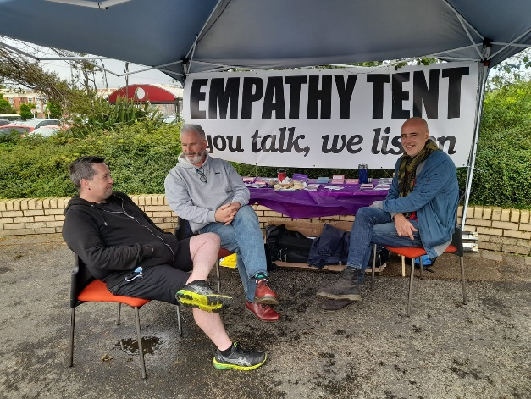

Ideas Fund Parenting NI project

About the role

**JOB DESCRIPTION**

**Project Officer**

**Purpose of the role:**

To coordinate the Supporting BAME Communities project at NWCN. This is a partnership project with our two key partner groups - African Caribbean Community Network (ACCN) and Kabalikat (Filipino Community)

**Reporting to:** NWCN Manager

**Location:** At NWCN office base, Derry

**Contract Type**: Fixed Term Contract for 3 years

**Salary scale**: NJC Scale 5 – Point 16 - £28,282.00

(pro rata)

**Hours:** 25 hours per week (working on the Supporting BAME project

12 hours per week (working on the overall work of NWCN)

**Probationary Period:** Six months’ probationary period will apply.

**Terms & Conditions of employment:** 2 satisfactory references to be provided, one which must be from a current/previous employer.

**Holiday Entitlement**: 25 days per annum and statutory/public holidays. The annual leave year runs from 1st January to 31st December.

**Key tasks**

**75% of tasks per week will include:**

* Develop strong connections with Project Partners and additional BAME groups.
* To devise and implement a project plan in partnership with BAME partner groups.
* To promote, recruit and retain BAME project participants.
* To record meetings and discussions.
* To set up communication channels with all of the groups involved e.g. email, Whatsapp etc
* Maintaining consistent communication with partners and participants.
* Organise and complete all project-related paperwork e.g. progress reports for funder, evidence of participation, minutes of meetings etc
* To carry out event management duties e.g.
  + organise events - e.g. training sessions
  + delivery of events
* Monitor and evaluate the project in partnership with partner groups.

**25% of tasks per week will include:**

* To assist the Manager of NWCN with the overall work of NWCN
  + To assist with event management such as required with the Human Library Project and the Ideas Fund project
  + To attend meetings on behalf of NWCN Manager when appropriate
  + Assist in promoting work and projects of NWCN on social media.
* To perform any other reasonable duties as required.

**PERSONNEL SPECIFICATION**

**Project Officer**

The successful candidate will be expected to demonstrate the following:

**Essential Criteria:**

* Relevant third level qualification and at least two years’ paid experience of working in the community sector
* Proven capability in project coordination, managing budgets, evaluation, delivering against agreed targets and reporting to funders and stakeholders.
* Demonstrable ability to work, both independently and as part of a team with high level organisational skills to successfully prioritise work without compromising quality.
* Previous experience in event management.
* Demonstrate skills and abilities to develop and facilitate a culture of partnership with a range of diverse groups.
* Proven ability to write up work to a high standard.
* A knowledge of using online meeting platforms e.g. Zoom and Teams
* Experience and competence with IT including Microsoft packages.
* Ability and willingness to travel across Northern Ireland when necessary.
* Ability and willingness to work flexibly including evenings, weekends and residentially.

**Desirable Criteria:**

* Previous experience of working with BAME communities.
* Awareness of issues and barriers facing BAME communities.

**Additional:**

Hold a current driving licence and access to a car (or have access to public transport) as this role may occasionally require the staff member to travel regionally.

How to apply?

We are asking potential candidates to complete an application form. Please email your completed application form to Roisin McLaughlin – [roisin@nwcn.org](mailto:roisin@nwcn.org).

The closing date for applications is **5pm on Monday 24th March 2025.**