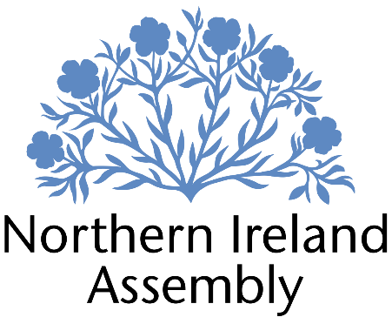

**Danny Donnelly MLA**

*Alliance Party Member of the Northern Ireland Assembly for East Antrim Constituency*

**POLICY AND RESEARCH OFFICER**

|  |  |
| --- | --- |
| Report to: | Danny Donnelly MLA |
| Office Location: | Primarily Parliament Buildings, Stormont but also, as required, at Constituency Office in East Antrim. |
| Hours: | 37 hours per week, Monday – Friday. |
| Holidays: | As per determination |
| Salary: | Grade 2 |
| Pension: | A central Assembly-approved pension scheme is provided. If enrolled an amount equivalent to 10% of employees salary will be paid into the pension scheme. |
| Duration: | Fixed Term whilst the member remains a MLA or until legislation is introduced to change Constituency expense provision. Six month probation period shall apply. |
| Closing Date | 5pm, Mon 17th March 2025. |
|  |  |

# JOB DESCRIPTION

“Responsibility for full range of policy and research support to Danny Donnelly MLA preparing briefings, questions and speeches, monitoring business, developing Motions, Questions and Private Members Bills plus identifying media and press opportunities”

* Providing rapid, accurate and detailed research on a wide range of policy issues in support of Danny Donnelly MLA’s work
* Drafting speeches, questions and briefing papers for Danny Donnelly MLA
* Preparing and developing Assembly motions and Private Members Bills
* Monitoring business of the Assembly and Committees, and providing detailed briefing for Danny Donnelly MLA
* Identifying media and press opportunities and drafting statements in both a pro-active and re-active manner as required
* Engaging and building relationships with various groups, representatives statutory organisations and Non-Governmental Organisations including attending meetings and conferences on behalf of Danny Donnelly
* Responding to correspondence and enquiries from constituents, the media, lobbyists and pressure groups
* Maintaining up to date knowledge of relevant legislation, policy and wider political and industry developments
* Assisting with planning and organising of events as required including physical and virtual
* Assisting the Casework and Constituency Manager with management and processing of constituent casework for Danny Donnelly MLA as required.
* Working with constituents directly on individual casework cases as required ensuring that casework is logged and dealt with sensitively and confidentially
* Ensuring efficient data and file management to comply with GDPR and data management.
* Attending work related training and networking meetings to develop skills.
* Other duties as required in support of the MLA carrying out their Assembly duties.

**PERSON SPECIFICATION**

|  |  |  |
| --- | --- | --- |
|  | **Essential Criteria** | **Desirable Criteria** |
| **Professional / Technical Qualifications** | * Five GCSE’s / O’ Levels or Equivalent at Grade C or above including both English Language and Mathematics * Third level qualification * Excellent written skills (Grammar, punctuation and spelling) * Proficiency in the use of   Microsoft Outlook, Word and Excel packages | * 7 GCSEs at Grade C or above including Maths and English Language * Master’s degree |
| **Experience / Job Knowledge** | * Minimum of one years’ experience in a full-time paid capacity undertaking policy research and analysis * Minimum of one years’ experience working in a paid or voluntary capacity in undertaking research in a political context * Knowledge of Northern Ireland political scene * Experience of working in a small team * Previous experience of working with the public | * Knowledge of the workings of the Northern Ireland Assembly * Minimum of one years’ experience working in a paid or voluntary capacity in speech writing * Minimum of one years’ experience working in a Communications role in a paid or voluntary capacity * Experience of dealing with sensitive and confidential information (both verbal and written) in line with the Data Protection Actand GDPR * Ability to update and maintain a database |
| **Personal Qualities /**  **Skills** | * Good punctuality and time management * Excellent verbal communication skills in person and on the phone * Flexible approach to work duties * Understanding of Alliance Party objectives | * Ability to multi task in the context of challenging deadlines. * Experience of organising online events * Proven ability to foster productive professional working relationships. |
| **Circumstances** | * Able to work unsupervised and as lone worker in office or at home when required | * May be required to travel to meetings |

Applicants must demonstrate clearly on their application form how they meet the criteria.