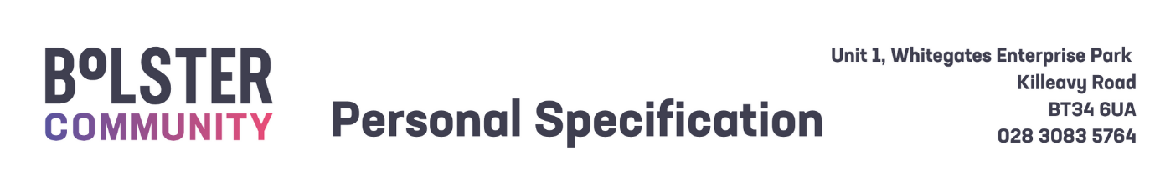

|  |  |  |
| --- | --- | --- |
| Personal Specification – Employability Support Worker | | |
|  | Essential Criteria | Desirable Criteria |
| 1. Circumstances | 1. Ability to work flexibly to meet the needs of the role, including evening and weekend hours when necessary.  2. A full current driving licence with access to a car or access to transport to fulfil the requirements of the post. |  |
| 2.Qualifications | 1. NVQ Level 3 or equivalent in an appropriate discipline e.g. Early Years, Social Care, Health or Youth Work. |  |
| 3. Skills and Expertise | 1. A minimum of one year experience working with young people or children with intellectual disabilities in an education, employment, or social care setting. 2. Strong relationship-building skills, with the ability to engage and collaborate with employers, parents and community partners. 3. A clear understanding of the barriers faced by individuals with intellectual, physical disabilities or autism. 4. Excellent communication skills—written, verbal, and digital—with the ability to interact effectively with a diverse range of people. 5. Strong planning, organisational, and record-keeping skills. 6. Ability to work independently, managing time effectively, while also contributing as part of a team. | * 1. A certified qualification in a relevant field e.g. Community Work or Youth Work.   2. Familiarity with inclusive employment practices and reasonable workplace adjustments. |
| Shortlisting will be based on the evidence that you supply on your application form to satisfactorily demonstrate how, and to what extent, you meet the above criteria. The Shortlisting Panel will not make assumptions as to your circumstances, qualifications, and experience. | | |
|  | | |
| Competencies – Candidates who are shortlisted for interview will be required to demonstrate how, and to what extent, they meet some or all of the competencies listed below during their interview. | | |
| 1. **Effective Communication**  Keeps people well informed and communicates messages clearly and concisely. Listens carefully, evaluates other opinions and is able to communicate successfully.  Engages in the exchange of ideas, information and feedback within their role.   1. **Leadership**   Demonstrates leadership attributes within their role towards their colleagues, volunteers, clients and customers.  Acts as a positive role model and supports a climate of continuous improvement.  Understands the strategic direction of SureStart, taking the opportunity to challenge and compromise as appropriate.  Demonstrates commitment to achieving SureStart strategy and operational objectives through their communications, actions and personal objectives.   1. **Clarity of Purpose**          Delivers results on time, within constraints and in line with organisational strategy, policy and procedure.  Strives to exceed the expectations and requirements of clients, internal and external customers; acts with customers in mind and values the importance of providing high-quality customer service.   1. **Ongoing Commitment to Development**   Demonstrates required job knowledge and understanding to successfully and competently fulfil or exceed the requirements of their post.  Challenges self to continually develop and improve performance to maximise their potential and job knowledge by proactively contributing to the culture of innovation, excellence and teamwork.   1. **Team and Partnership Working**   Demonstrates collaboration within and across teams.  Develops and encourages effective partnerships and a positive team atmosphere, both internally and externally, to improve the efficiency and effectiveness of service delivery based on shared outcomes.   1. **Wellbeing for all**   Actively involved in maintaining their own wellbeing.  Contributes to the conditions to develop and promote health and wellbeing for staff.  Promotes a safe and supportive working environment for staff. | | |