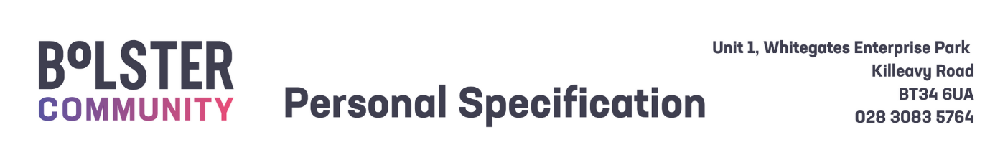

|  |  |  |
| --- | --- | --- |
| Personal Specification –Disability Support Worker | | |
|  | Essential Criteria | Desirable Criteria |
| 1. Circumstances | 1. Ability to work flexibly to meet the needs of the role, including evening and weekend hours when necessary. 2. A full current driving licence and access to a car insured for business use. *(Please note: The transportation of clients is a key part of this role, a full clean driving licence and access to a car insured for business use is required)* |  |
| 2.Qualifications | 1. Level 2 NVQ Health and Social Care or equivalent.   Or  Proven experience of supporting children or adults with additional needs. |  |
| 3. Skills and Expertise | 1. Effective verbal and written communication to include numeracy skills. 2. Understanding of the needs of people with learning and physical disabilities. 3. Ability to support service users to achieve their full potential. 4. Experience of collaborative working and the ability to work in a team to deliver our vision and strategic aims. 5. Commitment to building a community that recognises Equality and Diversity 6. Committed to ensuring the provision of high-quality person-centred services |  |
| Shortlisting will be based on the evidence that you supply on your application form to satisfactorily demonstrate how, and to what extent, you meet the above criteria. The Shortlisting Panel will not make assumptions as to your circumstances, qualifications, and experience. | | |
|  | | |
| Competencies – Candidates who are shortlisted for interview will be required to demonstrate how, and to what extent, they meet some or all of the competencies listed below during their interview. | | |
| 1. **Effective Communication**  Keeps people well informed and communicates messages clearly and concisely. Listens carefully, evaluates other opinions and is able to communicate successfully.  Engages in the exchange of ideas, information and feedback within their role.   1. **Leadership**   Demonstrates leadership attributes within their role towards their colleagues, volunteers, clients and customers.  Acts as a positive role model and supports a climate of continuous improvement.  Understands the strategic direction of SureStart, taking the opportunity to challenge and compromise as appropriate.  Demonstrates commitment to achieving SureStart strategy and operational objectives through their communications, actions and personal objectives.   1. **Clarity of Purpose**          Delivers results on time, within constraints and in line with organisational strategy, policy and procedure.  Strives to exceed the expectations and requirements of clients, internal and external customers; acts with customers in mind and values the importance of providing high-quality customer service.   1. **Ongoing Commitment to Development**   Demonstrates required job knowledge and understanding to successfully and competently fulfil or exceed the requirements of their post.  Challenges self to continually develop and improve performance to maximise their potential and job knowledge by proactively contributing to the culture of innovation, excellence and teamwork.   1. **Team and Partnership Working**   Demonstrates collaboration within and across teams.  Develops and encourages effective partnerships and a positive team atmosphere, both internally and externally, to improve the efficiency and effectiveness of service delivery based on shared outcomes.   1. **Wellbeing for all**   Actively involved in maintaining their own wellbeing.  Contributes to the conditions to develop and promote health and wellbeing for staff.  Promotes a safe and supportive working environment for staff. | | |