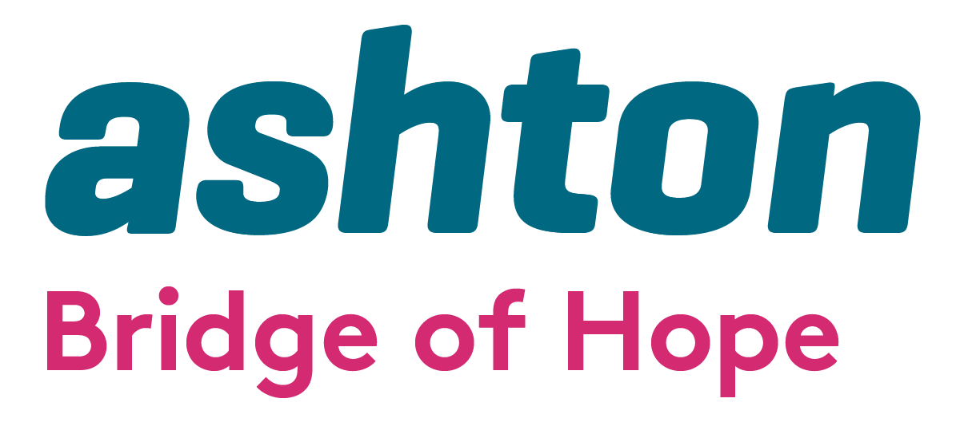

Invitation to Tender for Counselling & CBT
FACE to FACE, Telephone sessional Counsellors

Bridge of Hope, a project of Ashton’s Health and Wellbeing Department is inviting tender applications from competent, experienced and appropriately qualified Counsellors/Practitioners to deliver talking therapies on a sessional basis.

Bridge of Hope Overview

Bridge of Hope is a health and wellbeing service that supports individuals affected by the conflict and those experiencing poor physical and emotional health. Our mission is “To empower and promote positive change for victims and survivors through delivery of quality health and wellbeing services.”

Ashton Bridge of Hope holds organisational membership and is an accredited service with the British Association for Counselling and Psychotherapy (BACP), Membership Number: 211323. We operate in accordance with the BACP Ethical Framework for the Counselling Professions and ensure that all stakeholders/service users are aware of this professional code of conduct.

Our services are person-centered and based on the theory that no single approach will suit everyone. All services are monitored and outcomes recorded. We support people through a range of funding streams made possible by the Victims & Survivors Service, Belfast Health & Social Care Trust (BHSCT) and Public Health Agency. We are a Primary Care Talking Therapies Hub provider delivering services across the city of Belfast to meet the needs of individuals who are experiencing common mental health problems.

Holistic support services include: complementary therapies: physiotherapy; life coaching; counselling and psychological services; accredited VTCT training; personal development courses and conflict legacy programmes, including supporting those applying for the Troubles Pension (TPDPS). We also provide support through PEACE IV Health and Wellbeing Caseworkers. All of these services are designed to help manage and reduce stress and encourage the development of positive, healthy and resilient lives.

More details here: www.ashtoncentre.com and www.bridgeofhope.support


Role description

We see this role to have a range of priorities:

- To work with individuals on a one to one basis, using a range of platforms, including face to face and telephone Counselling sessions.
- To provide one to one psychological therapy to victims and survivors, individuals impacted by suicide and self-harm & individuals experiencing common mental health problems.
- To act as a liaison for other Bridge of Hope staff.
- To travel to any Bridge of Hope outreach centre as required.
- To inform individuals about the range of support services offered by Bridge of Hope to encourage a holistic approach.
- To work closely with identified Bridge of Hope staff to ensure that all appropriate procedures and processes are followed at all times.
- To be a critical point of contact for individuals presenting in crisis.
- Attend quarterly meetings with Clinical Lead and/or other relevant Bridge of Hope, Ashton staff throughout the year
- Liaise with Bridge of Hope Clinical Lead immediately should a problem arise relating to the wellbeing of any individual and/or if identified that an individual requires any other support or referral pathway.
- Attend an annual appraisal meeting with the Clinical Lead.
- Ensure all processes (including CoreNet and GP letters) are completed accurately and kept up to date and that any other required paperwork and data is submitted to Bridge of Hope fully completed and on time.
- Be prepared to deliver a flexible service for Bridge of Hope to enable us to meet the needs of our client base.

The tender format is as follows:

- Applicants must demonstrate and provide evidence where appropriate how they meet all elements of the essential criteria. Please note it is critical to address each of the criteria listed above in your application. Failure to do so will result in your tender application being deemed ineligible.
- Applicants must include the following
- copies of all relevant qualifications and certificates
- evidence of membership of BACP or equivalent body
- evidence of BACP accreditation or equivalent body (or working towards)
- evidence of Professional Liability Insurance to a minimum of £5 million.
- Applicants must outline what days and times they are available to deliver services on behalf of Bridge of Hope. Please be aware Bridge of Hope deliver sessions both during the day and some evenings.
- Tender applications must include a completed Declaration of Employment Status form.

Copies of tender proposals should be forwarded by email with “Tender for psychological therapies” in the subject line to: lindsay.whitten@ashtoncentre.com

Any tender applications not including all information required above will be discounted as incomplete and will not move to scoring.

All tenders must be received no later than 12.00 pm on Monday 24th March 2025. No late tenders will be accepted. Where appropriate, interviews will be held as soon as possible after this date.

Bridge of Hope will use the information supplied to score all tender applications. Please take note of scoring criteria as this will be used to total scores, and only applicants who score over 80 will be added to our Approved Suppliers List.

A score of 80 or more will enable an applicant’s details to be added to our Approved Suppliers List.

Please note being added to the Approved Suppliers List does not constitute any guarantee of sessional hours.

Any successful tender will be valid from 1st April 2025 to 31st March 2026.

Ashton’s Bridge of Hope operates in accordance with the General Data Protection Regulations 2018. This means we will treat the information you provide with strict confidentiality. At times we may need to share some of your information with other staff, funders and other stakeholders.

Award Criteria | Score out of 100
Demonstration of 2 years post-qualifying practice (with no less than 300 hours post-qualifying practice)  AND  Accredited Member of BACP/IACP/NCS, please include your number.  OR  Actively working towards accreditation with an understanding that this will be achieved within 24 months of starting client work with Ashton. | 30
Knowledge of the Step Care Model and working with individuals experiencing common mental health problems | 15
Demonstration of Trauma Training and experience working with Victims and Survivors | 15
Commitment to receiving regular monthly clinical supervision (minimum 1.5 hours) | 3
Commitment to ongoing CPD in line with a professional body | 10
Demonstration of qualifications | 3
Keeping Children Safe Training (completed within the last 2 years) or a commitment to achieve this within 3 months of starting. | 5
Keeping Adults Safe / Safeguarding Adults Training (completed within the last 2 years) or a commitment to achieve this within 3 months of starting. | 5
Demonstration of Value for Money | 3
Evidence of Professional Insurance – a minimum of £5million | 3
CV included | 3
Availability for delivery of sessions, commitment to update all client data/records on the same day of booked appointments. | 5

Contact Details: If you require further information, wish to clarify any points or have difficulty relating to the tender documentation before submission of your proposal please contact the Operations Manager Lindsay Whitten via email lindsay.whitten@ashtoncentre.com.

Invitation to Tender for Counselling, CBT
FACE to FACE, Telephone sessional Counsellors

NAME: _____________________________________ TELEPHONE: __________________

EMAIL: _____________________________________ DATE: ________________________

Essential Criteria
- Demonstration of 2 years post qualifying practice (with no less than 300 hours’ post-qualifying practice)

AND

Details of Accredited Member status of BACP/IACP/NCS

OR

Actively working towards accreditation with an understanding that this will be achieved within 24 months of starting client work.

2. Please demonstrate your knowledge of the Step Care Model and your work with individuals experiencing common mental health problems.

Essential Criteria contd.
3. Please detail any relevant Trauma Training and your experience of working with Victims & Survivors.

4. Please give your Clinical Supervisor’s contact details, including the regularity of appointments.

5. Please provide details of recent CPD completed and demonstrate your commitment to Continuing Personal Development.

6. Please state qualifications and dates of completion.

7. Have you completed Keeping Children Safe Training within the last 2 years? If so, please detail completion dates and include a copy of your certificate with your tender. OR demonstrate your commitment to achieving this within three months of submitting your tender.

8. Have you completed Keeping Adults Safe Training within the last two years? If so, please detail completion dates and include a copy of your certificate with your tender.
OR demonstrate your commitment to achieving this within three months of submitting your tender.

9. Have you completed Mental Health First Aid (or equivalent) training? If so, please detail completion dates and include a copy of your certificate with your tender.
OR demonstrate your commitment to achieving this within three months of submitting your tender.

10. Please state your cost per hour inclusive of travel, subsistence and VAT

11. Outline days, times, and your capacity to deliver sessions demonstrating your commitment to updating all client data/records on the same day of booked appointments.

Bridge of Hope use a blended modality approach for the delivery of talking therapies, offering Face to Face and telephone counselling sessions. On occasion it may be necessary to facilitate a remote session using Zoom.

Please indicate if you are offering exclusively face to face, a blended approach or exclusively telephone sessions.

Check List for Applicants

CV
Professional Liability Insurance
Certificates of Qualifications
Safeguarding Adults Certificate
Keeping Children Safe Certificate
Mental Health First Aid Certificate
Membership/Accreditation of BACP or Equivalent Body
Capacity and commitment to same-day data/recording

