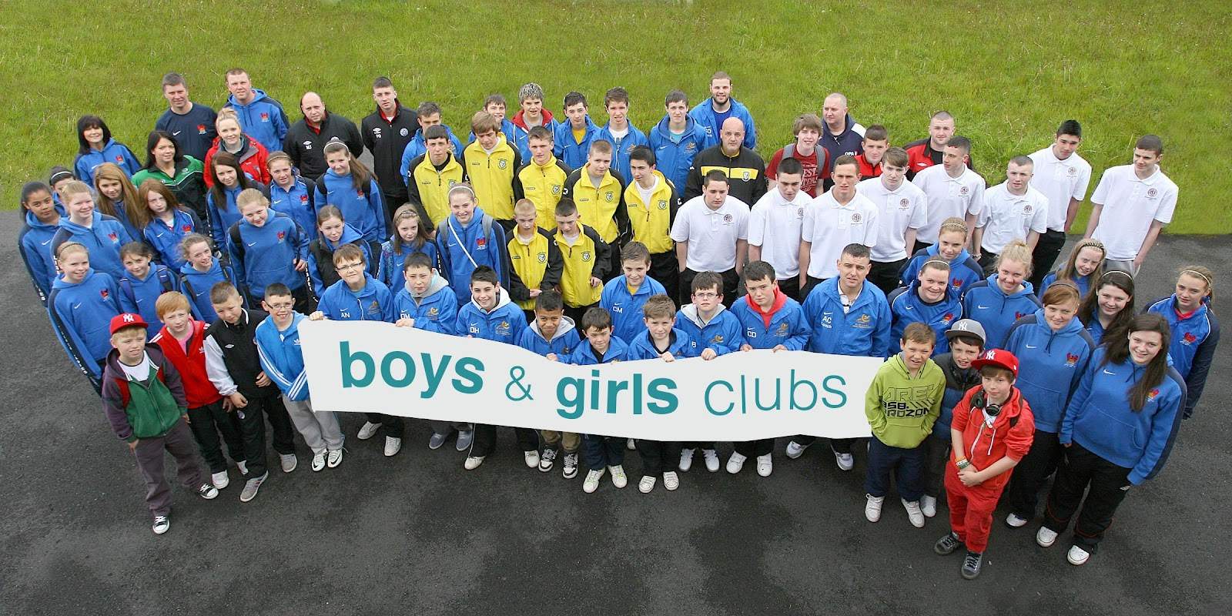

Youth Facilitator – Antrim/ Ballymena
Information Pack
March 2025
Job Ref: OGYW25

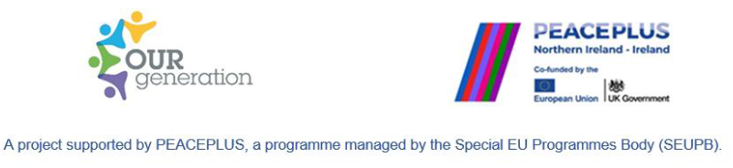

About Us
Boys & Girls Clubs (NI) is a leading Regional Voluntary Youth Organisation (RVYO), a registered charity and limited company that supports a membership of 147 local youth organisations.
Who we are
Boys & Girls Clubs (NI) was founded in 1940 as an independent, voluntary association of six local organisations that were dedicated to bringing communities together and enriching the lives of children & young people. Today, we have transformed into a modern membership organisation, supporting 147 member organisations. This membership is diverse and includes part-time & full-time youth organisations, community associations, schools, and sports clubs. The foundations and purpose of the charity remains strong and our mission is to support the personal development and social education of children & young people and to promote good relations and community development.
What We Do
Each year our professional youth work team engages directly with 3000 children, young people, volunteers & youth workers. Indirectly, we support a wider network of 48000 stakeholders on an annual basis. We work in partnership with local organisations and provide wraparound support through membership services, compliance and regulation, accredited training, networking opportunities, intervention projects, policy guidance, governance advice and an extensive programme of youth programmes. Our main office is located in Belfast, and we operate in both rural and urban areas across Northern Ireland through our professional team of area-based youth workers.
This post
The post holder will be a member of Boys & Girls Clubs OUR Generation operational team, with an overall purpose to deliver wellbeing, good relations and sports activities within local voluntary youth organisations within the areas of Antrim and/ or Ballymena.
The OUR Generation project aims to contribute to peace and reconciliation through a range of cross-community and cross-border youth mental health and wellbeing models, peace and youth leadership programmes. The project, which builds on the highly successful Peace IV OUR Generation project, is supported by PEACEPLUS, a programme managed by the Special EU Programmes Body (SEUPB).
Our Services
We serve children, young people, volunteers, and youth workers through a variety of support services all under the core 5 pillars of our service. This includes training for educational enrichment, networking opportunities, policy guidance, youth intervention projects, safeguarding packages, legal compliance/governance support, and an extensive programme of youth activities.

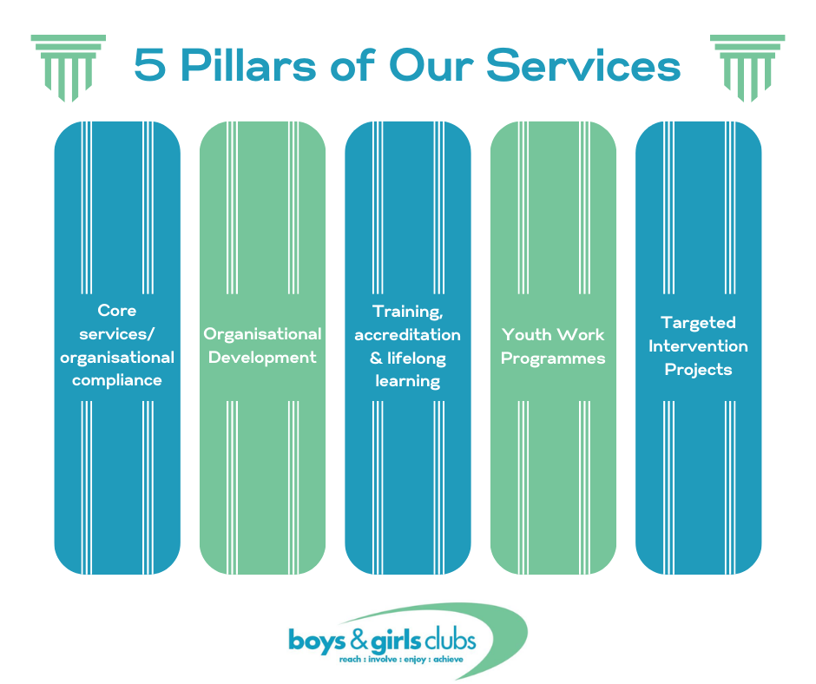

Job Description
Job Title: Youth Facilitator
Responsible to: Youth Work Coordinator
Based at: Antrim and/ or Ballymena
Hours per week: 10 hours
Salary: £25,221 – 27,560 p.a. (pro rata). Candidates are appointed at the start of the pay scale.
Holidays: The leave entitlement is 20 days Annual Leave, plus 10 days Public Holidays (calculated pro-rata for part-time employees). The leave-year runs from 1st January to 31st December.

Contract: This post is funded until 31st December 2027.
Probationary Period: 6 months
Additional benefits include
- Access to Private Health Care scheme
- Flexible working conditions

Purpose of Post
To provide support to membership organisations across NI through the delivery of sports, wellbeing, and good relations activities. The post-holder will be responsible for monitoring and evaluating their delivery, and ensuring key targets are met.
Key Responsibilities
- Promote youth participation and involvement in all organisational activities.
- To work as part of a youth work team, designing, delivering, and coordinating youth activities and events. The post holder must also ensure that all activities are compliant with current legislation; that policy and best practice is maintained at the optimum level in relation to all work with young people.
- Design and participate in regional initiatives, maintain organisational relationships, and work with other youth workers on the project to enrich the project.
- Design and deliver activities that promote the message of positive community relations.
- To facilitate and develop youth participation in decision-making, through building positive relationships with young people, and those who work on their behalf.
- To create awareness of and signpost for services for young people on a range of youth issues including employability, drugs and alcohol abuse, mental health etc.
- To maximise and enhance youth participation and empowerment by utilising and developing electronic communications, social media platforms, networks, and other appropriate forums of benefit to the organisation and its beneficiaries.
- To identify a cohort of young health champions, nurture their development through a variety of training schemes and empower them to become active volunteers in their communities.
- To support the Youth Work Coordinator to maintain accurate administrative documents as requested and required from the sponsor.
- Ensure compliance with all Boys & Girls Clubs (NI) polices with reference to the safeguarding, health and safety, equal opportunities, and communication policies.
Person Specification
Shortlisting Criteria
(i). Education experience:
Educated to Level 3 (A Level) or equivalent.
(ii). Experience & Knowledge:
Minimum one years’ experience of designing and delivering programmes and activities to meet the needs of children and young people.
(iii). Skills and abilities:
Knowledge of ICT with proficiency in the use of Microsoft Office packages and digital platforms.
Proven track record of implementing and maintaining monitoring and evaluation processes and producing reports in a timely manner.

(iii) Desirable Criteria and Qualifications.
These will be used for shortlisting purposes in the event of a large number of applicants.
- Qualifications. A relevant qualification in the community youth work, education, health, sport or social science field.
- Experience. Experience working, in a paid capacity, within a youth work setting.

Please Note:
Only those applicants, who appear, from the available information as provided, to be most suitable, in terms of relevant skills, experience and ability will be invited to interview. It is therefore essential that you fully describe in your application how you meet the experience and qualities sought. It is not appropriate simply to list the various posts that you have held. Assumptions will not be made from the title of posting(s) as to the skills and experience you may or may not have gained. CVs and cover letters that do not provide the necessary detailed information in relation to each of the stated criteria will be rejected.

Please submit a CV and cover letter, alongside Equality of Opportunity Monitoring Questionnaire & Disclosure of Criminal Convictions Form, to post@boysandgirlsclubs.net
CVs and cover letters must arrive no later than:
Wednesday 19th March at 2pm to post@boysandgirlsclubs.net.
LATE APPLICATIONS CANNOT BE ACCEPTED.

IN CONFIDENCE
For office use only: Applicant No. ____________________________________

Declaration of Criminal Convictions and Monitoring Questionnaire
Is there any reason why you cannot work with children or young people? Yes / No (please underline your response).
In compliance with our policy and current legislation, applicants must fully complete the attached forms and return in a separate sealed envelope:

[1] Declaration of Criminal Convictions

[2] Monitoring Questionnaire - Equality of Opportunity

Reference

All offers of employment are subject to receipt of satisfactory written references. Please provide the names, telephone numbers, addresses and email addresses of two referees, one of whom should be your present or most recent employer/line manager, and one who knows/has known you in a work capacity and can comment on your suitability for this post.

First Referee  Name: ___________________________  Address ___________________________  ___________________________  ___________________________  Tel: ___________________________  Email: ___________________________  Occupation: _______________________  Relationship to you: ___________________________________ | Second Referee  Name: ___________________________  Address ___________________________  ___________________________  ___________________________  Tel: ___________________________  Email: ___________________________  Occupation: _______________________  Relationship to you: ___________________________________

Declaration
I declare that the information provided in this Application Form is, to the best of my knowledge,
true and complete.
Signed: ________________________________ Date: _ _ / _ _ / _ _ _ _
Please read this information carefully.

Name of Applicant: ___________________________ Job Title: ___________________________

STATEMENT OF NON-DISCRIMINATION

Boys & Girls Clubs is committed to equal opportunity for all job applicants, including those with criminal convictions. Information about criminal convictions is requested to assist the selection process and will be taken into account only when the conviction is considered relevant to the role. Any disclosure will be seen in the context of the criteria of the role, the nature of the offence and the responsibility for the care of children and young people, volunteers and employees. Applicants are required to declare any convictions, cautions, reprimands and final warnings not protected by legislation.

ADVICE TO APPLICANTS
The disclosure of a criminal record or other information will not debar you from registration or appointment unless Boys & Girls Clubs considers that the conviction renders you unsuitable. In making this decision Boys & Girls Clubs will consider the nature of the offence, how long ago it was committed, your age at that time and other factors which may be relevant. This information will be verified through an appropriate AccessNI Enhanced Disclosure check. If you have received a formal caution or are currently facing prosecution for a criminal offence you should also bring this to our attention given the “exempted” nature of the role.
Please complete and sign this Declaration Form (below) accurately and return this with your application form. An arrangement may be made with you to discuss any convictions if clarification is required.

Thanking you in advance for your co-operation.

DECLARATION

Do you have any convictions that are not “protected” as defined by the Rehabilitation of Offenders (Exceptions) (Northern Ireland) Order 1979, as amended in 2014?

☐ Yes ☐ No
If ‘Yes’, please state the nature, date(s) and sentence of the offence(s) and provide any other information you feel may be of relevance, such as: the circumstances of the offence/incident; any relevant developments in your situation since; and whether or not you feel the conviction has relevance to this post. (Please continue on an additional separate page if required.)
_________________________________________________________________________________________________________________________________________________________________________________________________________________________________________________________________________________________________________________________________________________________________________________________________________________________________________

I declare that any and all answers provided herein are complete and correct to the best of my knowledge and I have informed Boys & Girls Clubs' Monitoring Officer in writing of any pending future convictions. I understand that I have applied for a role which is a Regulated Activity Position as defined by the Safeguarding Vulnerable Groups (NI) Order 2007 (as amended by the Protection of Freedom Act 2012) and which also falls within the definition of an “exempted” position as provided for by the Rehabilitation of Offenders (Exceptions) Order (NI) 1979 (as amended in 2014).

I give my consent for an AccessNI* check to take place and for this information to be shared only with relevant persons nominated as part of Boys & Girls Clubs' risk assessment and appointment procedures.

(Signature) ___________________________________ Date _ _ / _ _ / _ _ _ _

Please note that any information supplied will be treated in confidence and in accordance with the Data Protection Act and the Access NI Code of Practice (available here). Boys & Girls Clubs’ Privacy Policy is available on request and accessible on our website. The policy on the Safe Handling, Storage and Retention of Disclosure Information is available on request. Information on AccessNI can be found at www.accessni.go.uk

Job Title _____________________________ Job Ref: ____________ Date: _ _ / _ _ / _ _ _ _
Boys & Girls Clubs is committed to equality of opportunity in employment and aims to select and employ the best person for each post. All job applicants and employees shall receive equal treatment regardless of gender, marital status, age, disability, socio-economic circumstances, health, sexuality, religious or political belief, colour, race and ethnic or national origin. We will encourage positive attitudes and behaviour towards groups and individuals and will strive to eradicate prejudice and discrimination by promoting equality of opportunity in all areas of our work and organisational structure.
To demonstrate our commitment to equality in employment we need to monitor the community background of all employees and job applicants as required by the Fair Employment and Treatment (Northern Ireland) Order 1998.
Regardless of whether we practice religion, most of us in Northern Ireland are perceived as either Catholic or Protestant. We are therefore required to ask you to indicate your community background by ticking the appropriate box below.

DECLARATION
I am a member of the Catholic community ☐

I am a member of the Protestant community ☐

I am a member of neither the Protestant nor the Catholic community ☐

Please indicate whether you are: Female ☐ Male ☐ Prefer Not to Say ☐

Date of Birth: __ /__ / ____

ETHNIC ORIGIN (please tick appropriate box.)
☐ Bangladeshi | ☐ Black African | ☐ Black Caribbean
☐ Black/Other | ☐ Chinese | ☐ Indian
☐ Pakistani | ☐ White | ☐ Other (Please specify):

N.B. If you do not complete this questionnaire and return it with your Application Form, we will be unable to process your application to the next stage of the selection process.
** This form will be separated from your Application Form and will not be seen by the selection panel.

