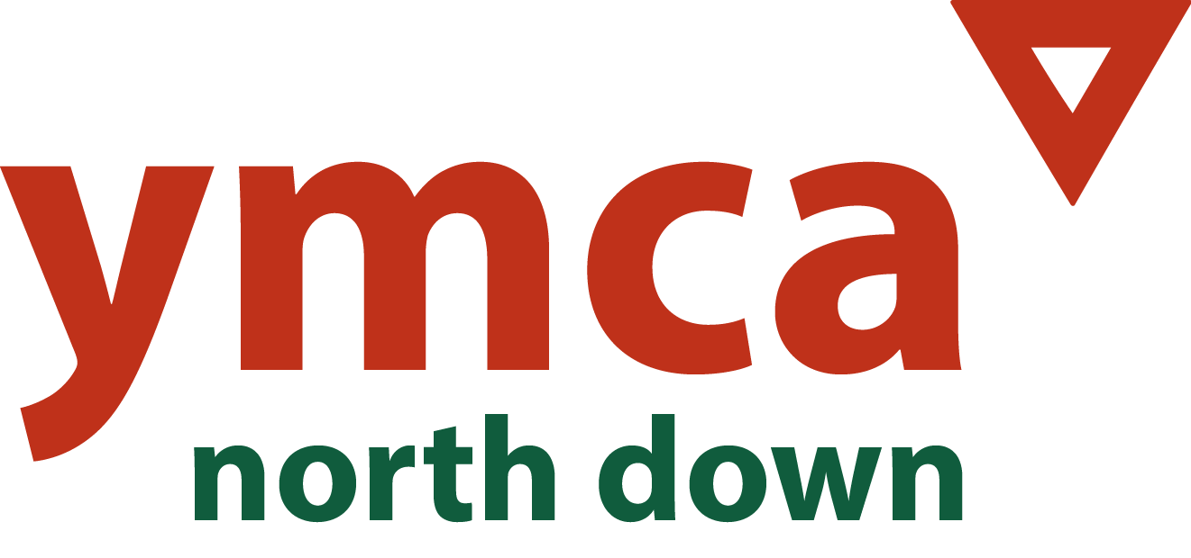

Dear Applicant

Thank you for expressing interest in the position of Finance & Administration Officer with North Down YMCA. We are seeking to fill a permanent position to fulfill a finance and administration function for our After School Programme and offer a contract of employment from **15 to 22.5 hours per week** (Flexibility on hours based on Needs - Reference Number F&A ASC 00325) The role of Finance & Administration Officer is a key position within the Team and we are looking for motivated, skilled, experienced and committed candidate.

In advertising this position, we need to be attentive to the legislative and good practice requirements placed upon us as an employer. Therefore, there are a number of forms to be completed. You must complete the Application Form, Equal Opportunities Form and The Criminal Declaration Section within the application Form or your application will not be considered. The successful candidate will also be required to complete a Health Declaration and undertake vetting in accordance with required standards by Social Services & DE.

Please be very careful to follow the instructions that follow:

Please be careful to download all forms related to this post. **The application should be completed and return to Victoria Gammon North Down YMCA by the deadline of** **12 noon on the 11th April 2025 –** Victoria@northdownymca.org

Interviews are provisionally scheduled for the week commencing 21st April 2025.

The application pack consists of:

* Copy of the job description and Person Specification
* Copy of Application Form
* Declaration & Consent Form for Regulated Activity
* Equal opportunity monitoring form

North Down YMCA is committed to the implementation of its Equal Opportunities Policy in all aspects of its work, including the recruitment of staff and the delivery of service. The monitoring form is, separated from the other documents and processed by the monitoring officer. It is for monitoring purposes only and will not form any part of the short listing or selection process.

In completing your application please ensure you demonstrate how you meet the requirements of the position and the relevant experience.

If you require any further clarification please do not hesitate to contact me. Thank you for your interest in YMCA and wish you every success with your application.

Yours Sincerely

Victoria gammon

ASC & Play Work Deputy Manager