` 

Invitation to Tender for Life Coaching Services 2025/2026

Bridge of Hope, a project of Ashton’s Health and Wellbeing Department is inviting tender applications from competent, experienced and appropriately qualified life coaches to deliver life coaching on a sessional basis.

Bridge of Hope Overview

Bridge of Hope is a health and wellbeing service that supports individuals affected by the conflict and those experiencing poor physical and emotional health. Our mission is “To empower and promote positive change for victims and survivors through delivery of quality health and wellbeing services.”

Holistic support services include: complementary therapies; physiotherapy; life coaching; counselling and psychological services; accredited VTCT training; personal development courses and conflict legacy programmes. We also provide support through PEACE IV Health and Wellbeing Caseworkers. All of these services are designed to help manage and reduce stress, and encourage the development of positive, healthy and resilient lives.

Our services are victims-centred and based on the theory that no single approach will suit everyone. All services are monitored and outcomes recorded.

We support people through a range of funding streams made possible by the Victims & Survivors Service, Belfast Health & Social Care Trust (BHSCT) and Public Health Agency. We are a Primary Care Talking Therapies Hub provider delivering services across the city of Belfast to meet the needs of individuals who are experiencing common mental health problems.

Bridge of Hope is actively engaged in researching the needs of victims and survivors of the conflict so that we can better advocate their needs at a strategic level. Together with our partner at the Transitional Justice Institute at Ulster University, we have developed a community-university human rights programme that speaks to people whose lives have been changed by conflict. The Transitional Justice Grassroots Toolkit Programme is globally relevant to areas moving out of conflict and has been translated into Spanish and Arabic.

Further information about us can be accessed on our websites:

www.ashtoncentre.com and www.thebridgeofhope.org

Role description

We see this role to have a range of priorities:

- To interact with individuals on a one to one basis.
- To provide one to one life coaching support to clients.
- To act as a liaison for other Bridge of Hope staff
- To travel to any Bridge of Hope outreach centre as required.
- To inform individuals about the range of support services offered by Bridge of Hope to encourage a holistic approach.
- To work closely with identified Bridge of Hope staff to ensure that all appropriate procedures and processes are followed at all times.
- To be a critical point of contact for individuals presenting in crisis.
- Attend a meeting with Head of Health & Wellbeing and/or other relevant Bridge of Hope, Ashton staff periodically throughout the year.
- Liaise with Bridge of Hope Head of Health & Wellbeing immediately should a problem arise, relating to the well-being of clients and/or if identified that an individual requires any other support or referral pathway.
- Attend regular one to one meetings with the Head of Health & Wellbeing.
- Ensure all relevant paperwork is completed and returned to the Operations Manager at Bridge of Hope fully completed and on time.
- Be prepared to deliver a flexible service for Bridge of Hope to enable us to meet the needs of our client base.

The tender format is as follows:

- Applicants must demonstrate and provide evidence where appropriate how they meet all elements of the essential criteria. Please note it is important to address each criteria listed above in your application. Failure to do so will result in your tender application being deemed ineligible.
- Applicants must include a full and up to date CV with their application.
- Applicants must include a copy of all relevant certificates.
- Applicants must include evidence of membership of Association for Coaching prior to commencement of sub-contracting.
- Applicants must include evidence of Professional Liability Insurance to a minimum of £5 million
- Applicants must outline what days and times they are available to deliver services on behalf of Bridge of Hope. Please be aware Bridge of Hope deliver sessions both during the day and some evenings.
- Tender applications must include a completed Declaration of Employment Status form.

Copies of tender proposals should be forwarded in a plain envelope clearly marked “Life Coaching Tender” to:

Lindsay Whitten
Operations Manager
Bridge of Hope
Ashton Centre
5 Churchill Street
Belfast
BT15 2BP

Any tender applications not including all information required above will be discounted as incomplete and will not move to scoring.

All tenders must be received no later than 12.00 pm on Monday 24th March 2025. No late tenders will be accepted. Where appropriate, interviews will be held as soon as possible after this date.

Bridge of Hope will use the information supplied to score all tender applications. Please take note of scoring criteria as this will be used to total scores, and only applicants who score over 80 will be added to our Approved Suppliers List.

A score of 80 or more will enable an applicant’s details to be added to our Approved Suppliers List.

Please note being added to the Approved Suppliers List does not constitute any guarantee of sessional hours.

Any successful tender will be valid from 1st April 2025 to 31st March 2026.

Ashton’s Bridge of Hope operates in accordance with the General Data Protection Regulations 2018. This means we will treat the information you provide with strict confidentiality. At times we may need to share some of your information with other staff, funders and other stakeholders.

Award Criteria | Score out of 100
Demonstration of Membership of Association for Coaching and commitment to Continuing Professional Development | 10
Demonstration of value for money | 10
Flexible approach to working | 5
Evidence of insurance | 5
Demonstration of qualifications | 5
Commitment to receiving regular supervision | 10
Experience working with individuals affected by trauma | 10
Minimum of 150 hours coach training | 10
Minimum of 150 hours post qualifying experience | 10
CV included | 5
Mental Health First Aid Qualification | 4
Emergency First Aid at Work Qualification | 4
Keeping Adults Safe or Safeguarding Adults Training Qualification | 4
Keeping Children Safe Training Qualification | 4
Trauma Training | 4

Contact Details: If you require further information, wish to clarify any points or have difficulty relating to the tender documentation before submission of your proposal the contact point Lindsay Whitten (Operations Manager).

Email: lindsay.whitten@ashtoncentre.com Tel: 028 9074 2255

START AND COMPLETION DATES

It is anticipated that funding for this service delivery will be from 1st April 2025 – 31st March 2026.

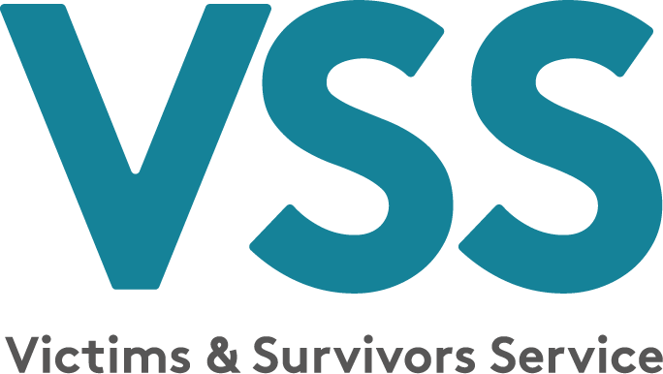

Invitation to Tender for Life Coaching Services 2025/2026

NAME: _________________________ TELEPHONE: __________________

EMAIL: ______________________________________DATE: _______________

Essential Criteria
1. Please provide details of 150 hours coach training and 150 hours post qualifying experience.

2. Please give Supervisors details, regularity of appointments.

3. Please demonstrate any experience of working with individuals who have experienced related trauma.

4. Please state membership details of Association for Coaching and demonstrate commitment to Continued Professional Development.

5. Please demonstrate how you have a flexible approach to delivery of life coaching.

6. Have you completed Keeping Children Safe Training within the last 2 years? If so please detail dates of completion and include a copy of your certificate with your tender.

7. Have you completed Keeping Adults Safe Training within the last 2 years? If so please detail dates of completion and include a copy of your certificate with your tender.

8. Have you completed Trauma training? If so please detail dates of completion and include a copy of your certificate with your tender.

9. Have you completed Emergency First Aid at Work training in the last 2 years? If so please detail dates of completion and include a copy of your certificate with your tender.

10. Have you completed Mental Health First Aid (or equivalent) training? If so please detail dates of completion and include a copy of your certificate with your tender.

11. Please state your cost per hour inclusive of travel, subsistence and VAT

12. Outline days and times available for delivery of sessions.

Check List for Applicants

CV included
Insurance Certificate to a minimum of £5 million
Certificate of Life Coaching qualification
Keeping Adults Safe / Safeguarding Adults Training Certificate
Emergency First Aid at Work Certificate
Keeping Children Safe Certificate
Mental Health First Aid Certificate
Proof of membership of Association for Coaching

