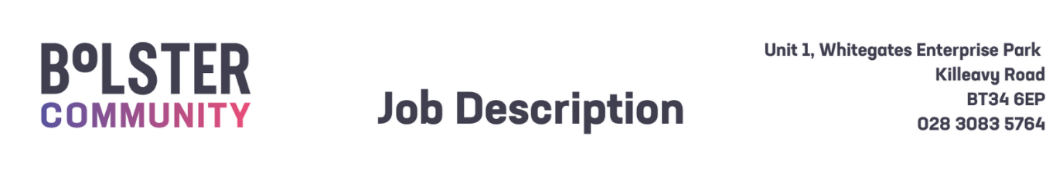

|  |  |  |
| --- | --- | --- |
| Job Description – Leader Developmental programme for 2 year olds Mourne Sure Start | | |
| **Title:**  Leader, Programme for 2year olds |  | **Reference:** Mourne / Permanent Term Time/25 |
| **Reports to:** Mourne SureStart Manager |  | **Responsible to**: CEO |
| **Base:** Mourne Surestart, 18 Newcastle Street, Kilkeel BT34 4AF |  | **Hours** 16 hrs per week Term Time |
| **Benefits:**   * **Basic salary:** £26,481 Pro-rata * **Pension:** 6% employer’s salary contribution (subject to conditions) * **Annual Leave:** 25 days per annum + Statutory Holidays (pro-rata for part-time posts) * **Allowances:** Travel Expenses will be paid according to Bolster Community rates (subject to conditions) | | |
| Purpose of Post: | | |
| Promote the Mourne Sure Start project and promote and develop high quality, evidence-informed early childhood services for young children and their families. Work with children, families and communities to ensure children have the best start in life, grow up healthy, enjoy learning and achieving. Live in safety and stability, enjoy economic wellbeing, and contribute positively to society, in a society that respects their rights. Work as a member of the multidisciplinary team to deliver on agreed targets and services.  The post holder will be involved in service delivery within the Mourne Sure Start area and specifically for the delivery and on-going development of the Programme for Two Year Olds. This will include working in partnership with families to promote and facilitate positive parenting and the enhancement of the role of parents as ‘first educators’.  The post holder will be responsible for ensuring the overall safety and wellbeing of the children and for implementing the standards laid down by Mourne Sure Start and Social Services registration requirements. | | |
| Key Duties and Responsibilities: | | |
| * Promote Mourne Sure Start and increase membership and engagement at every opportunity. * Regularly engage with families on an individual and group basis as appropriate to ensure children’s learning outcomes are shared and agreed with parents and carers. * Lead, develop and support and supervision, annual appraisals and meetings. * To promote parent-child interaction. * Work in partnership with parents. * To adhere to support and advice from programme Support Specialist to ensure high quality is maintained. * To liaise with staff and other agencies when necessary to ensure promotion of parental and child health and well-being * To be fully aware of the Sure Start and Bolster Child Protection Guidelines and ensure these guidelines are followed at all times where there are concerns of child abuse or neglect * To ensure confidentiality is maintained at all times * To keep and maintain client records, contacts, and work time records and ensure they are provided as required. * To attend meetings, seminars and training as appropriate * Carry out day to day office base administration as required.   General Requirements  The post holder will be required to:     1. Ensure the Bolsters policy on equality of opportunity is promoted through his/her own actions and those of any staff for whom he/she has responsibility. 2. Co-operate fully with the implementation of the Bolster Community Health and Safety arrangements, reporting any accidents/incidents/equipment defects to his/her manager, and maintaining a clean, uncluttered and safe environment for members of the public and staff. 3. Adhere at all times to all Bolster Community policies/codes of conduct, including for example:    * Smoke Free policy    * IT Security Policy and Code of Conduct    * standards of attendance, appearance and behaviour      1. Contribute to ensuring the highest standards of environmental cleanliness within your designated area of work.      1. Co-operate fully with regard to Bolster Community’s policies and procedures relating to infection prevention and control.      1. All employees of Bolster Community are legally responsible for all records held, created or used as part of their business with Mourne Sure Start including clients, corporate and administrative records whether paper-based or electronic and also including emails. All such records are public records and are accessible to the general public, with limited exceptions, under the Freedom of Information Act 2000 the Environmental Information Regulations 2004, the General Data Protection Regulations (GDPR) and the Data Protection Act 2018. Employees are required to be conversant with the Bolster Community policy and procedures on records management and to seek advice if in doubt. 2. Take responsibility for his/her own ongoing learning and development, in order to maximise his/her potential and continue to meet the demands of the post. 3. Represent Bolster Community’s commitment to providing the highest possible standard of service clients and members of the public, by treating all those with whom he/she comes into contact in the course of work, in a pleasant, courteous and respectful manner. | | |
| This Job description is neither exhaustive nor exclusive and is not intended to be rigid and inflexible but should be regarded as providing guidelines within which the individual works. It will be subject to review depending upon operational requirements and staffing levels | | |