Job Description

Job Title: Skills Tutor
Reporting To: Skills Manager
Location: Base of Belfast and/or Bangor – will be required to travel across various sites
Hours: Up to 30 per week: Flexibility around working days and hours
Salary: £25,875 pro rata + 7% employer pension contribution + 1% employee contribution

Main Purpose
The overall purpose of the post is to support individuals with Learning Disability or Autism to develop new skills relating to independence, employability, and personal development. This will be done through delivering accredited and non-accredited courses to groups based at our locations in either Belfast, Bangor or Lisburn. The aim is to support participants to overcome their individual employment barriers through the delivery of a comprehensive training programme.

MAIN RESPONSIBILITIES:

- Develop training materials for use in groups and to individuals relating to employability, independence and personal effectiveness eg interview skills, team work, CV development, money management, customer service, communication and vocational skills etc
- Develop practical training activities, delivered outside a classroom setting, which support the development of individual and employability goals.
- Prepare and plan training sessions which are engaging and informative including feedback from participants.
- Support participants to engage in training by identifying reasonable adjustments eg using assistive technology
- Ensure quality training standards are followed regarding outcomes and evidence.
- Internally and externally verify accredited programmes as required.
- Monitor and record progress of participants against personal action plans.
- Monitor progress against project targets relating to accredited qualifications and the development of basic skills.
- Support the Skills Manager to recruit participants to SkillSET as well as to register on specific training programmes.
- Liaise with participant stakeholders, e.g. internal colleagues, family, social workers, supporting housing regarding practical arrangements and any challenges that arise.
- Carry out group and individual risk assessments as required in relation to training activities.
- Support the Skills Manager to apply for funding opportunities and plan celebration events relating to training achievements.

Personnel Specification

Essential Criteria
- Educated to Level 3 or equivalent i.e. A level, AS level, NVQ level 3
- 1 years’ experience of delivering training programmes to people with learning disability or autism in a group-based setting within education, training, day opportunities or employment settings.
- Experience of developing training courses using a variety of methods and materials to engage learners.
- Able to communicate effectively and confidently with a wide range of stakeholders.
- Able to demonstrate good organisational skills including being proficient at using Microsoft Office applications.
- Current full driving license, valid in the UK, and access to a car or other form of transport which will permit you to carry out the duties of the post in full including business use insurance. N.B: Alternative transport methods will be considered for those who have a disability and cannot obtain a driving license.

Desirable Criteria
- Third Level qualification relating to training or youth work.
- OCN Assessor training
- Completion of adult safeguarding training

Requirements
The post holder will be asked for proof of the right to work in the UK and will be required to undergo an Enhanced Access NI check (funded by Orchardville).

Other
In addition, applicants must be able to demonstrate our values of Empowerment, Quality, User focused, Integrity, Passion (EQUIP)

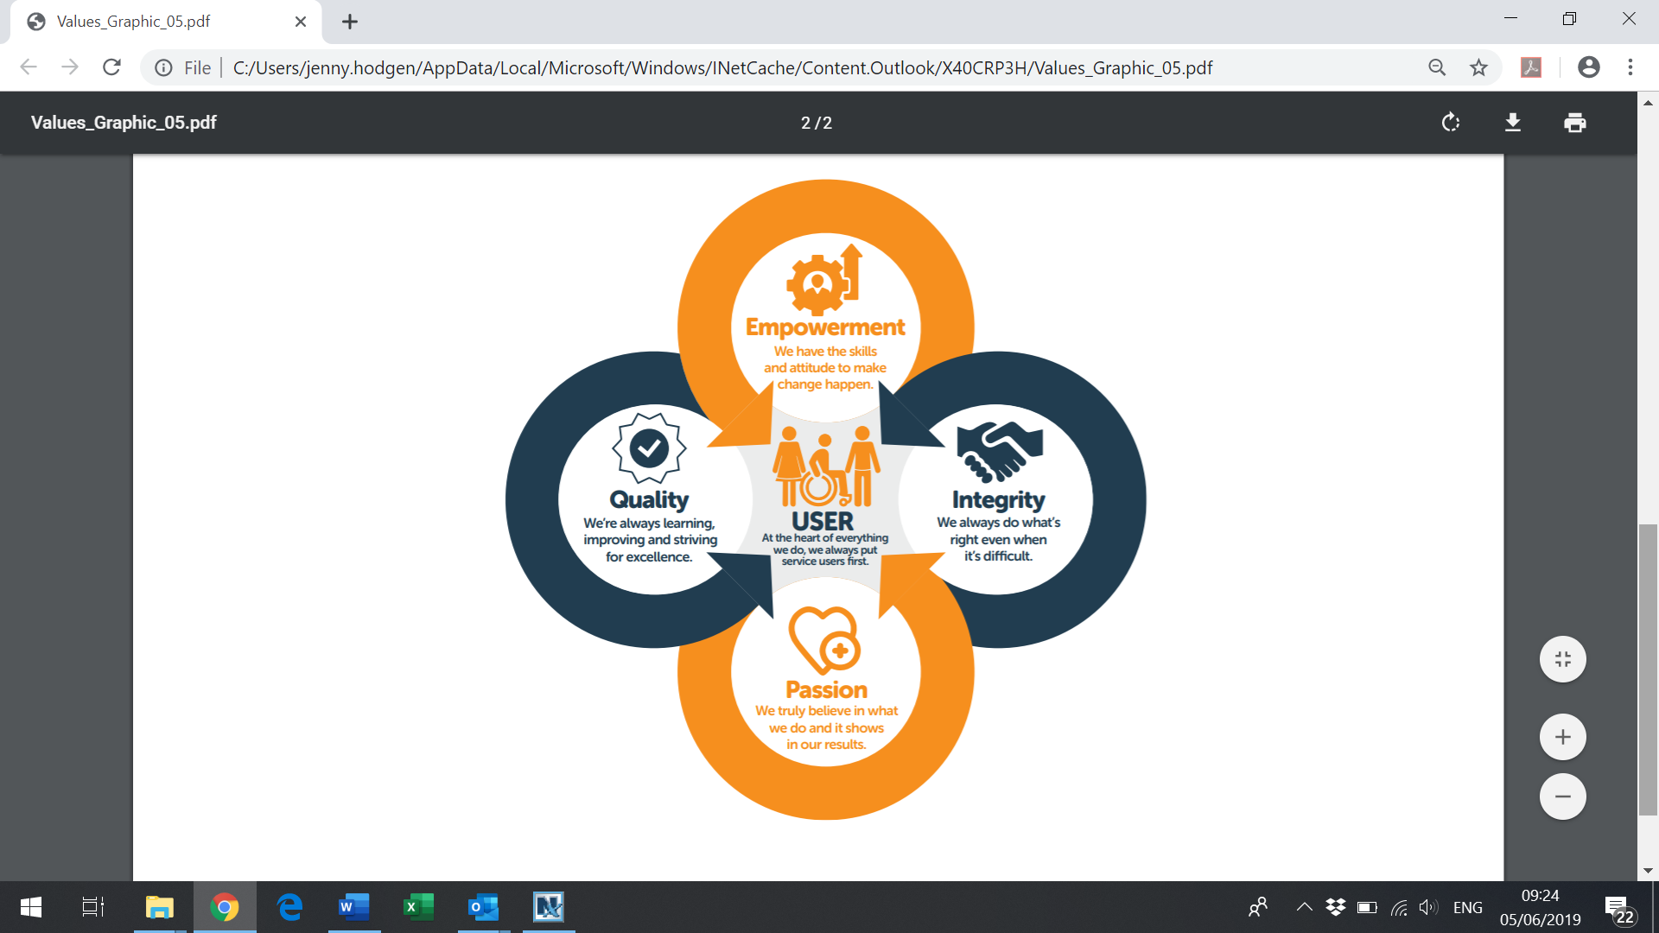

NB: Criteria may be enhanced to assist short-listing.

