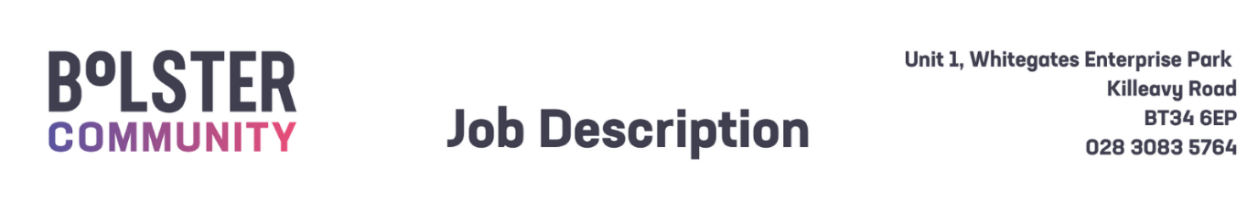

|  |  |  |
| --- | --- | --- |
| Job Description –Family Support Worker | | |
| **Title:**  Family Support Worker |  | **Reference:** FSW/25 |
| **Reports to:** Head of Operations and Development |  | **Responsible to**: CEO |
| **Base:** Bolster Community, Unit 1 Whitegates Enterprise Park, Killeavy Road, Newry |  | **Hours** 30 hrs per week |
| **Benefits:**   * **Basic salary:** £25,226.76 Pro-rata * **Pension:** 6% employer’s salary contribution (subject to conditions) * **Annual Leave:** 25 days per annum + Statutory Holidays (pro-rata for part-time posts) * **Allowances:** Travel Expenses will be paid according to Bolster Community rates (subject to conditions), Health Cash Plan (subject to conditions) | | |
| Purpose of Post: | | |
| To deliver specified early intervention and family support services to children aged 0-17 and their families residing within the Southern Trust geographical area with four main objectives:   * 1. The delivery of home-based emotional support to parents/carers and children.   2. The provision of practical support to parents and carers.   3. Early Intervention and detection.   4. Delivery of evidence-based parenting programmes to parents/carers and children. | | |
| Key Duties and Responsibilities: | | |
| * Build appropriate networks that will enable you to work closely with colleagues and other professionals & local organisations to support delivery of this service. * Ensure that parent and child’s confidentiality is maintained at all times and work within the Bolster Community policy on child protection. * Deliver time-limited support to enable families to deal with challenges and crisis and maintain independence. * Plan and deliver evidence-based parenting programmes as required. * Supporting and signposting parents in meeting with other appropriate agencies (schools, housing, health, social care). * Proactively engage with ‘hard to reach’ parents and children by providing clear and identifiable benefits available arising from service engagement. * Work in partnership with parents to support them with practical tasks. These could include:   1. Form filling   2. Making appointments for advice   3. Advice/ demonstration on preparing meals.   4. Encouraging parents with strategies for supporting their children in education   5. Supporting parents in a group   6. Accompanying parents to appointments * Take part in and encourage parents to join in Bolster Community family events. * Undertake training identified by management, attend staff meetings and development events. * Adhere to the policies and procedures of Bolster Community, strictly observing health and safety regulations and the Bolster Community policy on Child Protection. * To undertake any other duties commensurate with the post in discussion with management.   ***General Requirements***  The post holder will be required to:   1. Undergo pre-employment checks, including an Access NI check, in line with our safeguarding procedures. 2. Ensure the Bolsters policy on equality of opportunity is promoted through his/her own actions and those of any staff for whom he/she has responsibility. 3. Co-operate fully with the implementation of the Bolster Community Health and Safety arrangements, reporting any accidents/incidents/equipment defects to his/her manager, and maintaining a clean, uncluttered and safe environment for members of the public and staff. 4. Adhere at all times to all Bolster Community policies/codes of conduct, including for example:    1. Smoke Free policy    2. IT Security Policy and Code of Conduct    3. standards of attendance, appearance and behaviour    4. Safeguarding      1. Contribute to ensuring the highest standards of environmental cleanliness within your designated area of work. 2. All employees of Bolster Community are legally responsible for all records held, created or used as part of their business, including clients, corporate and administrative records whether paper-based or electronic and also including emails. All such records are public records and are accessible to the general public, with limited exceptions, under the Freedom of Information Act 2000 the Environmental Information Regulations 2004, the General Data Protection Regulations (GDPR) and the Data Protection Act 2018. Employees are required to be conversant with the Bolster Community policy and procedures on records management and to seek advice if in doubt. 3. Take responsibility for his/her own ongoing learning and development, in order to maximise his/her potential and continue to meet the demands of the post. 4. Represent Bolster Community’s commitment to providing the highest possible standard of service clients and members of the public, by treating all those with whom he/she comes into contact in the course of work, in a pleasant, courteous and respectful manner. | | |
| This Job description is neither exhaustive nor exclusive and is not intended to be rigid and inflexible but should be regarded as providing guidelines within which the individual works. It will be subject to review depending upon operational requirements and staffing levels | | |