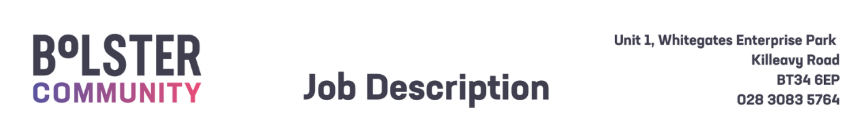

|  |  |  |
| --- | --- | --- |
| Job Description – Employability Support Worker | | |
| **Title:**  Employability Support Worker – **Term Time Only**  (1-year fixed term, with potential extension subject to funding) |  | **Reference:** ESW / Fixed Term /25 |
| **Reports to:** Head of Operations and Development |  | **Responsible to**: CEO |
| **Base:** Newry and Kilkeel |  | **Hours** 37.5 hrs per week |
| **Benefits:**   * **Basic salary:** £25,226.76 Pro-rata * **Pension:** 6% employer’s salary contribution (subject to conditions) * **Annual Leave:** 25 days per annum + Statutory Holidays (pro-rata for part-time posts) * **Allowances:** Travel Expenses will be paid according to Bolster Community rates (subject to conditions), Health Cash Plan (subject to conditions) | | |
| Purpose of Post: | | |
| As a **Employability Support Worker**, you will provide direct support to young adults with intellectual disabilities who participate in our **Positive Transitions** program, delivering a daily program of activities designed to enhance independent living, social and employability skills.  You will support participants in both classroom and employment settings, providing the necessary coaching and encouragement to enable them to succeed. You will work closely with the Employability Tutor, Teacher, Classroom Assistant and Employers to facilitate education, apprenticeship and employment opportunities. | | |
| Key Duties and Responsibilities: | | |
| 1. Support the Employability Tutor in planning activities that provide meaningful employment training and develop independent living skills for young people with intellectual disabilities. 2. Provide person-centered support to participants on the Positive Transitions Employability Programme. 3. Support participants in classroom and outdoor settings. 4. Encourage individuals to engage in opportunities and develop independence skills. 5. Build and maintain external networks and relationships to expand available opportunities for participants. 6. Support participants with route training to develop independent travel skills. 7. To provide regular reports including work plans as required 8. Participate in and contribute to organisational team meetings as required 9. Undertake continuing professional development 10. Contribute to the development of administrative procedures 11. Carry out all the duties with complete discretion and a high regard for confidentiality   ***General Requirements***  The post holder will be required to:   1. Undergo pre-employment checks, including an Access NI check, in line with our safeguarding procedures. 2. Ensure the Bolsters policy on equality of opportunity is promoted through his/her own actions and those of any staff for whom he/she has responsibility. 3. Co-operate fully with the implementation of the Bolster Community Health and Safety arrangements, reporting any accidents/incidents/equipment defects to his/her manager, and maintaining a clean, uncluttered and safe environment for members of the public and staff. 4. Adhere at all times to all Bolster Community policies/codes of conduct, including for example:    1. Smoke Free policy    2. IT Security Policy and Code of Conduct    3. standards of attendance, appearance and behaviour    4. Safeguarding      1. Contribute to ensuring the highest standards of environmental cleanliness within your designated area of work.      1. All employees of Bolster Community are legally responsible for all records held, created or used as part of their business, including clients, corporate and administrative records whether paper-based or electronic and also including emails. All such records are public records and are accessible to the general public, with limited exceptions, under the Freedom of Information Act 2000 the Environmental Information Regulations 2004, the General Data Protection Regulations (GDPR) and the Data Protection Act 2018. Employees are required to be conversant with the Bolster Community policy and procedures on records management and to seek advice if in doubt. 2. Take responsibility for his/her own ongoing learning and development, in order to maximise his/her potential and continue to meet the demands of the post. 3. Represent Bolster Community’s commitment to providing the highest possible standard of service clients and members of the public, by treating all those with whom he/she comes into contact in the course of work, in a pleasant, courteous and respectful manner. | | |
| This Job description is neither exhaustive nor exclusive and is not intended to be rigid and inflexible but should be regarded as providing guidelines within which the individual works. It will be subject to review depending upon operational requirements and staffing levels | | |