Job Description

Job Title: Community Officer
Reporting To: Community Manager (Belfast)
Hours: 35 per week Monday – Friday 9.00 – 4.30 pm
Salary: £25,875 per annum plus 7% employer pension contribution, 1% employee contribution
Holidays: 25 + 12 Statutory days

Main Purpose
The overall purpose of the post is to support individuals with Learning Disability or Autism who attend the community service to develop new skills relating to independence, employability, and personal development. This will be achieved through developing and delivering a timetable of engaging activities to support participants to achieve their goals, working with the Co-ordinator and/or Community Manager and Project Workers to do so. You will take the lead within the day opportunity group to deliver activities including day to day responsibility for responding to challenges that may arise. In addition you will be asked to support a number of participants who attend community placements and volunteering opportunities within host organisations.

MAIN RESPONSIBILITIES:
- Contribute to the development of monthly timetables incorporating a variety of activities relating to independence, wellbeing, employability and personal development .
- Develop resources for use in groups relating to employability, independence and personal effectiveness eg interview skills, team work, money management, travel training, cookery and health promotion etc
- Develop and deliver internal and external community-based activities which support the development of individual goals, taking the lead role in the group regarding planning and day to day decision making.
- Ensure quality standards are followed regarding health & Safety, Safeguarding and record keeping.
- Monitor and record progress of participants against personal action plans, holding reviews / meetings as required.
- Liaise with participant stakeholders, e.g. internal colleagues, family, social workers, supported housing regarding practical arrangements and addressing any challenges that arise.
- Carry out group and individual risk assessments as required in relation to all day opportunity activities.
- Support participants who attend community and volunteering placements in their local area.

Personnel Specification

Essential Criteria
- Educated to Level 3 or equivalent i.e. A level, AS level, NVQ level 3
- 1 years’ experience of delivering programmes to people with learning disability or autism in a group-based setting within education, training or day opportunity settings.
- Able to communicate effectively and confidently with a wide range of stakeholders.
- Able to demonstrate good organisational skills including being proficient at using Microsoft Office applications.
- Current full driving license, valid in the UK, and access to a car or other form of transport which will permit you to carry out the duties of the post in full. N.B: Alternative transport methods will be considered for those who have a disability and cannot obtain a driving license.

Desirable Criteria
- OCN Assessor training
- First Aid trained
- Completion of adult safeguarding training

Requirements
The post holder will be asked for proof of the right to work in the UK and will be required to undergo an Enhanced Access NI check (funded by Orchardville).

Other Requirements
- The post-holder will be required to travel to other Orchardville locations and to external stakeholder premises on a regular basis, therefore the successful candidate must have or be prepared to arrange “Business Use” car insurance to fulfil the duties of the role or be prepared to use public transport to travel.

In addition, applicants must be able to demonstrate our values of Empowerment, Quality, User focused, Integrity, Passion (EQUIP)

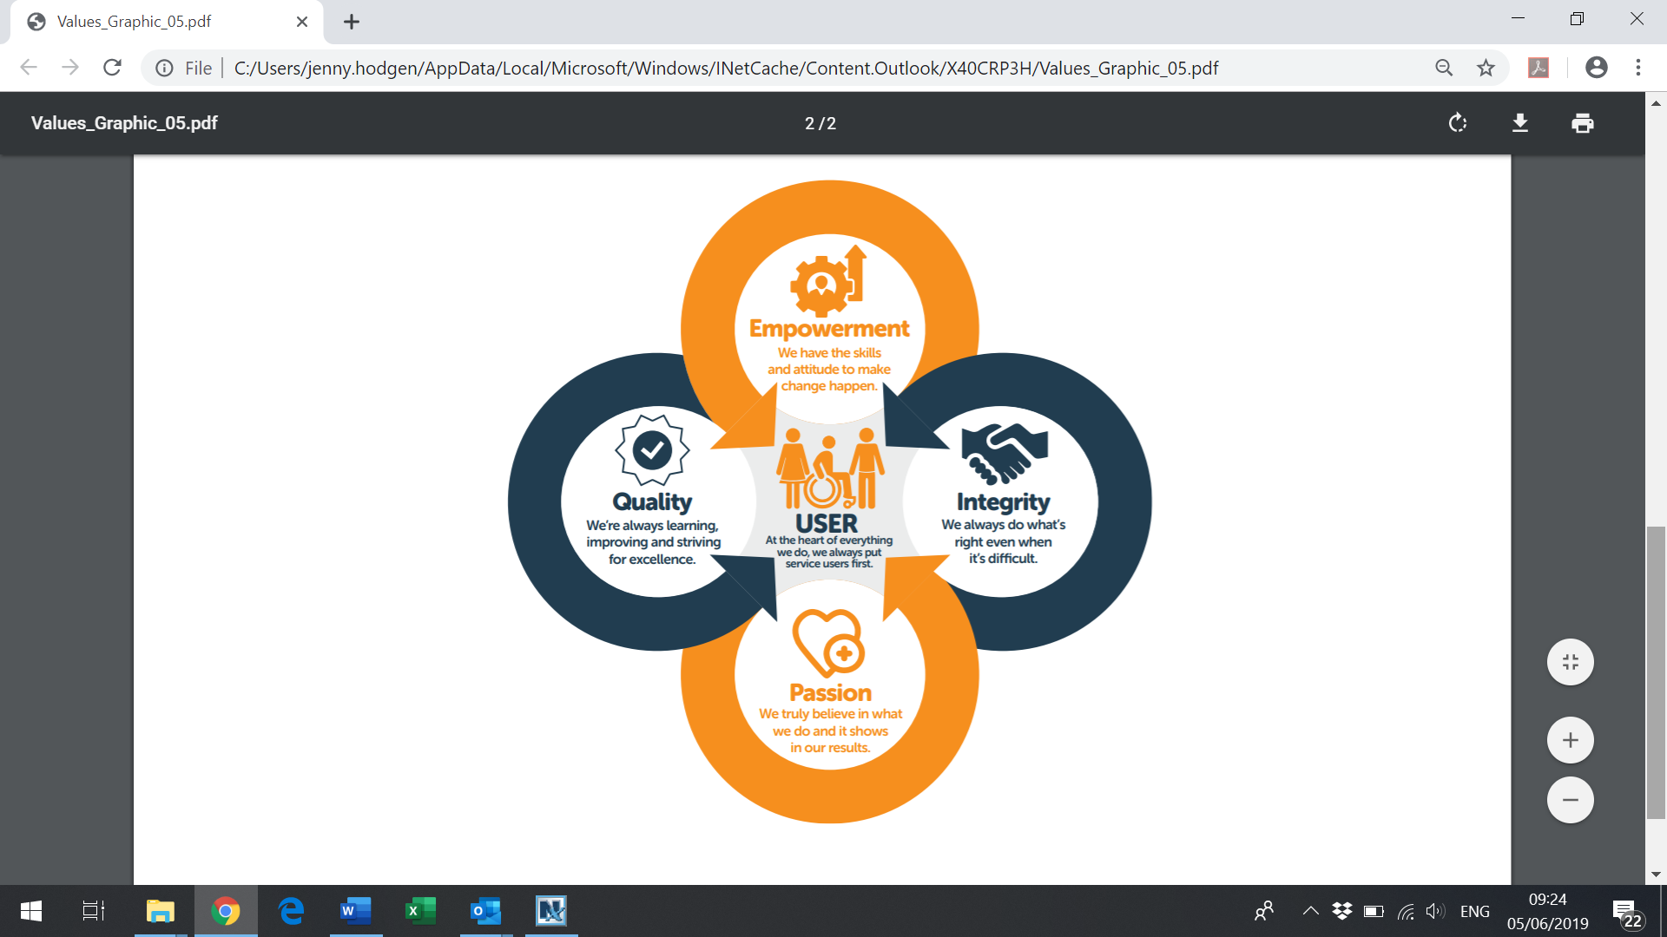

NB: Criteria may be enhanced to assist short-listing.

