Criminal Convictions Disclosure Form

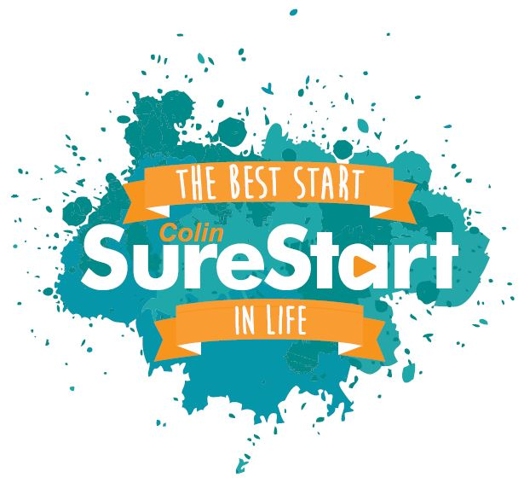
Applicant’s name:
Post applied for:
FW2505 -

Please read this information carefully

Advice to applicants:

Please complete this disclosure form as accurately as possible and return in a separate sealed envelope marked “confidential”. This should be returned to the Monitoring Officer along with your application form and monitoring form. The information will not be discussed at the interview itself.

Prior to confirming an offer of employment, a designated senior manager will decide the relevance of the conviction in relation to the post being applied for. A separate arrangement will be made with you to discuss the conviction in greater detail only if you have been successful at interview and if the conviction is potentially relevant to the post.

An offer of employment would only be withheld or withdrawn on the basis of a criminal conviction where information has been knowingly withheld or where the nature of the offence is relevant to the post and would impact detrimentally on the organisation, the applicant’s ability to carry out the function of the role, or would impact detrimentally for the care of existing members, service users or employees.

Please return this form in a sealed envelope even if you are submitting a nil return.

Statement of non discrimination

Colin Sure Start is committed to equal opportunity for all applicants including those with criminal convictions. Information about criminal conviction is requested to assist the selection process and will be taken into account only when the conviction is considered relevant to the post. Any disclosure will be seen in the context of the job criteria, the nature of the offence and the responsibility for the care of service users and employees.

Colin Sure Start have a policy entitled Recruitment of ex-offenders which can be made available to you, at any time, if required.

Information on ‘filtering’ enclosed.
For additional guidance on disclosure or filtering of protected information, please contact
NIACRO’s Employment Advice Line on 028 9032 0157 or
Access Helpline on 0300 200 7888.

Criminal Convictions Disclosure Form
You have applied for a post which is a Regulated Activity Position as defined by the Safeguarding Vulnerable Groups (NI) Order 2007 and also falls within the definition of an “excepted” position as provided by the Rehabilitation of Offenders (Exceptions) Order (NI) 1979 last amended 2014, therefore, all convictions including spent convictions must be disclosed. (with the exception of filtered / protected information)

Having a conviction will not necessarily debar your application from being considered. This information will be verified through an appropriate Access NI Enhanced Disclosure Check and Barred List check. If you have received a formal caution which is not filtered / protected, or are currently facing prosecution for a criminal offence, you should also bring this to our attention given the “excepted” nature of the role. Any failure to disclose such convictions could lead to dismissal or disciplinary action by the employer.

Question 1.
Is there any reason you cannot work in regulated activity? Yes / No

Question 2.
Are you currently subject to inclusion on the ADULTS and / or CHILDREN’S BARRED LIST Yes / No

Question 3.
Do you have any convictions, cautions, informed warnings or diversionary youth conferences that are not “filtered / protected” as defined by the Rehabilitation of Offenders Exceptions Order (NI) 1979, as amended in 2014.

Write NONE if no information to disclose.
Date of Conviction Offence Sentence
Please provide any other information you feel may be relevant such as:
- The circumstances of the offence
- A comment on the sentence received
- Any relevant developments in your situation since then
- Whether or not you feel the conviction has relevance to the post.
Please continue on a separate sheet if necessary.
I declare that any answers are complete and correct to the best of my knowledge. I give consent for an Access NI Enhanced check to take place at a later stage and for this information to be shared as part of Colin Sure Start risk assessment process.

Signed: Date:

