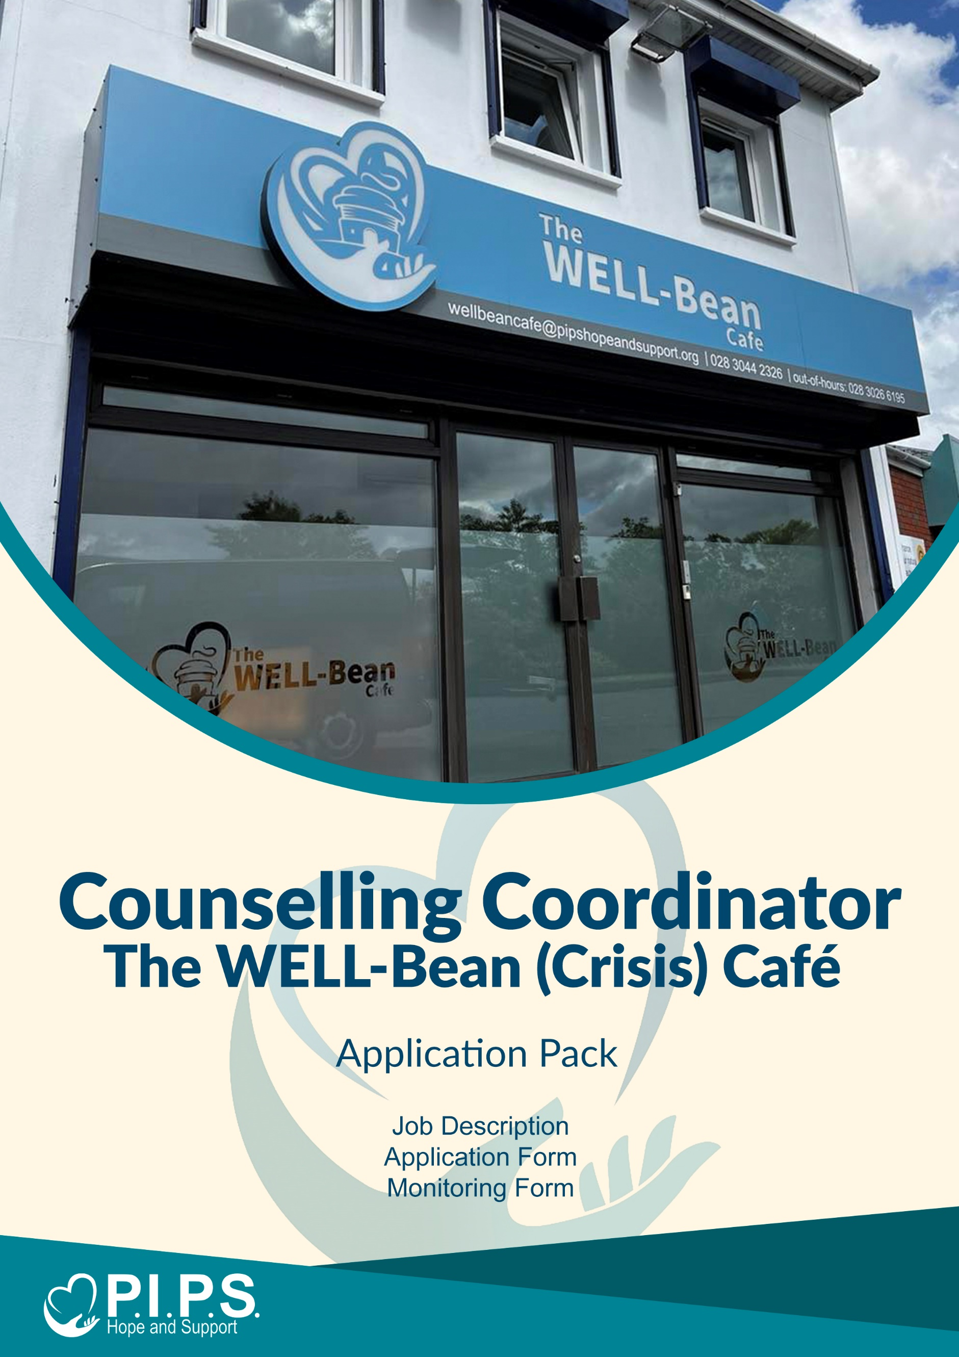
Dear Applicant,

Thank you for your interest in joining the team at PIPS Hope & Support.
We are delighted that you are considering applying for this exciting opportunity and look forward to receiving your application for the role of Counselling Coordinator – The WELL-Bean (Crisis) Café.

This application pack includes the following documents:

- Job Description and Person Specification
- Application Form
- Equal Opportunities Monitoring Form

Important Information – Please Read Carefully

- Review the Pack Thoroughly
This pack contains essential details about PIPS Hope & Support, the advertised vacancy, and the ideal candidate. Please ensure you read all documents carefully to confirm the role aligns with your skills and expectations.

- Completing Your Application

- Please complete the Application Form and Application Checklist in full.
- If you need more space to answer a question, you may continue a separate sheet.
- It is your responsibility to ensure that your application clearly demonstrates how you meet the criteria outlined in the Person Specification.

- CVs and Supporting Documents

- Applications will only be accepted on the official application form. This ensures consistency and fairness in the recruitment process.
- CVs will not be accepted, either in place of or alongside the application form.
- Additional sheets will only be considered if used as continuation pages for sections where space is limited.

- Submission Deadline

Completed application forms and the Equal Opportunities Monitoring Form (submitted in a separate envelope marked Monitoring Officer) must be returned by:

Friday 18th April 2025 at 12 noon. Late submissions will not be considered.
Please return your application to:

FAO: Services Manager – The WELL-Bean Café
PIPS Hope & Support
Mill Street
Newry
Co. Down
BT34 1AG

Or by email: manager@wellbeancafe.org

- Verification of Identity

In accordance with the Asylum and Immigration Act 1996, all successful applicants will be required to provide valid documentation confirming their identity and right to work in the UK.

- This role is classified as a regulated position under Article 33 of the Protection of Children and Vulnerable Adults (NI) Order 2003.

- Appointment will be subject to an Access NI enhanced disclosure check.

- A criminal record will not necessarily exclude you from employment. Each case will be assessed on its own merits, considering the nature of the role and the relevance of any convictions.

- Further information is provided by Access NI who have produced a Code of Conduct which can be downloaded from the website www.nidirect.gov.uk/accessni
All personal data provided as part of this application process will be stored securely, processed lawfully, and only used for the purposes of recruitment in line with UK GDPR and the Data Protection Act 2018. Unsuccessful applications will be deleted or securely disposed of within 1 month after the recruitment process concludes.

Applications emailed or hard copy should be returned no later than
Friday 18th April 2025 @ noon
Application forms received after this time and date will not be accepted.

RETURN TO:
FAO, Services Manager – The WELL-Bean Café
PIPS Hope & Support | 50 Mill Street | Newry | Co Down | BT34 1AG.
Or manager@wellbeancafe.org
We appreciate your interest in working with PIPS Hope & Support and wish you the best of luck with your application.

JOB DESCRIPTION

Job Role: Counselling Coordinator – The WELL-Bean (Crisis) Café
Place of work: The WELL-Bean Café, River Street, Newry
Reports to: The WELL-Bean Café Manager
Salary: £32,000 - £35,000 pro rata
Hours: 15 hrs (rotation basis every 2 weeks)
Team 1 – Fridays & Mondays (2:30pm – 10:00pm)
Team 2 – Saturday & Sundays (11:30am – 7:00pm)
Annual Leave: 24 days pro rata, based on 15 hours per week.

BENEFITS: Auto Enrolment, National Employment Savings Trust (NEST)
Pension Scheme
Access to Company Westfield Health Care package
Organisation Sick Pay scheme
Investors in People award
TOIL (time off in lieu) accrual system (monthly)

ABOUT THE SERVICE:

The WELL-Bean (Crisis) Café is Northern Ireland’s pioneering mental health crisis service, developed as part of the Towards Zero Suicide initiative and the Suicide Prevention Care Pathway. It offers a safe, supportive, and non-clinical environment for individuals aged 18 and over who are experiencing, or at risk of, a mental health crisis.

Individuals can access the service through self-referral or by being referred by professionals. Upon arrival, visitors are welcomed by trained staff who offer compassionate, person-centred support. This includes professional counselling, collaborative safety planning, and tailored signposting to other relevant services.

The café’s core aim is to help individuals reduce their immediate distress, identify personal strengths and coping strategies, and build resilience for the future.

The WELL-Bean (Crisis) Café is co-produced, with a strong emphasis on peer support through volunteering. It provides a warm and welcoming atmosphere, where a range of therapeutic and wellbeing-focused activities are delivered by fully qualified counsellors and trained volunteers.

KEY DUTIES & RESPONSIBILITIES:

The Counselling Coordinators will play a key role in supporting individuals who present at The WELL-Bean (Crisis) Café. They will engage with visitors to explore the nature of their crisis, identify potential triggers, and help them recognise personal strengths and coping strategies that can be used to reduce distress and build resilience for managing future challenges.

In addition to delivering frontline support, Counselling Coordinators will also work alongside, mentor, and help train volunteers involved in the café service, ensuring a high standard of care and peer support.

Working Hours

The operational hours of The WELL-Bean (Crisis) Café are currently spread across the following days and times:

- Friday & Monday evenings (15 hours total)
- Saturday & Sunday evenings (15 hours total)

The café operates every weekend, including bank holidays that fall on the listed days.
Counselling Coordinators will work on a rota basis, typically covering:

- One Saturday & Sunday every two weeks
- One Monday & Friday every two weeks

This schedule ensures a fair and balanced workload across the counselling team.

MAIN DUTIES:

- To deal with clients presenting in The WELL-Bean (Crisis) Café in mental or emotional crisis.

- Conduct comprehensive clinical assessments and provide counselling as required.

- To help the creation of a relaxed and friendly atmosphere which will maintain and enhance the quality of care to each client/visitor to the café.

- Prepare for and attend monthly line management, clinical supervision, team meetings, and staff training days.

- Following all policies and procedures as led down by PIPS Hope & Support Limited and the relevant professional bodies.

- To be responsible for both personal and professional attitude and behaviour when interacting with fellow colleagues and service users.

- Participate in staff, team, and project meetings on a regular basis.

- Provide monthly progress reports on all activities undertaken.

- To keep accurate record keeping of all clients.

- To apply COREnet for all clients presenting to the café.

- To adhere to all policies and procedures laid down by PIPS Hope & Support Limited.

- Ensure all processes (including Salesforce & CoreNet and GP letters) are completed accurately and kept up to date and that any other required paperwork is filed and fully completed and on time.

- To perform such duties as may be required from time to time in negotiation with the PIPS Hope & Support CEO and/or Board of Directors.

PERSON SPECIFICATION:

Essential requirements: | Essential
- Recognised Diploma in Counselling (300 hr theory and practice). | √
- At least two years supervised counselling practice with adults. | √
- BACP /IACP /UKCP or equivalent accreditation which includes current membership & evidence of associate membership number. | √
- Have knowledge of and work according to ethical framework of professional bodies. Commitment to confidentiality, professional boundaries, and safeguarding protocols. | √
- Ability to keep confidential records in keeping with the policies and procedures of the organisation. | √
- Experience conducting risk assessments and developing or implementing safety plans. | √
- Excellent oral & written communication skills including IT skills. | √
- Strong interpersonal and communication skills, with the ability to manage sensitive and complex emotional disclosures in a calm and compassionate manner. | √

Desirable requirements: | Desirable
- Demonstrable understanding of suicide prevention, trauma, and self-harm. | √
- Experience working with diverse communities and individuals facing multiple disadvantages. | √
- Previous experience working in a crisis or helpline service. | √
- Training in suicide prevention e.g., ASIST, SAFETALK, STORM. | √
- Experience using client management systems (e.g., Salesforce, CORE Net, PCMIS, or other case management databases). | √
- Knowledge of local mental health services and referral pathways. | √
- Group facilitation experience (e.g., support groups, psychoeducation sessions). | √

TERMS AND CONDITIONS OF EMPLOYMENT:

- Appointment is subject to the receipt of two satisfactory references.
- In accordance with the Asylum and Immigration Act, successful applicants must provide evidence of their right to work in the United Kingdom. This is typically demonstrated through a valid passport; alternative forms of identification will be outlined if a passport is not available.
- Appointment to this post is subject to a satisfactory Access NI enhanced disclosure check.

This job description is not intended to be exhaustive or restrictive.
The duties and responsibilities outlined may be subject to reasonable change in line with the needs and development of the organisation and the services it provides.

PIPS HOPE & SUPPORT JOB APPLICATION FORM
Job Ref: PIPWBC2025
Application No:

- Please write clearly (type or block capitals)
- All information will be treated in confidence and will be used by PIPS Hope & Support to assess your suitability for the job.
- Candidates will be short listed based on information contained in this application.

THE VACANCY

Job Applied For: Counselling Coordinator – The WELL-Bean (Crisis) Café

Where did you see ad? ________________________________________

Family Name: ________________________________________

Forename (s): ________________________________________

Address: ________________________________________
________________________________________
________________________________________
Postcode: ________________________________________

Home Tel. No. ________________________________________

Mobile No. _______________________________________

Email Address ________________________________________

National Insurance No. _______________________________________

REFERENCES

All offers of employment are subject to receipt of satisfactory written references. Please provide the names, telephone numbers, addresses and email addresses of two referees, one of whom should be your present or most recent employer/line manager, and one who knows/has known you in a work capacity and can comment on your suitability for this post.

FIRST REFEREE | SECOND REFEREE
NAME: | NAME:
ADDRESS: | ADDRESS:
TEL: | TEL:
EMAIL: | EMAIL:
OCCUPATION: | OCCUPATION:
RELATIONSHIP TO YOU: | RELATIONSHIP TO YOU:

We will only contact referees after a conditional offer.

Have you ever been convicted of a criminal offence? Yes / No
[Exclude convictions which are spent under the
Rehabilitation of Offenders (NI Order 1978)]

Have you ever been excluded / barred from working with Yes / No
children and/or young people?

YOUR QUALIFICATIONS

Type of Exam (GCSE, NVQ, A Level, Degree etc) | Subject | Grade

Are you currently employed? Yes / No

Current Salary: ______________________

Notice Required: ______________________
PREVIOUS JOBS (Start with present or most recent job)

Name & Address of Employer | Dates employed & salary | Type of Job (give brief description of duties) | Reason for Leaving
[Please attach additional sheet if required]

ESSENTIAL CRITERIA

Referring to the Person specification above (Essential criteria) Please ensure that you complete the following checklist ensuring you meet the essential criteria on points numbered 1 – 6 to assist us in the processing of your application.

Shortlisting will be based on evidence that you meet the requirements for this post.

Criteria – Essential

- Recognised Diploma in Counselling (300 hr theory and practice).
- At least two years supervised counselling practice with adults.
- BACP / IACP / UKCP or equivalent accreditation which includes current membership & evidence of associate membership number.
- Have knowledge of and work according to ethical framework of professional bodies. Commitment to confidentiality, professional boundaries, and safeguarding protocols.
- Ability to keep confidential records in keeping with the policies and procedures of the organisation.
- Experience conducting risk assessments and developing or implementing safety plans.
- Excellent oral & written communication skills including IT skills.
- Strong interpersonal and communication skills, with the ability to manage sensitive and complex emotional disclosures in a calm and compassionate manner

Criteria – DESIRABLE

- Demonstrable understanding of suicide prevention, trauma, and self-harm.
- Experience working with diverse communities and individuals facing multiple disadvantages.
- Previous experience working in a crisis or helpline service.
- Training in suicide prevention e.g., ASIST, SAFETALK, STORM.
- Experience using client management systems (e.g., Salesforce, CORE Net, PCMIS, or other case management databases).
- Knowledge of local mental health services and referral pathways.
- Group facilitation experience (e.g., support groups, psychoeducation sessions).

OTHER INFORMATION

Please tell us about you, your interests and indicate why you are interested in this position.

Please include any other information which you feel may be of interest in considering your application.

By submitting this application, I consent to my personal data being used for the purposes of recruitment in accordance with UK GDPR and the Data Protection Act 2018. I understand that if unsuccessful, my data will be securely deleted within one month of the recruitment process concluding.

DECLARATION

I declare that the information I have given is correct.

Signed: ________________________________
Date: ________________________________

MONITORING FORM Ref: PIPSWBC2025

PIPS Hope & Support is committed to promoting equality, diversity, and inclusion in all aspects of its work. We aim to create a supportive environment that respects and values individual differences and ensures equal opportunities for all.

To help us monitor how well we are meeting our equality and diversity objectives, we ask all applicants to complete this form. The information you provide will be treated with the strictest confidence, stored securely, and used solely for monitoring purposes in accordance with the UK General Data Protection Regulation (UK GDPR) and the Data Protection Act 2018.

This form is separate from your application and will not be used in the selection process.

Please provide information below about yourself that would assist this process.

Please indicate the community background to which you belong or are perceived to belong (required for monitoring under the Fair Employment and Treatment (NI) Order 1998):

☐ I am a member of the Protestant community.
☐ I am a member of the Roman Catholic community.
☐ I am a member of neither the Protestant nor Roman Catholic community.
☐ Prefer not to say.

Please indicate your gender by ticking the appropriate box below:

☐ Female
☐ Male
☐ Non-binary
☐ Prefer to self-describe: ____________________
☐ Prefer not to say.

Is your gender identity the same as the sex you were assigned at birth?

☐ Yes
☐ No
☐ Prefer not to say.

Sexual Orientation.
☐ Heterosexual / Straight  ☐ Asexual  ☐ Other (please specify): | ☐ Gay or Lesbian  ☐ Pansexual | ☐ Bisexual  ☐ Prefer not to say

Do you consider yourself to have a disability as defined under the Equality Act 2010, defined as a physical or mental impairment, which has a substantial and long-term adverse effect on a person’s ability to conduct normal day to day activities?

☐ Yes
☐ No
☐ Prefer not to say.

If yes, please state the nature of your disability (optional):

Age Group
☐ Under 18  ☐ 35–44  ☐ 65+ | ☐ 18-24  ☐ 45–54  ☐ Prefer not to say | ☐ 25–34  ☐ 55–64

Please tick the option that best describes your ethnic group.
☐ Bangladeshi  ☐ Black other  ☐ Irish Traveller  ☐ Other Ethnic Group:  (Please state) | ☐ Black Africa  ☐ Chinese  ☐ Pakistani | ☐ Black Caribbean  ☐ Indian  ☐ White

Please tick the option that best describes your Religious Belief.
☐ Roman Catholic  ☐ Methodist  ☐ Hindu  ☐ Sikh | ☐ Presbyterian  ☐ Baptist  ☐ Jewish  ☐ Prefer not to say | ☐ Church of Ireland  ☐ Muslim  ☐ Buddhist  ☐ Other, please specify:

Caring Responsibilities
☐ None  ☐ Primary carer of a disabled adult (18+)  ☐ Prefer not to say. | ☐ Primary carer of a child or children (under 18)  ☐ Primary carer of an older person (65+) | ☐ Primary carer of a disabled child  ☐ Secondary carer (e.g., assists a primary carer)

Please return this form in a sealed envelope marked Private & Confidential – Monitoring to:
Monitoring Officer
PIPS Hope & Support
50 Mill Street
Newry
Co. Down
BT34 1AG

