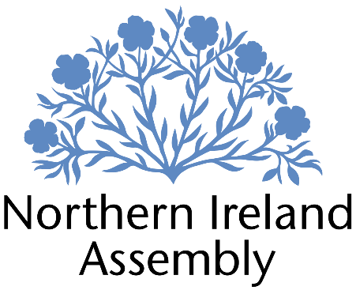

**Connie Egan MLA**

*Alliance Party Member of the Northern Ireland Assembly for North Down Constituency*

**Constituency & Communications Internship**

|  |  |
| --- | --- |
| Report to: | Connie Egan MLA |
| Office Location: | Parliament Buildings, Stormont, Belfast, BT4 3XX and 12 Hamilton Road Bangor BT20 4LE |
| Hours: | 17 hours per week over three working days. Preferably full day Tuesday and Friday, half day Monday. |
| Holidays: | 1.5 days over six week period |
| Salary: | £13.88 per hour |
| Pension: | A central Assembly-approved pension scheme is provided. If enrolled an amount equivalent to 10% of employees salary will be paid into the pension scheme. |
| Duration: | Six weeks; 27th May – 4th July 2025 |
| Closing Date | Noon, Wednesday 2nd April 2025 |
| Interview dates: | It is anticipated that shortlisted candidates will be interviewed on Friday 11th April 2025 |

# JOB DESCRIPTION

This role requires an organised and hardworking person who has the ability to use social media and other platforms in order to improve communication between Connie Egan MLA and North Down constituents and stakeholders.

Responsibilities:

* Providing general admin support (typing, emails, phone calls, distributing mail, filing, photocopying, etc.)
* Attending meetings and events as required
* Drafting letters and correspondence
* Responding to correspondence and enquiries from constituents, the media, lobbyists and pressure groups
* Drafting and issuing press releases and articles on behalf of Connie Egan MLA
* Regularly review Connie Egan MLA’s social media presence to improve communications with constituents
* To manage and regularly update Connie Egan MLA’s various digital platforms
* Take photographs and create videos of Connie Egan MLA for use in various communications
* Propose concepts for improved communication for and with constituents
* Coordinate and plan communications in a pro-active manner
* Other duties as required in support of the MLA carrying out their Assembly and constituency duties, including assisting Constituency Office Manager and Policy and Research Officer

**PERSON SPECIFICATION**

|  |  |  |
| --- | --- | --- |
|  | **Essential Criteria** | **Desirable Criteria** |
| **Professional / Technical Qualifications** | * Five GCSEs / O Levels or Equivalent at Grade C or above including both English Language and Mathematics * Excellent written skills (Grammar, punctuation and spelling) * Proficiency in the use of digital communications programmes | * A-level qualifications or equivalent |
| **Experience / Job Knowledge** | * Experience working with the public in a paid or voluntary capacity * Experience and knowledge of a range of social media platforms * Knowledge of the Northern Ireland political system | * Experience in creating content for social media platforms * Experience of working in an office environment, in a paid or voluntary capacity * Experience in using Canva |
| **Personal Qualities /**  **Skills** | * Flexible approach to work * Innovative and enthusiastic approach * Understanding of the aims and objectives of the Alliance Party | * Ability to work to tight deadlines and competing demands |
| **Circumstances** | * Available for duration of 6 week internship 26th May – 4th July 2025 * Ability to work unsupervised | * Flexibility in working between Constituency Office, 12 Hamilton Road Bangor BT20 4LE, and Stormont Parliament Buildings |

Applicants must demonstrate clearly on their application form how they meet the criteria.