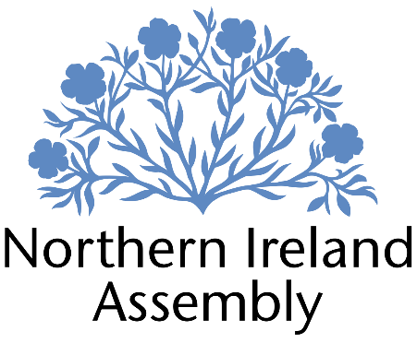

**Mark H Durkan MLA**

*SDLP Member of the Northern Ireland Assembly for Foyle Constituency*

**CONSTITUENCY CASEWORK ASSISTANT**

|  |  |
| --- | --- |
| Report to: | Mark H Durkan MLA |
| Office Location: | Constituency Office 141 H Strand Road, Frank Long’s Complex, Derry BT48 7PB in the Foyle Constituency with possible requirement to work from Parliament Buildings, Stormont. |
| Hours: | 34 hours per week, Monday – Friday. |
| Holidays: | As per determination |
| Salary: | £27,990 per annum (Grade 1). Subject to satisfactory performance of duties, on 1 April every year, the employer may determine to move employee one point up the salary scale as set out within the Independent Financial Review Panel (IFRP) Assembly Members (Salaries and Expenses) (Amendment) Determination (Northern Ireland) 2020 (the determination). Salary £27,990. |
| Pension: | A central Assembly-approved pension scheme is provided. If enrolled an amount equivalent to 5% of employees salary will be paid into the pension scheme. |
| Duration: | Fixed Term whilst the member remains a MLA or until legislation is introduced to change Constituency expense provision. Three month probation period shall apply. |
| Closing Date | 5PM, Thursday 20th March 2025.  Interviews for shortlisted candidates shall take place on Friday 28th March 2025 at a venue in the Foyle Constituency |

# JOB DESCRIPTION

To carry out the function of providing constituency services and support for Mark H Durkan MLA - SDLP MLA for Foyle residents, businesses, communities and groups in the Foyle Constituency and appropriate stakeholders”

* Delivering effective management and processing of constituent casework for Mark H Durkan MLA.
* Working with constituents directly on individual cases, issues and constituency matters ensuring that casework is logged and dealt with sensitively and confidentially
* Responsibility for monitoring progress of cases, ensuring all identified actions are taken.
* Ensuring efficient data and file management to comply with GDPR and data management.
* Dealing with complex queries and complaints on Member’s behalf, including drafting letters for Member to sign.
* Maintaining up to date knowledge of relevant legislation, policy and developments locally relevant to the constituency
* Assisting MLA with preparation of questions and motions with the Policy and Research Officer
* To work with MLA and the staff team to identify opportunities to progress change for the benefit of constituents and a shared future in Northern Ireland.
* Building relationships and liaising with community, businesses and other groups in the constituency on behalf of Mark H Durkan MLA.
* Planning and organising events
* Maintaining and updating MLA social media and other communication channels to ensure the work of Mark H Durkan MLA is appropriately communicated to constituents and relevant stakeholders.
* Responding to correspondence and enquiries from constituents, media, lobbyists, businesses and community groups in conjunction with Mark H Durkan MLA's requirements.
* Attending surgeries, meetings and conferences as appropriate.
* Management and maintenance of office systems, processes and procedures in conjunction with the Constituency Office Co-ordinator.
* Assist, as required, Constituency Office Co-ordinator with planning and organising meetings, MLA’s diary management and provision of secretarial support as required.
* Attending work related training and networking meetings to develop skills.
* Other duties as required in support of the MLA carrying out their Assembly duties.

**PERSON SPECIFICATION**

|  |  |  |
| --- | --- | --- |
|  | **Essential Criteria** | **Desirable Criteria** |
| **Professional / Technical Qualifications** | * 2:2 Degree or higher * Five GCSE’s / O’ Levels or Equivalent at Grade C or above including both English Language and Mathematics Excellent written skills (Grammar, punctuation and spelling) * Proficiency in the use of   Microsoft Outlook, Word, Excel and social media | * 7 GCSEs at Grade C or above including Maths and English Language * ICT qualification * Customer Care qualification |
| **Experience / Job Knowledge** | * Experience of working with a range of stakeholders in order to achieve outcomes * Previous experience of working with the public * Ability to update and maintain a database * Experience of dealing with sensitive and confidential information (both verbal and written) in line with the Data Protection Actand GDPR | * Administration experience * Campaigning experience, political or otherwise * Experience of working with volunteers * Knowledge of the workings of the Northern Ireland Assembly * Experience of managing a budget * Experience of working in a small team * Experience of working on complex projects * Working knowledge of the Benefits and Housing processes in Northern Ireland * Experience of the advice sector |
| **Personal Qualities /**  **Skills** | * Good punctuality * Excellent verbal communication skills in person and on the phone * Flexible, innovative and enthusiastic approach to work duties * Understanding of SDLP objectives | * Patience and compassion * Time management * Ability to multi task |
| **Circumstances** | * Able to work unsupervised and as lone worker in office when required | * May be required to travel to meetings/appeals |

Applicants must demonstrate clearly on their application form how they meet the criteria.

All applicants will be required to provide copies of their qualifications at interview if shortlisted on Friday 28th March 2025.