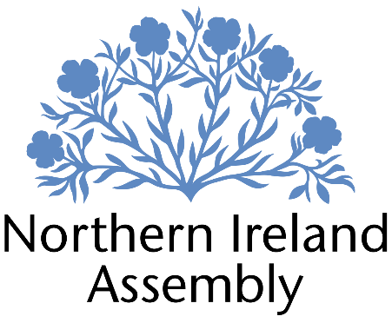

**Michelle Guy MLA**

*Alliance Party Member of the Northern Ireland Assembly for Lagan Valley Constituency*

**CASEWORK OFFICER – PART TIME**

|  |  |
| --- | --- |
| Report to: | Michelle Guy MLA |
| Office Location: | Primarily Lagan Valley Constituency Office (Unit 4 Rawdon Court, Moira, BT67 0LQ) but also, as required, Parliament Buildings, Stormont |
| Hours: | 11 hours per week (over Thursday/ Friday) |
| Holidays: | As per determination |
| Salary: | £26,694 Grade 1 pro rata |
| Pension: | A central Assembly-approved pension scheme is provided. If enrolled an amount equivalent to 10% of employees salary will be paid into the pension scheme. |
| Duration: | Permanent.  Employment contingent upon member remaining an MLA or until legislation is introduced to change Constituency expense provision. Six-month probation period shall apply. |
| Closing Date | Noon, Friday 25th April 2025 |
| Interview dates: | It is anticipated that shortlisted candidates will be interviewed during week beginning 5th May 2025 |

# JOB DESCRIPTION

The Casework Officer will be predominantly responsible for managing casework and constituency queries to support the work of Michelle Guy MLA. This is a vital role that requires someone who is dedicated, proactive, organised and resourceful.

* To assist in the work of the Constituency Office by delivering effective casework as part of Michelle Guy MLA’s constituency services, and any other duties required to run the Constituency service.
* Log casework, monitor progress and take appropriate action
* Deal with enquiries sensitively and confidentially
* Review key themes emerging from casework to identify issues to be progressed either with statutory agencies or by legislative action
* Responsibility for efficient data and file management to comply with GDPR and data management
* Planning and organising meetings and provision of secretarial support as required
* Liaising with groups within the constituency and the general public on behalf of Michelle Guy MLA
* Responding to correspondence and enquiries from constituents, media, lobbyists, businesses and community groups as required
* Dealing with complex queries and complaints on the Member’s behalf, including drafting letters for the Member to sign
* Attending surgeries and as appropriate
* Attending work related training and networking meetings to develop skills
* Other duties as required in support of the MLA carrying out their Assembly duties

**Communications**

* Publish updates to social media platforms to support and promote the work of Michelle Guy MLA
* Other communications related tasks as required

**PERSON SPECIFICATION**

|  |  |  |
| --- | --- | --- |
|  | **Essential Criteria** | **Desirable Criteria** |
| **Professional / Technical Qualifications** | * Five GCSE’s / O’ Levels or Equivalent at Grade C or above including both English Language and Mathematics * Excellent written skills (Grammar, punctuation and spelling) * Proficiency in the use of * Microsoft Outlook, Word and Excel packages | * 7 GCSEs at Grade C or above including Maths and English Language * ICT qualification * Customer Care qualification |
| **Experience / Job Knowledge** | * Experience of working with a range of stakeholders to achieve outcomes * Previous experience of working with the public * Ability to update and maintain a database * Proficiency using key social media platforms such as Facebook, Instagram and X (Twitter). * Experience of working in an office environment | * Campaigning experience, political or otherwise * Experience of working with volunteers * Knowledge of the workings of the Northern Ireland Assembly * Experience of working in a small team * Experience of working on complex projects * Working knowledge of the Benefits and Housing processes in Northern Ireland * Experience of the advice sector * Experience of using casework or similar software package. * High proficiency using social media including producing video content and adding captions. |
| **Personal Qualities /**  **Skills** | * Good punctuality * Excellent verbal communication skills in person and on the phone * Flexible, innovative and enthusiastic approach to work duties * Understanding of Alliance Party objectives | * Patience and compassion * Time management * Ability to multi-task |
| **Circumstances** | * Able to work unsupervised and as lone worker in office when required | * May be required to travel to meetings/appeals |

Applicants must demonstrate clearly on their application form how they meet the criteria.