

Invitation to Tender for Complementary Therapy Services 2025/2026

Bridge of Hope, a project of Ashton’s Health and Wellbeing Department is inviting tender applications from ethical, competent, experienced and appropriately qualified complementary therapists to deliver complementary therapies on a sessional basis.

Bridge of Hope Overview

Bridge of Hope is a health and wellbeing service that supports individuals affected by the conflict and those experiencing poor physical and emotional health. Our mission is “To empower and promote positive change for victims and survivors through delivery of quality health and wellbeing services.”

Alongside Complementary Therapies, our holistic support services include: life coaching; counselling and psychological services; accredited VTCT training; personal development courses and conflict legacy programmes. We also provide support through PEACE IV Health and Wellbeing Caseworkers. All of these services are designed to help manage and reduce stress, and encourage the development of positive, healthy and resilient lives.

Our services are victims-centred and based on the theory that no single approach will suit everyone. All services are monitored and outcomes recorded.

We support people through a range of funding streams made possible by the Victims & Survivors Service, Belfast Health & Social Care Trust and Public Health Agency.

More details here: www.ashtoncentre.com and www.thebridgeofhope.org

Role description

We see this role to have a range of priorities:

- To interact with individuals on a one-to-one basis.
- To provide one-to-one therapeutic support.
- To act as a liaison for other Bridge of Hope staff.
- To update computer-based client record systems
- To be compliant with BOH systems and processes.
- To travel to any Bridge of Hope outreach centre as required.
- To inform individuals about the range of support services offered by Bridge of Hope to encourage a holistic approach.
- To work closely with identified Bridge of Hope staff to ensure that all appropriate procedures and processes are followed.
- To be a critical point of contact for Victims and Survivors presenting in crisis.
- Attend a meeting with the Head of Health & Wellbeing and/or other relevant Bridge of Hope, Ashton staff periodically throughout the year.
- Liaise with Ashton’s Head of Health & Wellbeing immediately should a problem arise, relating to the wellbeing of any client.
- Attend regular one-to-one meetings with the Head of Health & Wellbeing.
- Ensure all relevant paperwork is fully and accurately completed and returned to the Operations Manager at Bridge of Hope on time.
- Be prepared to deliver a flexible service for Bridge of Hope to enable us to meet the needs of our client base.
The tender format is as follows:

- Applicants must demonstrate and provide evidence where appropriate how they meet all elements of the essential criteria. Please note it is important to address each criterion listed above in your application. Failure to do so will result in your tender application being deemed ineligible.
- Applicants must be able to demonstrate value for money. A cost per hour inclusive of travel, subsistence, and VAT should be provided up to a maximum of £30 per session.
- Applicants must be able to demonstrate a flexible approach to service delivery.
- Applicants must include a full and up-to-date CV with their application.
- Applicants must include a copy of all relevant certificates.
- Applicants must include evidence of membership of FHT.
- Applicants must include evidence of Professional Liability Insurance to a minimum of £5 million
- Applicants must demonstrate a commitment to receiving regular supervision in the context of which continuing professional development should be addressed. If the applicant has a current supervisor, then their name and contact details should be included in the tender.
- Applicants must outline what days and times they would be available to deliver services on behalf of Bridge of Hope. Please be aware Bridge of Hope delivers sessions both during the day and some evenings.
- Tender applications must include a completed Declaration of Employment Status form.

Copies of tender proposals should be forwarded in a plain envelope clearly marked “Complementary Therapies” to:

Lindsay Whitten
Operations Manager
Bridge of Hope
Ashton
5 Churchill Street
Belfast BT15 2BP

Please note tender applications can also be submitted via email to Lindsay.whitten@ashtoncentre.com by 12 noon on Monday 24th March 2025.

Any tender applications not including all information required above will be discounted as incomplete and will not move to scoring.

All tenders must be received no later than 12.00 pm on Monday 24th March 2025. No late tenders will be accepted. Where appropriate, interviews will be held as soon as possible after this date.

Bridge of Hope will use the information supplied to score all tender applications. Please take note of scoring criteria as this will be used to total scores, and only applicants who score over 80 will be added to our Approved Suppliers List.

A score of 80 or more will enable an applicant’s details to be added to our Approved Suppliers List.

Please note being added to the Approved Suppliers List does not constitute any guarantee of sessional hours.

Any successful tender will be valid from 1st April 2025 to 31st March 2026.

Ashton’s Bridge of Hope operates in accordance with the General Data Protection Regulations 2018. This means we will treat the information you provide with strict confidentiality. At times we may need to share some of your information with other staff, funders and other stakeholders.

Award Criteria | Score out of 100
Membership of FHT/ commitment to join | 5
Demonstration of value for money | 10
Flexible approach to working | 10
Evidence of insurance | 15
Demonstration of qualifications | 15
Commitment to receiving regular supervision | 10
Mental Health First Aid Qualification | 5
Emergency First Aid at Work Qualification | 10
Keeping Adults Safe Training Qualification | 5
Keeping Children Safe Training Qualification | 5
Details of hours of availability | 5
CV included | 5

Contact Details: If you require further information, wish to clarify any points, or have difficulty relating to the tender documentation before submission of your proposal please contact the Operations Manager Lindsay Whitten via email at lindsay.whitten@ashtoncentre.com or phone at 02890742255.

START AND COMPLETION DATES

It is anticipated that funding for this service delivery will be from 1st April 2024 to 31st March 2025.

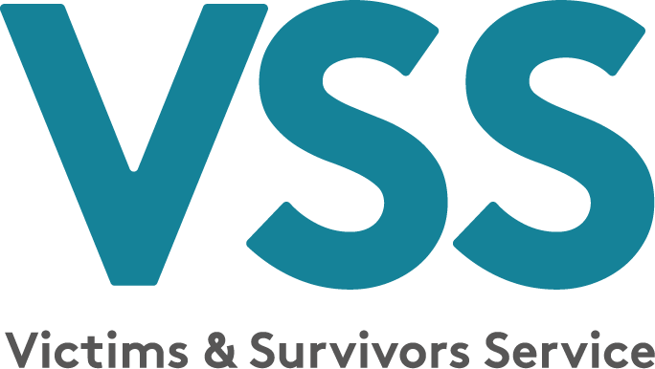

Invitation to Tender for Complementary Therapy Services 2025/2026

NAME: _________________________ TELEPHONE: __________________

EMAIL: ______________________________________ DATE: ______________

Essential Criteria
1. Please provide details of relevant qualifications this must include minimum of a Level 3 Certificate in Body Massage and a Level 3 Diploma in Reflexology.

2. Please demonstrate your experience of working on a one to one basis with individuals affected by the conflict, poor mental health and suicide and self-harm.

3. Please give Supervisors details, regularity of appointments.

4. Please state membership details of FHT.

5. Have you completed Mental Health First Aid (or equivalent) training? If so please detail dates of completion and include a copy of your certificate with your tender.

6. Have you completed Keeping Children Safe Training within the last 2 years? If so please detail dates of completion and include a copy of your certificate with your tender.

7. Have you completed Keeping Adults Safe Training within the last 2 years? If so please detail dates of completion and include a copy of your certificate with your tender.

8. Have you completed Emergency First Aid training within the last 2 years? If so please detail dates of completion and include a copy of your certificate with your tender.

9. Please state your cost per hour inclusive of travel, subsistence and VAT.

10. Outline days and times available for delivery of sessions.
Additional information:
Please use this section to provide any additional information about any acquired skills you think may be useful in your role that are not already listed in the essential criteria above:

Check List for Applicants

Work with Victims and Survivors
Demonstration of value for money/breakdown of costs
CV included
FHT details
Insurance Certificate to a minimum of £5 million
Mental Health First Aid Certificate
Emergency First Aid at Work certificate
Keeping Adults Safe Training Certificate
Keeping Children Safe Training Certificate
Certificates
Experience of working on a one to one basis with individuals affected by the conflict, poor mental health and suicide and self-harm.

