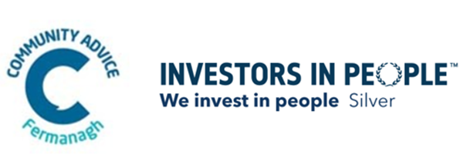
COMMUNITY ADVICE FERMANAGH

JOB DESCRIPTION

JOB TITLE: Manager (One year Maternity Cover)

RESPONSIBLE TO: Management Committee

Responsible for:

- The provision of an accessible responsive advice service to the public within a customer service framework.

- The management of the organisations staff, providing staff support and performance appraisals.

- Management of referrals into the service.

- Preparation of papers, policies and management accounts for the meetings of the Management Committee.

- Preparation and maintenance of all finance work including annual budgets, payroll, arranging payments and keeping accounts.

- Administration of grant funding and overseeing project delivery.

- Fundraising on behalf of the organisation, to maximise and diversify its income stream, and to promote the continuous improvement and development of the service.

- Maintaining and developing positive working relationships with external stakeholders and funders.
- Taking the work of the Management Committee forward and scheduling bimonthly meetings with the Management Committee to ensure that targets and timetables are being met.

- Ensuring that the organisation complies with its legal responsibilities and with the policies of Community Advice Fermanagh.

- Attendance at Advice NI Managers’ meetings to keep abreast of regional and strategic developments.

- Co-operation with Advice Centre Managers and with the staff of Advice NI.
- Such other duties as the Trustee Board may from time-to-time request, and such other duties that are consistent with the grade.

COMMUNITY ADVICE FERMANAGH

Manager Duties - Person Specification

Selection Criteria | Essential | Desirable
- Qualification/Education

1i. Possess a relevant (level 6) University degree and 1 years relevant management experience

OR

1ii. 3 years relevant management experience and a less formal management qualification (e.g. ILM Level 5).

1iii. Law Centre NI, Advice NI or NIACAB accredited Qualification in Welfare Rights.

- Experience & Knowledge

- Recent experience in the management and motivation of a staff team.

- Ability to prepare papers, reports and policies.

- Recent experience in representing an organisation to a variety of external stakeholders.

- Experience with budgets, financial management, administration of grant funding and overseeing project delivery.

- Experience of fundraising and securing grants

- Experience of the community and voluntary sector

- Skills and Abilities

- Excellent written, oral and communication skills.

- Ability to plan, prioritise and organise own workload and meet deadlines.

- Excellent ICT skills

- Understanding of working with vulnerable clients and meeting their needs

- Knowledge of Advicepro system
- Other Requirements

- *Current driving licence and access to a suitable vehicle (appropriately maintained and insured for business). (*This criteria will be waived in the case of an applicant whose disability prohibits driving but who is able to demonstrate an appropriate alternative means of meeting the mobility requirements of the post).

- Willingness to work unsocial hours when required e.g. management committee meetings.

- Commitment to the provision of free, confidential, impartial and independent advice.

- A commitment to equal opportunities and inclusion

.

TERMS AND CONDITIONS OF SERVICE

- The post Maternity Cover for one year - July 2025 - July 2026

- The post is subject to an Access NI check.

- The post-holder will be based in the office of Community Advice Fermanagh in Fermanagh House.

- The post is full - time i.e. 37 hours/ week. Working Hours 9am-5.30pm Monday-Thursday, 9am-5pm on a Friday.

- The salary for the post is £32,000 per annum.

- All members of staff are enrolled within the NEST pension scheme and can choose to opt out if they wish.

- The annual leave entitlement will be 25 days and the Organisation recognises 11 other holidays in the year which will be pro-rata.

- Any other reasonable duties requested by the chairperson.

Community Advice Fermanagh is an Equal Opportunities Employer and welcomes applications from all sections of the community.

