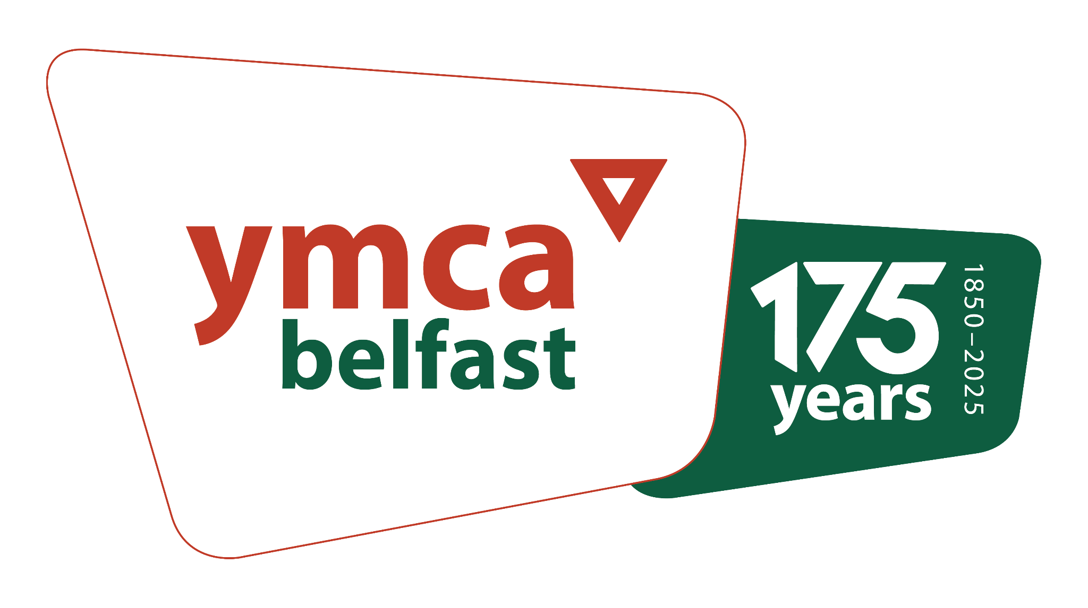

|  |  |
| --- | --- |
| Application pack for: | **Family Project Coordinator** |
| Name of Applicant: |  |

Please read the [Information Pack](https://docs.google.com/document/d/1hJZA5hh0ySzqTrKerRs8x6K9YyJ0K3s1uVayOSStgA0/edit?usp=sharing) for this position before completing this application. Complete all sections fully and accurately. If there is insufficient space for your answer, please continue on a separate sheet.

When completed, this form should be emailed to [jobs@belfast-ymca.org](mailto:jobs@belfast-ymca.org)

**Please do not send a CV.**

Complete and return the following documents to [alyson@belfast-ymca.org](mailto:alyson@belfast-ymca.org)

[Monitoring form](https://drive.google.com/file/d/12SQHqnpHWkNAvLdg-wn5tfUCy7aLvoAU/view?usp=drive_link)

[Declaration form](https://docs.google.com/document/d/1hS7M6tMCNlgHPzOwkS-XywCb8ZXf0j17W5PUBVoerE0/edit?usp=drive_link)

**To arrive no later than 12 noon on Wednesday 2nd April, 2025.**

|  |
| --- |
| **Personal details** |

|  |  |
| --- | --- |
| First name  (Please underline the name you are usually known by) |  |
| Surname |  |
| Address (including postcode) |  |
|  |
|  |
|  |
| Mobile number |  |
| National Insurance Number |  |
| How did you learn of this position? |  |
| Email address |  |

|  |
| --- |
| **Education**  (Please give details of all qualifications obtained along with grade and date achieved. Please give your most recent first). |

|  |  |  |  |  |
| --- | --- | --- | --- | --- |
| Level:  Secondary/Further/  Higher | Dates from  dd/mm/yy | Dates  to  dd/mm/yy | Course details and exam results | Year  obtained |
|  |  |  |  |  |
|  |  |  |  |  |
|  |  |  |  |  |
|  |  |  |  |  |

|  |
| --- |
| **Professional qualifications**  (Held or working towards) |

|  |  |  |  |  |
| --- | --- | --- | --- | --- |
| Professional Body/  College/University | Dates  from  dd/mm/yy | Dates  to  dd/mm/yy | Course details and results | Date obtained |
|  |  |  |  |  |
|  |  |  |  |  |
|  |  |  |  |  |

|  |
| --- |
| **Relevant professional development** |

|  |  |  |  |
| --- | --- | --- | --- |
| Course taken (including accreditation level if applicable) | Organised or run by | Location | Date  dd/mm/yy |
|  |  |  |  |
|  |  |  |  |
|  |  |  |  |
|  |  |  |  |
|  |  |  |  |
|  |  |  |  |

|  |
| --- |
| **Current / most recent employer** |

|  |  |  |  |
| --- | --- | --- | --- |
| Job title |  | | |
| Name of most recent employer |  | | |
| Address |  | | |
|  | | |
|  | | |
| Post code |  | Tel No: |  |

|  |  |  |  |
| --- | --- | --- | --- |
| Date started  dd/mm/yy | Date left (if applicable)  dd/mm/yy | Reason for leaving | Notice period (if applicable) |
|  |  |  |  |

|  |
| --- |
| Position held and a brief outline of duties |
|  |
|  |
|  |
|  |
|  |

|  |
| --- |
| **Previous employment history**  Please give details of employment (paid or unpaid) over the last 10 years and begin with your most recent first |

|  |  |  |  |  |
| --- | --- | --- | --- | --- |
| Name and address of employer and nature of business | Dates of Employment | | Position held | Reason for Leaving |
| From  dd/mm/yy | To  dd/mm/yy |
|  |  |  |  |  |
|  |  |  |  |  |
|  |  |  |  |  |
|  |  |  |  |  |

|  |
| --- |
| **Your suitability for this role**  Please ensure when completing this section that you demonstrate that you meet the shortlisting criteria as set out in the Person Specification in the Information Pack. Please use examples, where possible, to demonstrate how you meet the criteria. |

1 Tell us how your **experience** meets the criteria:

2. Tell us how your **knowledge** meets the criteria:

3. Tell us how your **skills** meet the criteria:

4. Tell us how you meet the “**other**” criteria on the Person Specification:

|  |
| --- |
| **References**  Please give details of 2 referees; 1 should be your current or most recent Line Manager. References from relatives or friends are not acceptable. |

|  |  |
| --- | --- |
| **Reference 1** | **Reference 2** |

|  |  |  |  |
| --- | --- | --- | --- |
| Name |  | Name |  |
| Job Title |  | Job Title |  |
| Their relationship to you |  | Their relationship to you |  |
| Organisation |  | Organisation |  |
| Address |  | Address |  |
| Postcode |  | Postcode |  |
| Tel number |  | Tel number |  |
| Email address |  | Email address |  |

Belfast YMCA is committed to safeguarding children, young people, and adults at risk and to ensuring equal opportunity for all applicants. Information about criminal convictions is requested to assist the selection process and will be taken into account only when the conviction is considered materially relevant to the position applied for.

|  |
| --- |
| **Is there any reason why you cannot work in a regulated position with children and young people or adults in need of protection or at risk of harm? (Please respond with either “Yes” or “No”)** |
|  |

|  |
| --- |
| **Declaration and Signature** |

|  |
| --- |
| The employer reserves the right to interview only candidates who meet the specified criteria. Short-listing will be based only on the information supplied by the candidate on this application form. Candidates selected for interviews will be asked to attend in-person (date to be confirmed). If you are completing this form digitally, please type your name below or insert an image of your signature.  **Signature:**  **Date:**  **Print name:**  **Please return this application form to: jobs@belfast-ymca.org on or before 12 noon on Wednesday 2nd April, 2025.** |