

JOB DESCRIPTION

POST: Administrative Assistant – Carers Team

LOCATION: Currently Graham House, Knockbracken

BAND: Band 3 - Permanent Full-time post

REPORTS TO: Carers Coordinator (Band 7 Team Lead)

RESPONSIBLE TO: Senior Manager: Carer Support Service

Job Summary / Main Purpose

The Carer Support Service provides a range of support for Carers in the Belfast Health and Social Care Trust area. These services include individual and peer support groups, a Hello Carers Activity Programme, health and wellbeing courses. The service also holds a Carers Register List providing a range of Carer information and signposting, Newsletters, listening ear services, information and accessing carer assessments and a carer counselling service. The Carers Team work to provide support to carers of all ages across all caring situations with the aim of promoting and protecting the health and wellbeing of carers.

The post holder will be required to provide an efficient and effective administrative support service to the Carer Support Service Team. The post holder will also provide admin and secretarial support for the Senior Manager: Carers. They will be the first point of contact for carers / members of the public and staff making enquiries in both person and by telephone.

Main Duties / Responsibilities

Under the leadership and direction of the Carer Coordinator (Band 7 Team Lead) the post holder will;

- Act as a first point of contact for people accessing the service by phone, email and in person

- Respond in timely manner to and processing correspondence within the Carer Services email box

- Be responsible for processing all carer support applications for services and maintaining an accurate and up-to-date database of all processed applications

- To advertise Carer Support activities, maintain records and process enrolments / bookings/ confirmations for activities.

- To collate number of carers, attendances and hours of support provided on a monthly basis and contribute to the compilation of reports as required.

- Book venues and maintain records of any required risk assessments.

- Be responsible for maintaining the BHSCT Carer, staff and Community & Voluntary sector electronic and postal mailing lists

- Undertake a range of admin support duties including, making appointments, maintaining diaries, receiving, processing and distributing incoming mail, personally dealing with routine items, and admin support to staff

- To be responsible for co-ordinating meetings, drafting agendas and papers and ensuring that the calendar of events is managed effectively.

- Provision of administrative / secretarial support to the Senior Manager: Carer Support Service as required.

- Co-ordinate and process a range of correspondence in accordance with agreed procedures within area of responsibility.

- Deal with incoming / outgoing mail and ensure that mail is distributed and redirected appropriately to relevant staff and in a timely manner.

- To collate Carer information for dissemination to service areas and ensure that it is up-to-date and of a professional standard.

- Organise, plan, support and minute-taking of meetings and committees where required.
.
- Ensure that all systems used both manual and electronic are maintained in an accurate and timely way and in accordance with local policy and procedure.

- Support the Team Leader in records management including archiving and disposal to meet legislative and Trust policy requirements.

- Support the Team Leader in ensuring data protection standards within Trust policies are maintained for administrative records within the Carer Support Service

- Support and assist other staff in PR/ events as required.

- Assist in the production/collation of statistics using Excel, as required.

- Contribute to quality assurance exercises

- Contribute to the development of local policies and procedures, as appropriate

- Monitor and maintain adequate supplies of stock, stationery and PR materials, as required for the Carer Support Service.

- Ensure that work for which responsible is accurate, checked and processed in a timely manner in accordance with agreed performance standards

- Establish, maintain and develop close working relationships with managers and staff at all levels throughout the Trust and interact effectively with members of the public as required.

- Maintain standards of confidentiality regarding all information held in respect of service users, carers and professional staff

- To participate in the Trust’s Performance Review Scheme, supervision as required.

- To take responsibility for his/her own performance and to identify personal development areas.

- Prioritise workload in accordance with expected outcomes

- Provide cover by attending online and face to face sessions (e.g. sick leave / annual leave) as and when required and to be flexible in approach to meet changing demands on the service. This may include, after appropriate consultation, the need to make changes to your location, duties and/or responsibilities.

- To promote the HSC values and culture of the organisation through the implementation of relevant policies and procedures and appropriate personal behaviour.

- Demonstrate knowledge and plans to promote and maintain own health and wellbeing within the Carer Support Service.

- Work within own boundaries of the role seeking advice of senior staff when appropriate.

- Carry out all roles and duties of Fire Officer / First Aid Officer as required.

- Work actively to promote Working Well Together policies to creative a positive and harmonious team working environment.

General Responsibilities

Employees of the Trust are required to promote and support the mission and vision of the service for which they are responsible and:
- At all times provide a caring service and to treat those with whom they come into contact in a courteous and respectful manner.
- The post holder will promote and support effective team working, fostering a culture of openness and transparency. The post holder will ensure that they take all concerns raised with them seriously and act in accordance with Belfast Trust’s Whistleblowing Policy and their professional code of conduct, where applicable.
- Demonstrate their commitment by their regular attendance and the efficient completion of all tasks allocated to them.
- Comply with the Trust’s Smoke Free Policy.
- Carry out their duties and responsibilities in compliance with the Health and Safety Policies and Statutory Regulations.
- Adhere to Equality and Good Relations duties throughout the course of their employment.
- Ensure the ongoing confidence of the public in-service provision.
- Maintain high standards of personal accountability.
- Comply with the HPSS Code of Conduct.

Information Governance

All employees of Belfast Health & Social Care Trust are legally responsible for all records held, created or used as part of their business within the Belfast Health and Social Care Trust, including patient/client, corporate and administrative records whether paper based or electronic and also including e-mails. All such records are public records and are accessible to the general public, with limited exceptions, under the Freedom of Information Act 2000, the Environment Regulations 2004, the General Data Protection Regulation (GDPR) and the Data Protection Act 2018. Employees are required to be conversant and to comply with the Belfast Health and Social Care Trust policies on Information Governance including for example the ICT Security Policy, Data Protection Policy and Records Management Policy and to seek advice if in doubt.

For further information on how we use your personal data within HR, please refer to the Privacy Notice available on the HUB or Your HR

Environmental Cleaning Strategy

The Trusts Environmental Cleaning Strategy recognizes the key principle that “Cleanliness matters is everyone’s responsibility, not just the cleaners” Whilst there are staff employed who are responsible for cleaning services, all Trust staff have a responsibility to ensure a clean, comfortable, safe environment for patients, clients, residents, visitors, staff and members of the general public.

Infection Prevention and Control

The Belfast Trust is committed to reducing Healthcare associated infections (HCAIs) and all staff have a part to play in making this happen. Staff must comply with all policies in relation to Infection Prevention and Control and with ongoing reduction strategies. Standard Infection Prevention and Control Precautions must be used at all times to ensure the safety of patients and staff.

This includes:-
- Cleaning hands either with soap and water or a hand sanitiser at the appropriate times (WHO ‘5 moments’);
- Using the correct ‘7 step’ hand hygiene technique;
- Being ‘bare below the elbows’ when in a clinical environment;
- Following Trust policies and the Regional Infection Control Manual (found on intranet);
- Wearing the correct Personal Protective Equipment (PPE);
- Ensuring correct handling and disposal of waste (including sharps) and laundry;
- Ensuring all medical devices (equipment) are decontaminated appropriately i.e. cleaned, disinfected and/or sterilised;
- Ensuring compliance with High Impact Interventions.

Personal Public Involvement

Staff members are expected to involve patients, clients, carers and the wider community were relevant, in developing, planning and delivering our services in a meaningful and effective way, as part of the Trust’s ongoing commitment to Personal Public Involvement (PPI).

Please use the link below to access the PPI standards leaflet for further information.

http://www.publichealth.hscni.net/sites/default/files/PPI_leaflet.pdf

Clause: This job description is not meant to be definitive and may be amended to meet the changing needs of the Belfast Health and Social Care Trust.

PERSONNEL SPECIFICATION

JOB TITLE / BAND: Administration Assistant– Carer Support Service Band 3

DEPT / DIRECTORATE: Carer Support Service, Public Health Department

Notes to applicants:
- You must clearly demonstrate on your application form under each question, how you meet the required criteria as failure to do so may result in you not being shortlisted. You should clearly demonstrate this for both the essential and desirable criteria.
- Shortlisting will be carried out on the basis of the essential criteria set out below, using the information provided by you on your application form. Please note the Trust reserves the right to use any desirable criteria outlined below at shortlisting. You must clearly demonstrate on your application form how you meet the desirable criteria.
- Proof of qualifications and/or professional registration will be required if an offer of employment is made – if you are unable to provide this, the offer may be withdrawn.

ESSENTIAL CRITERIA

The following are ESSENTIAL criteria which will initially be measured at shortlisting stage although may also be further explored during the interview/selection stage.
You should therefore make it clear on your application form whether or not you meet these criteria. Failure to do so may result in you not being shortlisted. The stage in the process when the criteria will be measured is stated below.
Factor | Criteria | Method of Assessment
Experience  Qualifications  Registration | 4 GCSE’s Grade A-C / 9-4 to include English Language or equivalent qualification and one year’s administrative experience in a health and social care setting.**  OR  NVQ Level II in Administration or a recognised equivalent qualification on the RQF framework e.g. ICT and one year’s administrative experience in a health and social care setting.**  OR  A minimum of two year’s administrative experience in a health and social care setting.**  and  - 1 years’ experience of committee / meeting administration e.g. organisation of meeting schedules, minute-taking, circulation of correspondence.  - 1 year’s day to day experience in in Microsoft Office packages Outlook, Email, (Word, Excel, PowerPoint etc)  - 1 year’s day to day experience in Excel to include inputting, setting up database and producing reports  ** experience in a health and social care setting may be defined as for example, working in a HSC Trust, a GP setting, a community and voluntary sector organisation or relevant statutory organisation. Lived experience of being a carer of a loved one using HSC Trust services or other relevant statutory agencies will also be accepted as alternative experience of a health and social care setting. You still are required to have administrative experience in the workplace ** | Shortlisting by Application Form
Knowledge  Skills  Abilities | Demonstrate the following qualities, interpersonal and organisation skills.  - Effective communication skills, both verbal and written.  - Effective planning and organisational skills with an ability to prioritise own workload and meet deadlines.  - Actively embeds the Trust values within the team to support and work positively with colleagues.  - Effective team working skill.  - Ability to use own initiative.  - Flexibility to work in a changing environment;  - Compassion and empathy with the ability to relate to users of the Carer Support Service from all walks of life including staff, carers, families and service users.  - An ability to establish and maintain effective working relationships with a diverse range of stakeholders. | Shortlisting by  Application Form  Interview

DESIRABLE CRITERIA

Desirable criteria will ONLY be used where it is necessary to introduce additional job related criteria to ensure files are manageable. You should therefore make it clear on your application form how you meet these. Failure to do so may result in you not being shortlisted.
Factor | Criteria | Method of Assessment
Experience  Qualifications  Registration | Demonstrates by example the following:  Experience of using SharePoint & Page Tiger  Two years’ day to day experience in Excel to include inputting, setting up databases and producing reports  Experience of working in a setting with service users and carers. | Shortlisting by Application Form

NOTE:
Where educational/professional qualifications form part of the criteria you will be required, if shortlisted for interview, to produce original certificates and one photocopy of same issued by the appropriate authority. Only those certificates relevant to the shortlisting criteria should be produced. If educational certificates are not available an original letter and photocopy of same detailing examination results from your school or college will be accepted as an alternative.

If successful you will be required to produce documentary evidence that you are legally entitled to live and work in the United Kingdom. This documentation can be a P45, Payslip, National Insurance Card or a Birth Certificate confirming birth in the United Kingdom or the Republic of Ireland. Failure to produce evidence will result in a non-appointment.

Where a post involves working in regulated activity with vulnerable groups, post holders will be required to register with the Independent Safeguarding Authority.

HSC Values

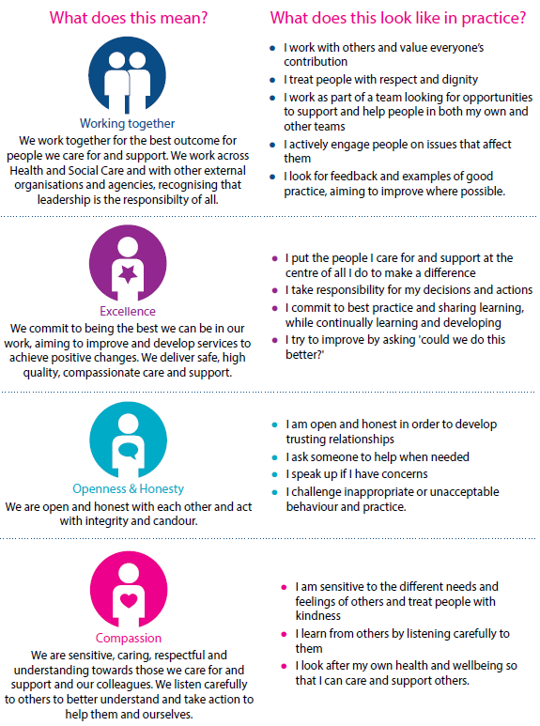
Whilst employees will be expected to portray all the values, particular attention is drawn to the following values for this role

