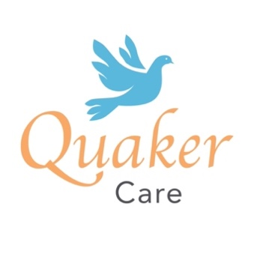
Quaker Care Ltd – Board Appointments

Seeking individuals to help shape our future

Quaker Care Ltd, established in 1998 as a trading company of Quaker Service, raises awareness and funds for the charity while serving the local community and offering volunteering opportunities. It has primarily operated as a charity shop on the Lisburn Road in Belfast, selling bric-a-brac/second-hand clothes, with past ventures including pop-up shops.

Following the appointment of a Social Enterprise Business Development Manager, and to support future development, we seek expressions of interest from experienced individuals committed to our vision and values. Board members provide oversight and guidance in delivering our strategic plan, which aims to diversify and develop new social enterprise initiatives.

The role involves attending four Board meetings annually, either in person or online, scheduled to suit members' availability. We are particularly interested in hearing from those with experience in any of the following areas:

- Trading: Retail, market trading, business operations, or online sales.

- Financial Skills: Bookkeeping, accountancy, fundraising, bid writing, or financial planning.

- Marketing/Communications: Digital marketing, social media, public relations, design skills or advocacy.

- Business Development: Entrepreneurship, income generation, or knowledge of social enterprise models.

- Networking and Partnerships: Building collaborations across private, public, or voluntary sectors.

- HR and People Management: Recruitment, staff development, and fostering inclusive workplace cultures.

- Digital and Technological Skills: Understanding emerging technologies or leading digital transformation.

This voluntary non-executive role offers a meaningful opportunity to positively impact the company and Charity. It will appeal to experienced individuals or those seeking their first non-executive role. Please share this advert with anyone you know who might have experience in these areas and might like to support our cause or who may just wish to gain valuable non-executive experience. To request a simple expression of interest form, please email the company secretary, Shane Whelehan, at this email info@quakerservice.com

Closing date: Friday, 28th February 2025

Our Core Values

Quaker Care Ltd is guided by the Charities' Quaker values of integrity, sustainability, equality, and peace. We can interpret these values in the context of our company in the following ways:

- Integrity: Transparent and ethical business practices.

- Sustainability: Environmentally beneficial work contributing to circular economies and making use of short supply chains. We create positive pathways for people. We will future proof the company so that it can have a lasting impact. We will deploy creative problem-solving by being open to innovations and new approaches.

- Equality: We value individuals. We believe that someone’s circumstances, adversities or past don’t define them. We nurture diversity, inclusion and equity throughout the organisation. We make positive community contributions and believe in second chances

Quaker Care Ltd is a private company limited by guarantee without share capital. Company No NI03428. Registered at 541 Lisburn Road, Belfast, BT9 7GQ.

