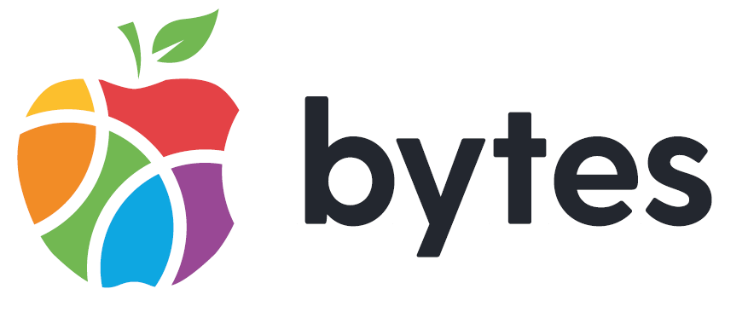

Application Pack
Specialist Youth Worker (JNC 15-20 - £31,528 - £35,547)

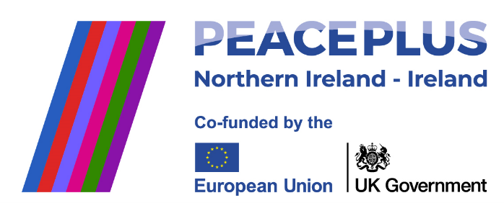

A project supported by PEACEPLUS, a programme managed by the Special EU Programmes Body (SEUPB).

Contents

Introduction 3
Bytes Organisational Structure and Principles 5
Innovation Mindset 6
Application Process and Interview Detail 7
Applications Returns 7
Job Description 9
Principal Tasks and Responsibilities 10
Person Specification 12
Application Form Guidance 15
General information 16

Introduction

The Bytes Project is a youth work charity that has been working with the most vulnerable young people in Northern Ireland for three decades. Bytes was established in April 1993, when a small group of people designed an innovative concept for Belfast, based on experience in an inner-city project in the USA. The original aim was to build on the entertainment and amusement attraction computers with marginalised young adults with a focus on 16–25-year-olds. Initial funding primarily came from Apple which supported Bytes to set up ten “open house” facilities for young adults to work on employability skills, confidence building, self-esteem and allowing the individuals a safe space to work on seeking further education or employment. In the first 10 years Bytes were able to engage many young people who gained skills in personal development and information technology.

Bytes are still providing young people, aged between 9-25, with the essential skills they need to flourish, and we now work across Northern Ireland. In 2022/23 our team of over 50 staff engaged directly with 1,000s of young people in schools, on the streets and in youth programmes and assisted hundreds of young people in gaining qualifications. You can read more about Bytes in our annual reports.

Our Vision: Young people transform their world for good.

Our Mission: Each year we will ensure that over 3000 young people access digital technology in communities of promise.

We are currently reviewing our strategy for January 2025 onwards, and we expect these to change.

Pillars of Our Work
At Bytes, we have identified three pillars for our work, which we have outlined below. Further details are available on our website www.bytes.org. This provides an insight into how we will resource this work, who our key partners will be, and the foundations on which we are building Bytes:
 | Youth Empowerment | Youth Employment and Digital | Youth Empathy
Activities | Create a cooperative eco-system of voluntary providers to lead on the delivery of all funded youth work and amplify, unify and mobilise the voice of young people to influence the public debate and, when possible, use digital platforms. | Enable young people from communities of promise to prepare for the future of work. | Support young people to build relationships that create empathy and mutual respect.
Outcomes | Delivery of youth services that place people, not bureaucracy, at the centre.  Young people advocate for and create social change. | Young people from communities of promise contribute the future of the NI economy. | Young people contribute towards an equal and inclusive society which values respect.
Connectors | Advocates of youth participation, Local Councils, key NI Assembly Departments, Local and Regional Voluntary Organisations, and Community Asset agencies. | Organisations that deliver programmes focused on digital skills and entrepreneurship,  Colleges, key NI Departments. | International Programmes, Organisations that focus on Peace Building and Inclusion.
Investment | Grants – NI, UK and RoI Governments and grant-making bodies focusing on those funders who invest in our pillars.  Social Economy – We aim to raise income through developing micro business models and delivering contracted services.  Corporations – We aim to engage with businesses that focus on the development of digital skills to support our work.
Key Contributors | Young People – leading and directing the services they want to see and improving their capacity to advocate for change.  Staff – skilled in youth work, basic digital skills, self-reflective, satisfied working for Bytes.  Board – providing good governance and protecting the growing public trust in the third sector.
Foundations | Digital Skills – we will embed digital skills across our offer to young people.  Flat Culture – we will maintain a culture that nurtures leadership across the organisation.  Quality Services - we will create and maintain a culture of continuous improvement.  Open innovation - we will always pivot to collaboration with third and commercial sectors.  Mobility and Flexibility – we will ensure our services can be scaled up across NI and wider afield.  Self-sustaining – we will aim to mix our income streams and focus on social economy business models.  Good governance – we will continue building on the public trust in charities.

Bytes Organisational Structure and Principles

The Bytes Project is registered as a charity with the NI Charity Commission and with the Revenue and Customs and as a Company Limited by Guarantee in Northern Ireland. We comply with all the relevant legislation and policies that enable us to provide a high-quality service.

The organisational chart below provides an overview of our structure and the areas our team cover: 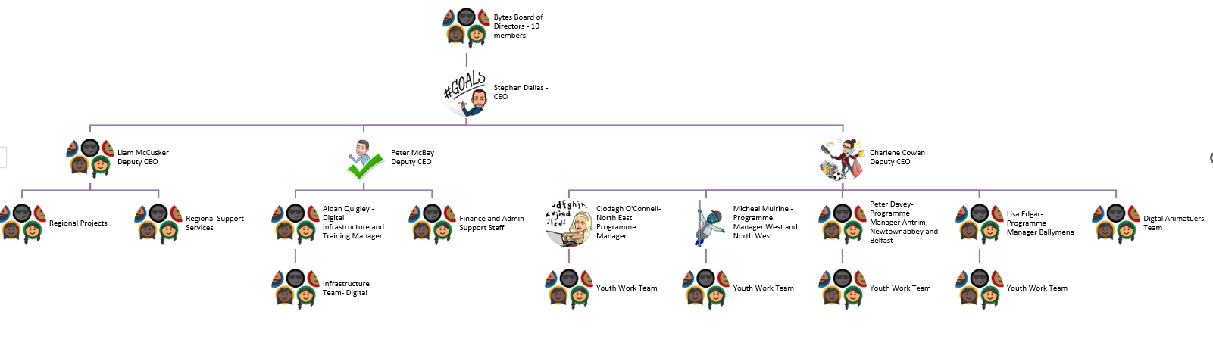
There are a range of principles that will drive the values and behaviours of staff in Bytes:

- Children and young people deserve the best services. At Bytes, we aim to ensure that we provide the highest standards of delivery. We also want to ensure that voluntary youth providers are in the best position to provide the highest standards of youth work delivery. We support this by providing effective support for governance, workforce development, curriculum development and representation.
- Humanity over bureaucracy. At Bytes, we pursue trusting relationships, reducing management tiers, and the principles of horizontal collaboration. This shapes how Bytes engages staff, members, and external partners.
- Innovation Mindset. At Bytes, we are comfortable adopting new approaches based on a culture of continuous learning.

In 2024 Bytes established a group structure. The parent company is the Bytes Project, and we have two subsidiaries:

- Bytes Local: this is focused on providing community-based youth services.
- Bytes Digital Innovation Ltd: this social enterprise delivers infrastructure services and engages in digital training and programmes. We aim to generate income for youth services through this subsidiary.

Innovation Mindset

Bytes is seeking individuals to work within a team that recognises and understands the importance of different mindsets. Based on Natalie Turner’s Six I’s Bytes is seeking:

People who can identify opportunities, with the ability to imagine the future and see opportunities and trends.

People who can ignite ideas, with the ability to stimulate ideas from others and build cultures where people are comfortable expressing ideas.

People who can investigate ideas, with the ability to structure and analyse ideas and carefully and methodically work through ideas.

People who can invest in ideas, with the ability to critically evaluate business plans and who can calmly make decisions and convince others of their validity.

People who can implement ideas, with the ability to work out the actions required to implement ideas, who can see what might go wrong and mitigate the risk by developing action orientated teams.

People who can improve ideas, with the ability to analyse feedback from service users and can create cultures of continuous learning.

At Bytes we will ask candidates questions about their mindset on the application and at the interview.

Application Process and Interview Detail

Stage One: Application
This application includes a range of questions based upon the essential criteria outlined in the Person Specification. We want to understand how you fulfil this criteria. All responses will be assessed by the recruitment panel. Those candidates who fulfil the essential criteria as set out in the Person Specification will be invited to interview.

Stage Two: Interview
The interview panel will ask a range of questions based on the detail outlined in the essential criteria.

Stage Three: Follow-up interview
Second interviews will be used in cases where the interview panel feels they require further information from applicants.

Rescheduling and No Shows
Interviews will not normally be rescheduled to accommodate applicants who are unable to attend on the agreed date. Reschedules will be entirely at the discretion of the panel. If an applicant fails to present herself/himself for interview, at the allocated time and does not respond when contacted, it will be deemed that they have withdrawn from the process.

Order of Merit
The selection panel will assess applicants against the essential criteria. Those applicants who meet the required standard(s) and pass mark will be deemed suitable for appointment. The selection panel will then list those suitable for appointment in order of merit with the highest scoring applicant ranked first.
Bytes will allocate an applicant(s) to a vacancy(ies) in the order listed. Bytes will hold a reserve list for similar post. The order of merit is valid for 12 months.

Applications Returns

Completed applications should be returned to Bytes at the following address:
Via email to: applications@bytes.org
Completed applications and Equal Opportunities Monitoring form must be received at the above email address by:
Friday 21st March 2025 by 1pm

Please use email subject heading: Private and Confidential – and name the job post you are applying for.
You are strongly advised to set your email to receive a ‘read receipt’ to confirm that we have received your application. Bytes will not accept incomplete application forms; application forms received after the deadline or reformatted application forms.
If you wish to return application by post, please contact email address above for postal address.

Job Description

Job title | Specialist Youth Worker
Reporting to | Relevant Area Manager
Responsibilities | Enabling Bytes to successfully deliver projects that promote the personal, educational, creative, and social development of young people using creative ICT and assist them in reaching their full potential. This will be in line with the NI Youth Work Curriculum.  Supporting the Programme Manager to successfully deliver projects that support us to achieve our strategic and operational objectives.
Job location | Antrim and Newtownabbey x2 (Glengormley and Ballyclare)  Mid and East Antrim x2 (Ballymena)  North East x3 (Ballymoney and Coleraine)  North West x1 (Derry/Londonderry)
Hours | 37.5 hrs per week. The applicant will be flexible in their working hours to meet the needs of the organisation; this will require availability between the hours of 9am – 11pm Monday – Sunday.
Salary | JNC 15-20 - £31,528 - £35,547
Contract length | Permanent
Holidays | Full-time total annual entitlement is 37 days, which includes set bank/customary days. Holiday entitlement will be calculated on a pro-rata basis for part-time employees or those working less than full-time hours per week.
Benefits | Access to a 7% employer contributory Pension Scheme (currently under review). We are always exploring new ways to support staff and improve our benefits package. Currently, we have these additional employee benefits: Maternity/Paternity Benefits, Paid Sick Leave, Paid Caring Responsibility Days, Training and Development Opportunities, and the Benenden Health Care Scheme.

Main Purpose of the Post
- Managing and Developing a Range of High-Quality Youth Work Programmes with Bytes and Member Groups
- Developing Staff and Volunteers Across Bytes and Member Groups
- Working with Agencies to Develop Services for Bytes and Member Groups
- Leading Project Development and Implementation Across Bytes and Member Groups
- Team Management Responsibility for Staff and Volunteers

Principal Tasks and Responsibilities

Managing and Developing a Range of High-Quality Youth Work Programmes with Bytes and Member Groups
- Recruit and co-design programmes with young people to meet identified needs, in line with the NI Youth Work Curriculum for Northern Ireland.
- Effective development of curriculum resource materials to enable Bytes to contribute to effective programmes across the region.
- Ensure that all programmes embed opportunities for young people to develop digital skills and STEM skills.
- Ensure the active participation of young people in the design and review of youth work programmes.
- Develop an Action Plan for projects and actively contribute to the overall Strategic Plan for Bytes.
- Implement effective monitoring and self-evaluation of agreed youth work programmes.
- Be responsible to the line manager for all management, administration, and financial matters relevant to the team.
- Engage in appropriate fund raising in line with Bytes’ objectives.
Developing Staff and Volunteers Across Bytes and Member Groups
- Motivate and develop staff and volunteers.
- Co-ordinate and deliver training for Bytes and Members Groups.
- Assist the Programme Manager with monitoring and quality assurance.
Working with Agencies to Develop Services Across the Bytes Member Groups
- Create and establish effective relationships with Bytes’ members.
- Support Bytes’ staff and members to develop, implement, manage, and evaluate programmes.
- Work with relevant agencies to develop services and partnerships.
Leading Project Development and Implementation Across Bytes and Member Groups
- Develop projects based on assessed needs of children and young people, underpinned by a strengths-based ethos.
- Ensure effective project implementation.
- Develop innovative approaches to capturing programme impact that are intuitive and reduce bureaucracy.

Team Management Responsibility for Staff
- Supervise appropriate staff and volunteers, including the management and allocation of duties.

General
- To maintain the required level of confidentiality.
- Undertake any other duties as required by the CEO.
- To be open to undertake a range of CPD opportunities.

Person Specification

Essential  Criteria |  | Assessment Method
Qualifications & Experience | Have at least two years’ experience delivering in a Youth Centre or Youth Project.  AND  Willing to work towards a Youth Work Level 4 qualification or above. | Application and Interview
Knowledge | Demonstrable knowledge of the following:  - NI Youth Work Curriculum.  - Department of Education Child Protection regulations.  Demonstrable working knowledge of information technology systems to include the following Microsoft Office packages: Outlook, Word, Excel, PowerPoint. | Interview  Application and Interview
Skills | Evidence of skills in designing, delivering, and evaluating youth work programmes as per the NI Youth Work Curriculum.  Evidence of delivering youth work programmes that incorporate basic digital skills.  Evidence of skills in designing, delivering, and evaluating youth work training.  Skills to manage several projects at the same time.  Excellent presentation/verbal communication skills.  Ability to create, develop and maintain effective relationships with voluntary youth work providers and statutory agencies.  Ability to work under pressure to strict deadlines. | Application  and Interview  Application and Interview  Application  Interview  Application and interview  Application and interview  Interview
Aptitudes | Innovative, pro-active, consistent and operates with a high level of personal integrity | Interview
Innovation | Demonstrable capacity for one of the following mindsets:  People who can identify opportunities:  - Skills to imagine the future.  - Can see opportunities and trends.  People who can ignite ideas:  - Skills in stimulating ideas from others.  - Ability to build cultures where people are comfortable expressing ideas.  People who can investigate ideas:  - Skills in structuring and analysing ideas.  - Can carefully and methodically work through ideas.  People who can invest in ideas:  - Skills in critically evaluating business plans.  - Can calmly make decisions and convince others of their validity.  People who can implement ideas:  - Skills in working out the actions required to implement ideas.  - Can see what can go wrong and mitigate the risk by developing action orientated teams.  People who can improve ideas:  - Skills in analysing feedback from service users  - Can create cultures of continuous learning. | Application &  Interview
Other | - Commitment to the aims and values of Bytes, including the principles that drive the values and behaviours of staff in Bytes as outlined on page 4.  - A full current driving licence* and access to a form of transport that will enable the postholder to meet the travel requirements of the Job.  *Consideration will be given to alternative travelling proposals in respect of applicants with a disability who cannot hold a licence.  - Have you the ability to work flexible hours and to travel throughout UK, Ireland, and occasionally abroad at times demanded by the job? | Application  Application  Application

Application Form Guidance

THE FOLLOWING INFORMATION PROVIDES GUIDANCE ON COMPLETING YOUR APPLICATION. PLEASE READ THIS INFORMATION CAREFULLY BEFORE SUBMITTING YOUR APPLICATION
The application form is designed to ensure that applicants provide the necessary information to determine how they meet the requirements of the post and the shortlisting criteria.
ALL sections of the application form should be completed.
Drawing upon all of your experience from work or on a voluntary basis and using the Person Specification, consider how your skills, experience and abilities relate to each criteria for this post.
In responding to the criteria below, it is essential that you describe fully how and to what extent you meet the experience sought by providing clear information and examples.
It is not appropriate to simply list various posts you have held with no examples or descriptions of the experience gained as the selection panel will not make assumptions on job titles or the nature of the organisation as to the experience gained. Shortlisting for this post will be undertaken using only the information you have provided in response to each criteria outlined in the Person Specification above.
Please remember it is the quality of the examples given along with precise details of where and when the experience was gained which matter, not the length of the response. If you do not provide sufficient detail, including the appropriate dates needed to meet the criteria, the selection panel will reject your application.
Bytes will not accept CVs, letters, or any other supplementary material in place of or in addition to completed application forms.
Applicants must complete the application form in either typescript font size 12, or legible, block capitals using black ink.
Information in support of your application will not be accepted after the closing date for receipt of applications.
Do not use acronyms, complex technical detail etc. Write for the reader who may not know your employer or your job.
Write down clearly your personal involvement in any experience you quote. Write “I” statements e.g. I planned meetings, I managed a budget, I prepared a presentation. It is how you carried out a piece of work that the panel will be interested in.
The examples you provide should be concise and relevant to the criteria. This is very important as the examples which you provide may be checked out at interview and you may need to be prepared to talk about these in detail if you are invited to interview. It is your unique role the panel are interested in, not that of your team or organisation.

General information

Equality of opportunity
Bytes is committed to a policy of equality of opportunity in its employment practices and aims to ensure that no actual or potential job applicant or employee is discriminated against, either directly or indirectly, on the grounds of gender, marital status, disability, race, community background or political persuasion, age, dependants, sexual orientation, or trade union membership.
Bytes welcomes applications from suitably qualified people from all sections of the community. All applications for employment are considered strictly on the basis of merit.
ONLY the details provided by you in your application form (Section 3 Membership of Professional Bodies, Section 4 Employment History, Section 5 Training, Section 6 Voluntary Service or Community Work and Section 7 Relevant Experience to the post.) will be provided to the selection panel for the purpose of determining your eligibility for the post.
Vetting procedure Assessment information
Appointment is subject to completion of required pre-employment checks to include:
  - appropriate documentary evidence of eligibility to work in the UK
  - security Check via Access NI – Enhanced Disclosure
  - documentary original evidence of qualifications
  - employment history validation.
Successful applicants must provide sufficient documentation to satisfy nationality and vetting requirements.
Nationality requirements
Bytes must ensure that you are legally entitled to work in the United Kingdom. Bytes will require ORIGINAL documentation to be provided that demonstrates the applicant’s right to work in the UK.
All successful applicants MUST provide when requested one of the single documents, or two of the documents in the specified combinations given, from List A;

LIST A Documents
A passport showing that the holder, or a person named in the passport as the child of the holder, is a British citizen or a citizen of the United Kingdom and Colonies having the right of abode in the United Kingdom.
A passport or national identity card showing that the holder, or a person named in the passport as the child of the holder, is a national of a European Economic Area country or Switzerland.
A residence permit, registration certificate or document certifying or indicating permanent residence issued by the Home Office or the Border and Immigration Agency to a national of a European Economic Area country or Switzerland.
A permanent residence card issued by the Home Office or the Border and Immigration Agency to the family member of a national of a European Economic Area country or Switzerland.
A Biometric Immigration Document issued by the Border and Immigration Agency to the holder which indicates that the person named in it is allowed to stay indefinitely in the United Kingdom or has no time limit on their stay in the United Kingdom.
A passport or other travel document endorsed to show that the holder is exempt from immigration control, is allowed to stay indefinitely in the United Kingdom, has the right of abode in the United Kingdom, or has no time limit on their stay in the United Kingdom.
Document combinations
An official document issued by a previous employer or Government agency, e.g. HM Revenue and Customs (formerly the Inland Revenue), the Department for Work and Pensions, Jobcentre Plus, the Employment Service, the Training and Employment Agency (Northern Ireland) or the Northern Ireland Social Security Agency, which contains the permanent National Insurance number and name of the person.
AND ONE OF THE FOLLOWING:
An Immigration Status Document issued by the Home Office or the Border and Immigration Agency to the holder with an endorsement indicating that the person named in it is allowed to stay indefinitely in the United Kingdom or has no time limit on their stay in the United Kingdom.
A full birth certificate issued in the United Kingdom which includes the name(s) of at least one of the holder’s parents.
A full adoption certificate issued in the United Kingdom which includes the name(s) of at least one of the holder’s adoptive parents.
A birth certificate issued in the Channel Islands, the Isle of Man or Ireland.
An adoption certificate issued in the Channel Islands, the Isle of Man or Ireland.
A certificate of registration or naturalisation as a British citizen.
A letter issued by the Home Office or the Border and Immigration Agency to the holder which indicates that the person named in it is allowed to stay indefinitely in the United Kingdom.
Advice on Nationality can be obtained from the Home Office website: www.ind.homeoffice.gov.uk.
ACCESS NI CHECKS (CRIMINAL CONVICTION CHECKS)
If you have applied for a post that involves “regulated activity” under the Safeguarding Vulnerable Groups (NI) Order 2007, Bytes be required to undertake an Enhanced Disclosure of Criminal Background.
The category of AccessNI check required for this post is: Enhanced Disclosure Check
Before appointing anyone to a post, it is our policy to request an Access NI check to be carried out. Access NI enables organisations in Northern Ireland to make more informed recruitment decisions by providing criminal history information about anyone seeking paid or unpaid work in certain defined areas, such as working with children or vulnerable adults.
The check will tell us if you have a criminal record, or if your name is included in the Independent Safeguarding Authority Barred Lists. Any information which we receive will be treated confidentially and we will talk to you about it before we make a final decision. A check will only be carried out if you are considered to be the successful candidate and are being offered an appointment. In your application you MUST tell us if you have ever been convicted of a criminal offence, cautioned by the Police, or bound over. You MUST tell us about ALL offences, even minor ones such as motoring offences and ‘spent’ convictions, that is, things that happened a long time ago. If you leave anything out it may affect your application. In addition, it is important to note that if your application is successful and you become an employee of Bytes, you MUST tell us IMMEDIATELY if you incur any criminal charge and/or conviction, no matter how minor.
You should not put off applying for a post because you have a conviction. We deal with all criminal record information in a confidential manner, and information relating to convictions is destroyed after a decision is made.
PLEASE NOTE: It is a criminal offence for anyone who is included on a barred list to work or seek work, in regulated activity. Individuals who are barred may be able to work in controlled activity.
Further details in relation to legislative requirements can be accessed on www.nidirect.gov.uk/vetting or www.accessni.org.uk.
Criminal Record information is subject to the provisions of the Rehabilitation of Offenders (NI) Order 1978

Turner, N (2017) Yes, You Can Innovate. Financial Times Publishing.

