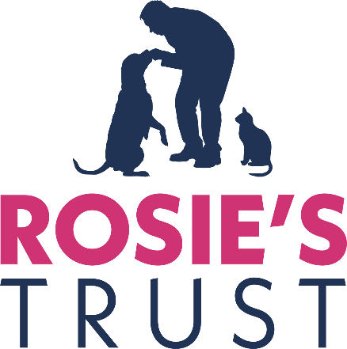

RECRUITMENT PACK
BOARD OF TRUSTEES

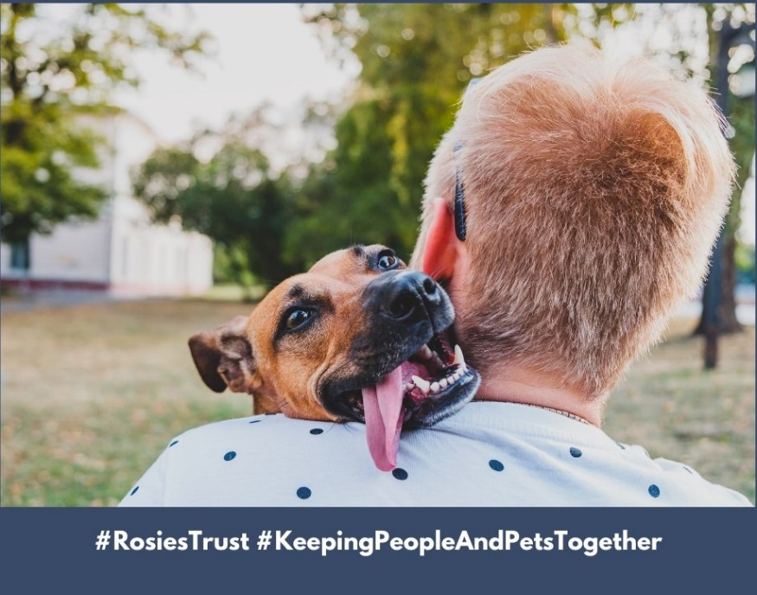

JANUARY 2025

Contents Page

Who we are, what we do 3
Our story 5
Organisation Chart 6
Role and responsibilities of Trustees 7
Application process 7

Who we are and what we do
When someone is faced with a cancer diagnosis, disability or terminal illness, their whole world changes. They have so much to worry about, so much to deal with and the one thing they need - especially those living alone – is the emotional support that their companion pet provides.

They are no longer able to provide their dog or cat with the same level of care they once could and their anxiety about the welfare of their beloved companion only serves to compound their distress.

At the most stressful time of their lives, they may be forced to give up their companion pet and, in so doing, experience tremendous loss, isolation and feelings of guilt.

Some people have reported that they considered delaying or even refusing treatment because they had no one to look after their pet.

Rosie’s Trust is Northern Ireland’s only charity dedicated to helping cancer patients, people receiving end of life care, or older people with mobility issues hold on to their beloved pets. We care for our beneficiaries’ companion dogs and/or cats in their homes when they are no longer able to look after them independently.

Subject always to our beneficiaries’ wishes, we can provide fostering services when they need to spend a period of time in hospital or in hospice care. We can also find new homes for their pets when the beneficiaries are no longer able to care for them, including when they die.

Rosie’s Trust also offers a pet bereavement service, providing emotional support to beneficiaries when their companion pet predeceases them.

We provide our services free of charge, 365 days of the year. We depend on donations to cover our service costs, and every penny gifted to us is carefully used.
Our services offer peace of mind for our beneficiaries as they know Rosie’s Trust will support them in the care of their companion pet for as long as they need us and our resources permit.
Rosie’s Trust services not only help to address loneliness and social exclusion in Northern Ireland, but also to promote animal welfare, in accordance with the Welfare of Animals Act (NI) 2011.
Extensive network of volunteers
Our full-time staff of four are supported by a team of 200+ committed volunteers who are the lifeforce of Rosie’s Trust. They provide help and support in all aspects of pet care, including feeding, grooming, exercising, play and stimulation, and vet visits. Our volunteers are our eyes and ears, ensuring when they visit that our beneficiaries are as well as can be and providing welcome social contact for many. Our volunteers work in teams, with each member making two visits a week.

Our volunteers receive intense training before being matched to a beneficiary. This ensures they all have a sound understanding Rosie’s Trust’s policies and procedures to promote the health and wellbeing of our beneficiaries, their pets and the volunteers themselves. They are also trained to signpost to partner organisations, wherever necessary.

Since our establishment in 2015, we have served 180+ beneficiaries. Currently we serve 64 beneficiaries, located in four of the five Health and Social Care Trusts (Belfast, Northern, Southern and South Eastern).
We receive our core funding from the National Lottery Community Fund.
Our Values
#Compassion #Integrity #Inclusiveness #Respect #Quality #Partnership #Confidentiality

Our story
The original idea for Rosie’s Trust was born in 2015 when our founder, Bronagh O’Neill, who was a nurse at the time, learned first-hand from a friend of hers the impact that cancer had had on his ability to look after his beloved dog. He lived alone and described how he could no longer care for his “very special friend”.
Through subsequent research and discussions with organisations such as Marie Curie, Macmillan Cancer Support, Age NI and local Health and Social Care Trusts, Bronagh also learned that large numbers of people were having to surrender their pets at a time when they needed them most because they were too weak to care properly for them themselves.
Bronagh’s findings demonstrated to her the pressing need for a charity such as Rosie’s Trust in Northern Ireland. Since its establishment, Rosie’s Trust has worked with an increasing number of individuals and organisations (statutory, corporate as well as community and voluntary sector) to ensure we are continuing to provide the care and support that is required.

ROSIE’S TRUST
ORGANISATION CHART

Board of Trustees
(Chair: Aileen Martin)
Board of Trustees

All volunteers

Finance Manager (consultant -7 hours per week)

Marketing and Communications Lead ¹ (Robyn McMurray– 28 hours per week)

CEO
(Catriona Mac Arthur – 16 hours per week)

Community Engagement and Fundraising Lead ¹ (Nuala Muldoon – 28 hours per week)

2 Development Officers
(Laura Quinn and
Aisling Fitzmaurice – both full-time)

(
Operations Manager
(Jayne McStay –
full-time)
(
Volunteer Support Officer
(Molly Finlay –
full-time)

- Both positions - Marketing and Communications Lead and Community Engagement and Fundraising Lead – are funded for two years (to April 2025) through the Dormant Accounts Fund, administered by the National Lottery Community Fund. Other positions are funded for three years (to March 2026) by the National Lottery Community Fund (People and Communities grant programme).

Role and responsibilities of Trustees
Trustees ensure the charity has a clear strategy, and that its work and goals are in line with its vision. A trustee's role in a charity is to be the ‘guardians of purpose’, making sure that all decisions put the needs of the beneficiaries first.
They safeguard the charity’s assets – both physical assets, including property, and intangible ones, such as its reputation. They make sure these are used well and that the charity is run sustainably.
Trustees don’t usually do the day-to-day running of the charity. They delegate this to the staff, led by the Chief Executive. They play the role of a ‘critical friend’ to the Chief Executive by giving support and by challenging – in a supportive way – to help them manage effectively. However, in smaller charities with few staff, Trustees may take hands-on roles too.¹
Good governance is about putting in place the right policies, procedures and checks to help a charity achieve its objects, enabling it to clearly demonstrate the good outcomes it has achieved for its beneficiaries, its staff and volunteers, and the community.
Trustees come from all walks of life, and bring with them their own skills, knowledge and experience. However, no matter their age or background, all trustees need the practical help required to develop high standards of governance and improve practice. Rosie’s Trust is guided at all times by the Code of Good Governance, developed by the Charity Commission for Northern Ireland. A copy of the Code is attached for ease of reference.
Application Process
If you would like to apply for the position of Trustee with Rosie’s Trust, please send your CV together with a cover letter outlining the skills and experience that you would bring to Rosie’s Trust and explaining your interest in the position.
Please send this documentation to catriona@rosiestrust.org by 5.00pm, Tuesday 25 February 2025.

- The essential trustee: what you need to know, what you need to do. May 2018. The Charity Commission.

