APPLICATION PACK

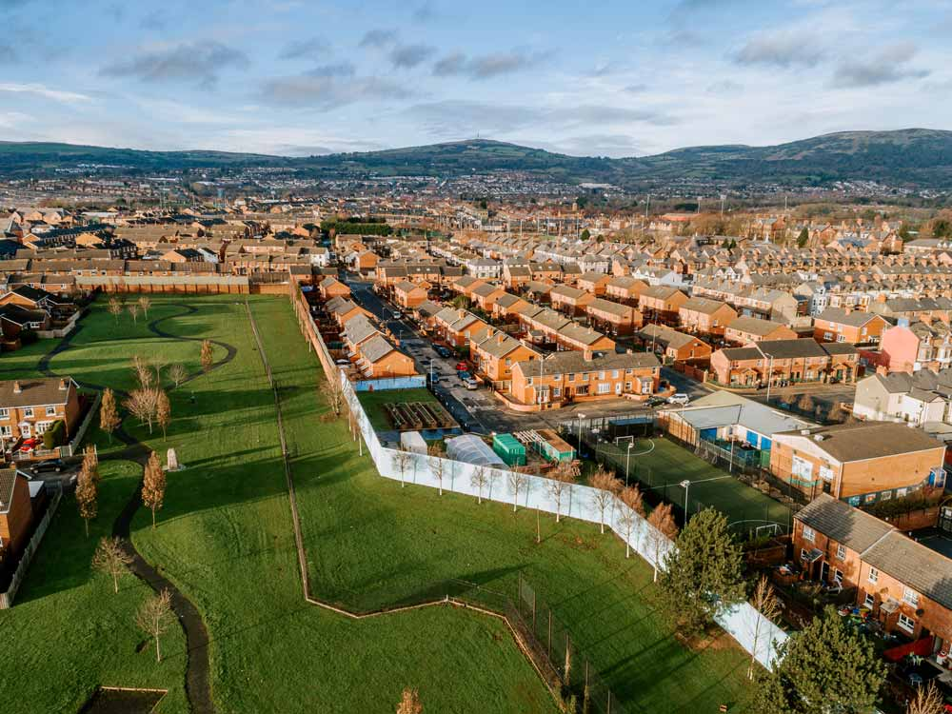

POSITION: Peace Barriers Project Worker

CLOSING DATE: Friday 28th February 2025, at 12 noon.

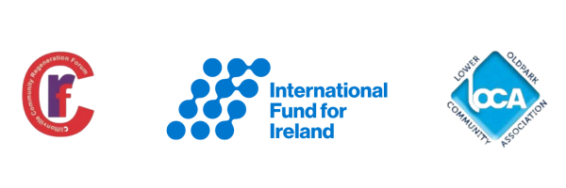

Welcome letter from Cliftonville Community Regeneration Forum

Dear Applicant,

Thank you for your interest in the Peace Barriers Project Worker position with the IMAGINE Peace Barriers Project. This initiative is a partnership between Cliftonville Community Regeneration Forum and Lower Oldpark Community Association, supported by the International Fund for Ireland (IFI).

Peace Barriers are among the most visible symbols of division in Northern Ireland, with over 100 barriers, primarily in Belfast, still standing. The Peace Barriers Programme, launched by IFI in 2012, focuses on creating the conditions necessary for the safe and consensual removal of these barriers.

This programme supports interface communities through confidence and relationship-building initiatives, helping residents feel secure enough to engage in discussions about removing Peace Barriers.

The IMAGINE Peace Barriers Project is one of the cross-community initiatives funded by IFI. Focused on peace barrier structures in the Lower Oldpark and Cliftonville areas of North Belfast, this resident-led project seeks to:

- Enhance the quality of life for residents and improve the appearance of the area.
- Increase residents' confidence and capacity to engage in discussions about peace barriers, fostering a higher quality of life for both communities.
- Ensure that any changes to the structures, no matter how minor, occur only when community and resident safety is guaranteed and when those most affected have given their consent.
- Develop a comprehensive good relations programme involving local residents, young people, senior citizens, and other community members.

As we continue this vital work, we are seeking to recruit a Peace Barriers Project Worker to join our team and help drive the IMAGINE Peace Barriers Project forward.

Yours sincerely,

Manus Maguire, Manager

Cliftonville Community Regeneration Forum

Application Submission Instructions

Thank you for your interest in the Peace Barriers Project Worker position. To apply, please carefully review the following instructions to ensure your application is complete and submitted on time.

- Application Pack:

Please find enclosed an application pack containing the following:

- A Job Description and Person Specification
- An Application Form
- An Equal Opportunities Monitoring Form

- Closing Date:

The closing date for completed applications is Friday 28th February 2025, 12 noon.

Please ensure your application includes both the Application Form and the Equal Opportunities Monitoring Form. Applications can be submitted by post or email as follows:

- Email Applications:
  - Send your application to: anne@ccrf.org.uk
  - Please ensure the subject line is clearly marked as: Peace Barriers Project Worker Application.

- Postal Applications:
  - Address your application to: Anne Mulvenna, 185 Cliftonpark Ave, Belfast BT14 6DT
  - Clearly mark the envelope with: Peace Barriers Project Worker Application.

- Interview Date:
Please note that the anticipated interview date is Monday 10th March 2025. Interviews will be held on this date, and no alternative dates will be available unless the interview panel is unable to proceed as scheduled.

Important: Please note that CVs will not be considered by the Recruitment and Selection Panel. Ensure that all relevant information is provided within the application form.

JOB DESCRIPTION

Job Title | Peace Barriers Project Worker
Location | Lower Oldpark Community Association
Responsible To | Peace Barriers Project Coordinator
Contract Terms | This is a fixed-term contract until 31 March 2026, with the possibility of extension, subject to additional funding.
Salary | NJC Scale 20-23
Hours | Full time post – 37.5 hours per week, worked flexibly with appropriate time-off in lieu.
Annual Leave | 25 days plus 11 public holidays
Job Summary | The IMAGINE Peace Barriers Project is a partnership between Lower Oldpark Community Association and Cliftonville Community Regeneration Forum.  The post holder will work as part of the IMAGINE Peace Barriers Project Team with communities and a range of stakeholders across Lower Oldpark and Lower Cliftonville and its bordering areas to create an environment where identified ‘peace barriers’ structures can be transformed for the benefit of the communities that reside close to them. This work will be wholly reliant on local agreement and commitment from those that live close to these structures.
Key Duties | - Work with the IMAGINE Peace Barriers Project team and deliver on its Action Plan to transform and regenerate the interface area in Lower Oldpark and Cliftonville.  - Build relationships, understanding and respect within and across the two main communities for peace building activities.  - Help co-ordinate a series of local forums for facilitating dialogue and mediation within and between interface communities. To build greater cross-community cohesion and confidence with a view to building partnerships and relationships to bring about physical change to ‘peace barrier’ structures across the Lower Oldpark/Cliftonville areas.  - Establish a process of engagement with individuals living in interface communities who have not previously participated in community development or peace building activities.  - Help create the conditions where interface communities are willing to explore the physical enhancement, and potential removal or modification of ‘peace barrier’ structures.  - Ensure the project builds positive relationships with residents and women’s and men’s groups across the interface area.  - Able to work co-operatively with a dynamic team.  - Ensure the project builds positive working relationship with political representatives, statutory sector officials and other stakeholders in the area.  - Support any external research being carried out on interfaces across the city as part of the Peace Barriers Project.  - Participate in the meetings of the project – project team meetings, staff meetings, etc.  - Maintain the effective recording, monitoring and evaluation of the IMAGINE Peace Barriers Project ensuring the outcomes of the project are met and written reports are provided.  - Identify good practice in other interface locations that may benefit this Peace Barriers Project.  - Participate in any training necessary for the development of a competent and professional staff team.  - To carry out any other duties as required by management.

PERSON SPECIFICATION

 | Essential | Desirable
 | The successful candidate must have:
Qualifications/  Work experience | Essential Criteria 1  - A relevant 3rd level qualification and a minimum of 2 years’ experience of working in community relations/community development/ peace building field.  OR  - 5 years’ experience of working in community relations/community development/ peace building field (within the last 7 years). | Desirable 1  - A third level qualification in community development/peace building/ peace building.
Attitudinal | Essential Criteria 2  - Ability to create and sustain effective working relationships and build consensus with key stakeholders.  - Ability for using own initiative, to make effective decisions and prioritise a substantial workload.  - Commitment to the good relations/cross community ethos of project.  - Able to work co-operatively and positively with a dynamic team.  - Ability to successfully engage with a diverse range of stakeholders without allowing their personal or political views to impact on their ability to engage or carry out their duties.
Skills and Knowledge: | Essential Criteria 3  - Knowledge of current developments in peace building and good relations work in interface areas.  - Knowledge and understanding of the issues faced by people living in an interface community.  - Ability to facilitate discussions around contentious issues relating to interface areas.  - Strong organisational skills and the ability to prioritise workloads and respond to crisis situations of external pressures.  - Experience of planning, measuring, tracking, evidencing and reporting on attitudinal change and outcomes.  - Self-motivated with the ability to work both on own initiative and as part of a team.  - Awareness of Adult and Child Safeguarding legislation. | Desirable 2  - Experience of using Outcomes Based Accountability  - Experience of event management and planning community events.  - Experience of facilitation and working with groups.
Communication Skills | Essential Criteria 4  - Strong inter-personal and communication skills including the ability to communicate both orally and in writing.  - Excellent IT skills including Word, PowerPoint, Outlook, Excel and social media.
Circumstances | Essential Criteria 5  - Willingness and ability to work flexible and unsocial hours, as required, to meet project needs.  - Available to undertake duties no later than four weeks from the interview date.

