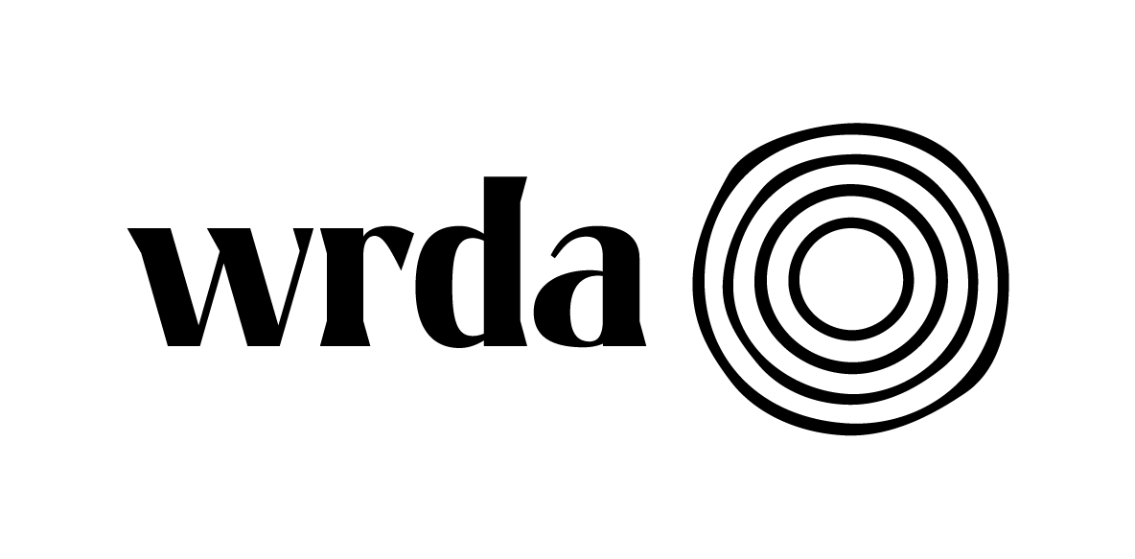
Office, Data, and Financial Administrator

WRDA’s mission as a regional organisation is to advance women’s equality and participation in society by working to transform political, economic, social and cultural conditions.

We are looking for an enthusiastic and experienced person to provide comprehensive office management support and data entry, retrieval and analysis, to ensure an effective working environment within WRDA. Flexibility is required in relation to tasks to be undertaken and you should have a conscientious approach to work and a keen attention to detail. This is an office-based role.
The salary is NJC Scale 5 pt 12-17 £28624+ 6% pension contribution. (The salary is based on 2024/25 NJC Scales.)

This is a full-time contract until end of March 2026 and is expected to be extended subject to funding.
Application packs can be downloaded from our website www.wrda.net.

Completed application form should be emailed no later than 5pm on 27 February 2025 to liz.cutler@wrda.net.

Interviews will be held 12 March 2025

WRDA offer a comprehensive induction, competitive rates of pay and benefits.

Previous applicants need not apply but will be considered

