

Dear Applicant

Thank you for expressing interest in the position of Family Support Practitioner with YMCA. We are seeking to fill a full time fixed term position (Reference Number FSP25 - Please note a reduction to 25 or 30 hrs of a pro-rate contract may be accommodated in the role on request from applicant)

The role of the Family Support Practitioner is a key position within the team and we are looking for high-calibre, skilled, experienced and committed candidates.

In advertising positions we need to be attentive to the legislative and good practice requirements placed upon us as an employer. Therefore, there are a number of forms to be completed. You must complete the Application Form, Equal Opportunities Form and The Criminal Declaration Section within the application Form or your application will not be considered. Please be very careful to follow the instructions that follow:

Please be careful to download all forms related to this post. The application should be completed and returned to Lisburn YMCA by the deadline on Wednesday 26th February 2025 at 12.00 noon.

Interviews are provisionally scheduled for the week commencing Monday 3rd March 2025.

The application pack consists of:
- Copy of the job description
- Copy of Application Form and Person Specification
- Equal opportunity monitoring form

Lisburn YMCA is committed to the implementation of its Equal Opportunities Policy in all aspects of its work, including the recruitment of staff and the delivery of service. The monitoring form is, separated from the other documents and processed by the monitoring officer. It is for monitoring purposes only and will not form any part of the short listing or selection process.

In completing your application please ensure you demonstrate how you meet the requirements of the position and the relevant experience.

If you require any further clarification please do not hesitate to contact me. Thank you for your interest in Lisburn YMCA and wish you every success with your application.

Yours Sincerely
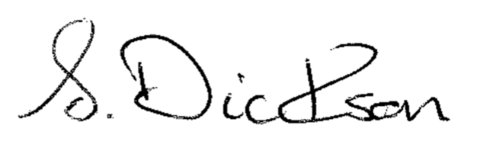
Sharon Dickson
Sharon.d@lisburnymca.com

