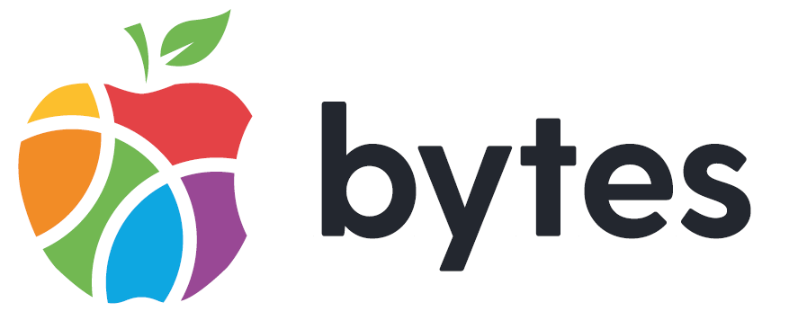

Application Pack
Digital Empowerment Manager
(NJC 27-32 - £35,745 - £40,221)

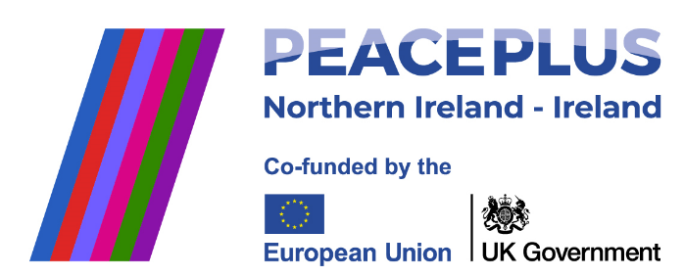
A project supported by PEACEPLUS, a programme managed by the Special EU Programmes Body (SEUPB).

Contents

Introduction 3
Bytes Organisational Structure and Principles 5
Innovation Mindset 6
Application Process and Interview Detail 7
Applications Returns 7
Job Description 9
Principal Tasks and Responsibilities 10
Person Specification 12
Application Form Guidance 15
General information 16

Introduction

The Bytes Project is a youth work charity that has been working with the most vulnerable young people in Northern Ireland for three decades. Bytes was established in April 1993, when a small group of people designed an innovative concept for Belfast, based on experience in an inner-city project in the USA. The original aim was to build on the entertainment and amusement attraction computers with marginalised young adults with a focus on 16–25-year-olds. Initial funding primarily came from Apple which supported Bytes to set up ten “open house” facilities for young adults to work on employability skills, confidence building, self-esteem and allowing the individuals a safe space to work on seeking further education or employment. In the first 10 years Bytes were able to engage many young people who gained skills in personal development and information technology.

Bytes are still providing young people, aged between 9-25, with the essential skills they need to flourish, and we now work across Northern Ireland. In 2022/23 our team of over 50 staff engaged directly with 1,000s of young people in schools, on the streets and in youth programmes and assisted hundreds of young people in gaining qualifications. You can read more about Bytes in our annual reports.
Our Vision: Young people transform their world for good.
Our Mission: Each year we will ensure that over 3000 young people access digital technology in communities of promise.
We are currently reviewing our strategy for January 2025 onwards, and we expect these to change.

The Role: The Digital Empowerment Manager is an exciting new position within Bytes. It is being created to work alongside a team of youth workers and support them in integrating and animating digital themes within their programmes with young people. We also view the role as leading the advocation of digital approaches within youth work approaches. For example:
- Using future technologies like XR, Drones, Robotics, AI to enable young people to prepare for the future of work.
- Developing user-friendly content on an LMS platforms that makes learning fun and rewarding for young people.
- Ensure young people are introduced to the wide range of cyber and online risks in an engaging and helpful way.
- Encouraging the use of our new site, Voices for Impact, to engage the voice of young people using digital platforms.
We are looking for people with skills to enable youth workers to improve their ability to adopt fun and creative new digital approaches. You don’t necessarily need to have worked with young people to apply for this role. If you want to find out more, contact our CEO at stephen.dallas@bytes.org.

Pillars of Our Work
At Bytes, we have identified three pillars for our work, which we have outlined below. Further details are available on our website www.bytes.org. This provides an insight into how we will resource this work, who our key partners will be, and the foundations on which we are building Bytes:
 | Youth Empowerment | Youth Employment and Digital | Youth Empathy
Activities | Create a cooperative eco-system of voluntary providers to lead on the delivery of all funded youth work and amplify, unify and mobilise the voice of young people to influence the public debate and, when possible, use digital platforms. | Enable young people from communities of promise to prepare for the future of work. | Support young people to build relationships that create empathy and mutual respect.
Outcomes | Delivery of youth services that place people, not bureaucracy, at the centre.  Young people advocate for and create social change. | Young people from communities of promise contribute the future of the NI economy. | Young people contribute towards an equal and inclusive society which values respect.
Connectors | Advocates of youth participation, Local Councils, key NI Assembly Departments, Local and Regional Voluntary Organisations, and Community Asset agencies. | Organisations that deliver programmes focused on digital skills and entrepreneurship,  Colleges, key NI Departments. | International Programmes, Organisations that focus on Peace Building and Inclusion.
Investment | Grants – NI, UK and RoI Governments and grant-making bodies focusing on those funders who invest in our pillars.  Social Economy – We aim to raise income through developing micro business models and delivering contracted services.  Corporations – We aim to engage with businesses that focus on the development of digital skills to support our work.
Key Contributors | Young People – leading and directing the services they want to see and improving their capacity to advocate for change.  Staff – skilled in youth work, basic digital skills, self-reflective, satisfied working for Bytes.  Board – providing good governance and protecting the growing public trust in the third sector.
Foundations | Digital Skills – we will embed digital skills across our offer to young people.  Flat Culture – we will maintain a culture that nurtures leadership across the organisation.  Quality Services - we will create and maintain a culture of continuous improvement.  Open innovation - we will always pivot to collaboration with third and commercial sectors.  Mobility and Flexibility – we will ensure our services can be scaled up across NI and wider afield.  Self-sustaining – we will aim to mix our income streams and focus on social economy business models.  Good governance – we will continue building on the public trust in charities.

Bytes Organisational Structure and Principles

The Bytes Project is registered as a charity with the NI Charity Commission and with the Revenue and Customs and as a Company Limited by Guarantee in Northern Ireland. We comply with all the relevant legislation and policies that enable us to provide a high-quality service.

The organisational chart below provides an overview of our structure and the areas our team cover: 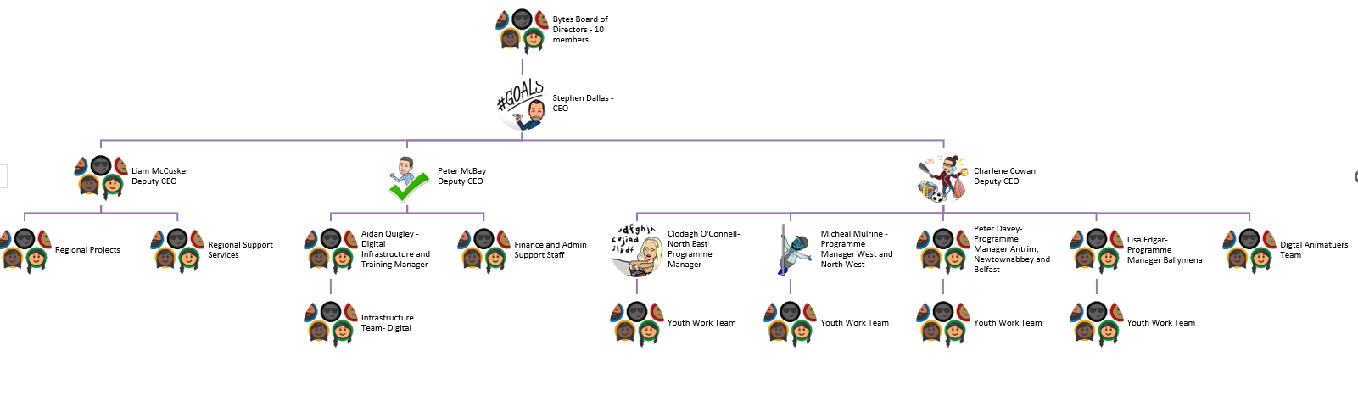
There are a range of principles that will drive the values and behaviours of staff in Bytes:

- Children and young people deserve the best services. At Bytes, we aim to ensure that we provide the highest standards of delivery. We also want to ensure that voluntary youth providers are in the best position to provide the highest standards of youth work delivery. We support this by providing effective support for governance, workforce development, curriculum development and representation.
- Humanity over bureaucracy. At Bytes, we pursue trusting relationships, reducing management tiers, and the principles of horizontal collaboration. This shapes how Bytes engages staff, members, and external partners.
- Innovation Mindset. At Bytes, we are comfortable adopting new approaches based on a culture of continuous learning.

In 2024 Bytes established a group structure. The parent company is the Bytes Project, and we have two subsidiaries:

- Bytes Local: this is focused on providing community-based youth services.
- Bytes Digital Innovation Ltd: this social enterprise delivers infrastructure services and engages in digital training and programmes. We aim to generate income for youth services through this subsidiary.

Innovation Mindset

Bytes is seeking individuals to work within a team that recognises and understands the importance of different mindsets. Based on Natalie Turner’s Six I’s Bytes is seeking:

People who can identify opportunities, with the ability to imagine the future and see opportunities and trends.

People who can ignite ideas, with the ability to stimulate ideas from others and build cultures where people are comfortable expressing ideas.

People who can investigate ideas, with the ability to structure and analyse ideas and carefully and methodically work through ideas.

People who can invest in ideas, with the ability to critically evaluate business plans and who can calmly make decisions and convince others of their validity.

People who can implement ideas, with the ability to work out the actions required to implement ideas, who can see what might go wrong and mitigate the risk by developing action orientated teams.

People who can improve ideas, with the ability to analyse feedback from service users and can create cultures of continuous learning.

At Bytes we will ask candidates questions about their mindset on the application and at the interview.

Application Process and Interview Detail

Stage One: Application
This application includes a range of questions based upon the essential criteria outlined in the Person Specification. We want to understand how you fulfil this criteria. All responses will be assessed by the recruitment panel. Those candidates who fulfil the essential criteria as set out in the Person Specification will be invited to interview.

Stage Two: Interview
The interview panel will ask a range of questions based on the detail outlined in the essential criteria.

Stage Three: Follow-up interview
Second interviews will be used in cases where the interview panel feels they require further information from applicants.

Rescheduling and No Shows
Interviews will not normally be rescheduled to accommodate applicants who are unable to attend on the agreed date. Reschedules will be entirely at the discretion of the panel. If an applicant fails to present herself/himself for interview, at the allocated time and does not respond when contacted, it will be deemed that they have withdrawn from the process.

Order of Merit
The selection panel will assess applicants against the essential criteria. Those applicants who meet the required standard(s) and pass mark will be deemed suitable for appointment. The selection panel will then list those suitable for appointment in order of merit with the highest scoring applicant ranked first.
Bytes will allocate an applicant(s) to a vacancy(ies) in the order listed. Bytes will hold a reserve list for similar post. The order of merit is valid for 12 months.

Applications Returns

Completed applications should be returned to Bytes at the following address:
Via email to: applications@bytes.org
Completed applications must be received at the above email address by:
Friday 21st March 2025 by 1pm

Please use email subject heading: Private and Confidential – and name the job post you are applying for.
You are strongly advised to set your email to receive a ‘read receipt’ to confirm that we have received your application. Bytes will not accept incomplete application forms; application forms received after the deadline or reformatted application forms.

Job Description

Job title | Digital Empowerment Manager
Reporting to | Deputy CEO
Responsibilities | The Digital Empowerment Manager role is an exhilarating new opportunity within Bytes, designed to collaborate closely with a dynamic team of youth workers. This position aims to enrich their programs with cutting-edge digital themes, empowering young people to thrive in the modern world. Our current view of this role is that it will:  - Utilize futuristic technologies such as XR, Drones, Coding, and AI to equip young people with essential skills for the future workforce.  - Create user-friendly content on an LMS platform that transforms learning into a fun and rewarding experience.  - Engagingly educate young people about the vast array of online opportunities and risks, ensuring they navigate the digital world safely.  - Promoting our new platform, Voices for Impact, to amplify young voices through digital engagement.  We seek individuals who can inspire and enable youth workers to embrace innovative digital approaches that are both enjoyable and imaginative. Previous experience working with young people is not a prerequisite. If this role excites you and you wish to learn more, please contact our CEO at stephen.dallas@bytes.org
Job location | The role is based in one of these hubs:  - Ballymoney  - Derry/Londonderry  Bytes has a hybrid working policy.
Hours | 37.5 hours per week. The applicant will be flexible in their working hours to meet the needs of the post.
Salary | NJC 27-32 - £35,745 - £40,221
Contract length | Permanent
Holidays | The full-time total annual entitlement is 37 days, including bank/customary days. Holiday entitlement will be calculated on a pro-rata basis for part-time employees or those working less than full-time hours per week.
Benefits | Access to a 7% employer contributory Pension Scheme (currently under review). We are always exploring new ways to support staff and improve our benefits package. Currently, we have these additional employee benefits: Maternity/Paternity Benefits, Paid Sick Leave, Paid Caring Responsibility Days, Training and Development Opportunities, and the Benenden Health Care Scheme.

Main Purpose of the Post
- Managing and Developing a Range of High-Quality Youth Work Programmes with Bytes and External Groups to Embed Digital Approaches to Youth Work.
- Developing Staff and Volunteers Across Bytes and External Groups to Maximise Digital Approaches to Youth Work.
- Supporting Digital Training and Youth Projects across Bytes and with External Groups
- Support the Development and Implementation of Digital Approaches to Youth Work Across with Bytes and External Groups
- Team Management Responsibility for Staff

Principal Tasks and Responsibilities
Managing and Developing a Range of High-Quality Youth Work Programmes with Bytes and External Groups to Embed Digital Approaches to Youth Work.
- Develop Bytes’ public profile and foster good relationships with government, statutory, voluntary, and private bodies and other external stakeholders regarding the quality of digital approaches to youth work.
- Develop explicit knowledge and understanding of digital approaches to youth work. provided across the organisation and external groups to represent this quality in quantitative and qualitative forms.
- Ensure high levels of support are available to improve workforce development on digital approaches to youth work.
- Manage and/or support Bytes staff and external groups undertaking external inspections or moderations related to digital approaches to youth work.
- Manage and/or support Bytes staff to deliver digital approaches to youth work using user feedback, self-evaluation, and external reports on service quality.
- Ensure Bytes recognise and celebrate digital approaches to youth work to create a culture that effectively merges youth work with digital approaches.
- Develop effective digital resource materials to enable Bytes to be a sectoral lead on digital approaches to youth work and contribute to effective regional programmes.
- Ensure that all youth work in Bytes embed opportunities for young people to develop digital skills and STEM skills.
- Ensure the active participation of young people in the design and review of digital approaches to youth work
- Ensure that staff Action Plan’s for projects contribute to the overall Strategic Plan for Bytes. This includes acting as a champion for digital approaches to youth work to meet our Strategic Plan.
- Implement effective monitoring and self-evaluation of agreed work programmes.
- Be responsible for all management, administration, and financial matters relevant to the team.
- Engage in appropriate fundraising in line with Bytes’ objectives.
- Manage all accreditations related to digital systems

Developing Staff and Volunteers Across Bytes and External Groups to Maximise Digital Approaches to Youth Work.
- Main lead for the management of all staff and volunteers on digital approaches to youth work.
- Manage all training for teams and external groups on digital approaches to youth work.
- Manage all monitoring and quality assurance in specified area.
Supporting Digital Training and Youth Projects across Bytes and with External Groups
- Create structures to ensure effective relationships with Bytes’ staff and external groups.
- Manage a culture that enables Bytes’ staff and external groups to develop, implement, manage, and evaluate programmes using digital methods.
- Lead role for creating and developing training on digital approaches to youth work.
- Lead role for creating and developing partnership to improve digital approaches to youth work.
- Support role for creating and developing digital training services and partnerships with the Digital Infrastructure and Training Manager.
Support the Development and Implementation of Digital Approaches to Youth Work Across with Bytes and External Groups
- Create a structure to ensure all projects are based on the assessed needs of children and young people, underpinned by a strengths-based ethos.
- Create a culture of effective project implementation.
- Create approaches that welcome innovative approaches to capturing programme impact that are intuitive and reduce bureaucracy.

Team Management Responsibility for Staff
- Supervise appropriate staff, including management and allocation of duties.

General
- To maintain the required level of confidentiality.
- Undertake any other duties as required by the CEO.
- To be open to undertake a range of CPD opportunities.

Person Specification

Essential  Criteria |  | Assessment Method
Qualifications & Experience | A relevant HND/HNC, equivalent or higher qualification in IT or similar.  OR  Able to demonstrate a minimum of 3 years’ experience devising creative ICT solutions  *Please note we will accept applications from those graduating in the Summer 2024  OR  3 years delivering ICT support to clients. | Application  Application and Interview  Application and Interview
Knowledge | Demonstrable knowledge of the following:  - Department of Education Child Protection regulations.  - ICT systems, with confidence in learning any new systems or software as required.  Demonstrable working knowledge of information technology systems to include the following Microsoft Office packages: Outlook, Word, Excel, PowerPoint, etc. | Interview  Application and Interview
Skills | Strong competence in IT, demonstrated either through a relevant qualification or substantial applied practice.  Skills in building and sustaining effective relationships and working collaboratively with external providers and organisations.  Skills to manage a project budget.  Skills to manage concurrent projects.  Excellent presentation/verbal communication skills.  Ability to effectively manage and influence people to deliver outcomes.  Ability to work under pressure to strict deadlines.  Skills in managing the delivery of programmes and developing digital skills focusing on the pillars of the Bytes Strategy.  Proficiency in digital approaches to learning, including developing digital resource materials and embedding digital skills within programmes.  Ability to devise innovative and effective ICT solutions tailored to children's and young people's needs.  Using digital tools to reduce bureaucracy and improve intuitive understanding, skills in capturing and analysing programme impact. | Application and Interview  Application and interview  Application and interview  Application and interview  Application and interview  Application and interview  Application and interview  Interview  Interview  Interview  Interview  Interview
Aptitudes | Innovative, pro-active, consistent and operates with a high level of personal integrity | Interview
Innovation | Demonstrable capacity for one of the following mindsets:  People who can identify opportunities:  - Skills to imagine the future  - Can see opportunities and trends.  People who can ignite ideas:  - Skills in stimulating ideas from others  - Ability to build cultures where people are comfortable expressing ideas.  People who can investigate ideas:  - Skills in structuring and analysing ideas  - Can carefully and methodically work through ideas.  People who can invest in ideas:  - Skills in critically evaluating business plans  - Can calmly make decisions and convince others of their validity.  People who can implement ideas:  - Skills in working out the actions required to implement ideas  - Can see what can go wrong and mitigate the risk by developing action orientated teams.  People who can improve ideas:  - Skills in analysing feedback from service users  - Can create cultures of continuous learning. | Application &  Interview
Other | - Commitment to the aims and values of Bytes, including the principles that drive the values and behaviours of staff in Bytes as outlined on page 4.  - A full current driving licence* and access to a form of transport that will enable the postholder to meet the travel requirements of the Job  *Consideration will be given to alternative travelling proposals in respect of applicants with a disability who cannot hold a licence  - Have you the ability to work flexible hours and to travel throughout UK, Ireland, and occasionally abroad at times demanded by the job? | Application  Application  Application
Desirable | - Experience in using ICT in an educational/youth work context.  - Awareness of the NI Youth Work Curriculum.  - Experience in utilising Creative Media such as Adobe Creative Suite | Application  Application  Application

Application Form Guidance

THE FOLLOWING INFORMATION PROVIDES GUIDANCE ON COMPLETING YOUR APPLICATION. PLEASE READ THIS INFORMATION CAREFULLY BEFORE SUBMITTING YOUR APPLICATION
The application form is designed to ensure that applicants provide the necessary information to determine how they meet the requirements of the post and the shortlisting criteria.
ALL sections of the application form should be completed.
Drawing upon all of your experience from work or on a voluntary basis and using the Person Specification, consider how your skills, experience and abilities relate to each criteria for this post.
In responding to the criteria below, it is essential that you describe fully how and to what extent you meet the experience sought by providing clear information and examples.
It is not appropriate to simply list various posts you have held with no examples or descriptions of the experience gained as the selection panel will not make assumptions on job titles or the nature of the organisation as to the experience gained. Shortlisting for this post will be undertaken using only the information you have provided in response to each criteria outlined in the Person Specification above.
Please remember it is the quality of the examples given along with precise details of where and when the experience was gained which matter, not the length of the response. If you do not provide sufficient detail, including the appropriate dates needed to meet the criteria, the selection panel will reject your application.
Bytes will not accept CVs, letters, or any other supplementary material in place of or in addition to completed application forms.
Applicants must complete the application form in either typescript font size 12, or legible, block capitals using black ink.
Information in support of your application will not be accepted after the closing date for receipt of applications.
Do not use acronyms, complex technical detail etc. Write for the reader who may not know your employer or your job.
Write down clearly your personal involvement in any experience you quote. Write “I” statements e.g. I planned meetings, I managed a budget, I prepared a presentation. It is how you carried out a piece of work that the panel will be interested in.
The examples you provide should be concise and relevant to the criteria. This is very important as the examples which you provide may be checked out at interview and you may need to be prepared to talk about these in detail if you are invited to interview. It is your unique role the panel are interested in, not that of your team or organisation.

General information

Equality of opportunity
Bytes is committed to a policy of equality of opportunity in its employment practices and aims to ensure that no actual or potential job applicant or employee is discriminated against, either directly or indirectly, on the grounds of gender, marital status, disability, race, community background or political persuasion, age, dependants, sexual orientation, or trade union membership.
Bytes welcomes applications from suitably qualified people from all sections of the community. All applications for employment are considered strictly on the basis of merit.
ONLY the details provided by you in your application form (Section 3 Membership of Professional Bodies, Section 4 Employment History, Section 5 Training, Section 6 Voluntary Service or Community Work and Section 7 Relevant Experience to the post.) will be provided to the selection panel for the purpose of determining your eligibility for the post.
Vetting procedure Assessment information
Appointment is subject to completion of required pre-employment checks to include:
  - appropriate documentary evidence of eligibility to work in the UK
  - security Check via Access NI – Enhanced Disclosure
  - documentary original evidence of qualifications
  - employment history validation.
Successful applicants must provide sufficient documentation to satisfy nationality and vetting requirements.
Nationality requirements
Bytes must ensure that you are legally entitled to work in the United Kingdom. Bytes will require ORIGINAL documentation to be provided that demonstrates the applicant’s right to work in the UK.
All successful applicants MUST provide when requested one of the single documents, or two of the documents in the specified combinations given, from List A;

LIST A Documents
A passport showing that the holder, or a person named in the passport as the child of the holder, is a British citizen or a citizen of the United Kingdom and Colonies having the right of abode in the United Kingdom.
A passport or national identity card showing that the holder, or a person named in the passport as the child of the holder, is a national of a European Economic Area country or Switzerland.
A residence permit, registration certificate or document certifying or indicating permanent residence issued by the Home Office or the Border and Immigration Agency to a national of a European Economic Area country or Switzerland.
A permanent residence card issued by the Home Office or the Border and Immigration Agency to the family member of a national of a European Economic Area country or Switzerland.
A Biometric Immigration Document issued by the Border and Immigration Agency to the holder which indicates that the person named in it is allowed to stay indefinitely in the United Kingdom or has no time limit on their stay in the United Kingdom.
A passport or other travel document endorsed to show that the holder is exempt from immigration control, is allowed to stay indefinitely in the United Kingdom, has the right of abode in the United Kingdom, or has no time limit on their stay in the United Kingdom.
Document combinations
An official document issued by a previous employer or Government agency, e.g., HM Revenue and Customs (formerly the Inland Revenue), the Department for Work and Pensions, Jobcentre Plus, the Employment Service, the Training and Employment Agency (Northern Ireland) or the Northern Ireland Social Security Agency, which contains the permanent National Insurance number and name of the person.
AND ONE OF THE FOLLOWING:
An Immigration Status Document issued by the Home Office or the Border and Immigration Agency to the holder with an endorsement indicating that the person named in it is allowed to stay indefinitely in the United Kingdom or has no time limit on their stay in the United Kingdom.
A full birth certificate issued in the United Kingdom which includes the name(s) of at least one of the holder’s parents.
A full adoption certificate issued in the United Kingdom which includes the name(s) of at least one of the holder’s adoptive parents.
A birth certificate issued in the Channel Islands, the Isle of Man or Ireland.
An adoption certificate issued in the Channel Islands, the Isle of Man or Ireland.
A certificate of registration or naturalisation as a British citizen.
A letter issued by the Home Office or the Border and Immigration Agency to the holder which indicates that the person named in it is allowed to stay indefinitely in the United Kingdom.
Advice on Nationality can be obtained from the Home Office website: www.ind.homeoffice.gov.uk.
ACCESS NI CHECKS (CRIMINAL CONVICTION CHECKS)
If you have applied for a post that involves “regulated activity” under the Safeguarding Vulnerable Groups (NI) Order 2007, Bytes be required to undertake an Enhanced Disclosure of Criminal Background.
The category of Access NI check required for this post is: Enhanced Disclosure Check
Before appointing anyone to a post, it is our policy to request an Access NI check to be carried out. Access NI enables organisations in Northern Ireland to make more informed recruitment decisions by providing criminal history information about anyone seeking paid or unpaid work in certain defined areas, such as working with children or vulnerable adults.
The check will tell us if you have a criminal record, or if your name is included in the Independent Safeguarding Authority Barred Lists. Any information which we receive will be treated confidentially and we will talk to you about it before we make a final decision. A check will only be carried out if you are considered to be the successful candidate and are being offered an appointment. In your application you MUST tell us if you have ever been convicted of a criminal offence, cautioned by the Police, or bound over. You MUST tell us about ALL offences, even minor ones such as motoring offences and ‘spent’ convictions, that is, things that happened a long time ago. If you leave anything out it may affect your application. In addition, it is important to note that if your application is successful and you become an employee of Bytes, you MUST tell us IMMEDIATELY if you incur any criminal charge and/or conviction, no matter how minor.
You should not put off applying for a post because you have a conviction. We deal with all criminal record information in a confidential manner, and information relating to convictions is destroyed after a decision is made.
PLEASE NOTE: It is a criminal offence for anyone who is included on a barred list to work or seek work, in regulated activity. Individuals who are barred may be able to work in controlled activity.
Further details in relation to legislative requirements can be accessed on www.nidirect.gov.uk/vetting or www.accessni.org.uk.
Criminal Record information is subject to the provisions of the Rehabilitation of Offenders (NI) Order 1978

Turner, N (2017) Yes, You Can Innovate. Financial Times Publishing.

