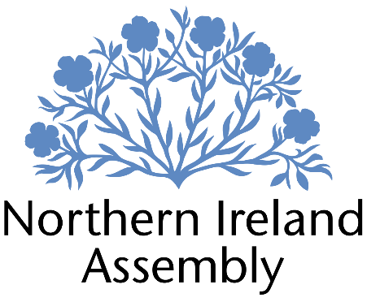
Kate Nicholl MLA

Alliance Party Member of the Northern Ireland Assembly for Belfast South Constituency

COMMUNICATIONS AND CONSTITUENCY OFFICER – (TEMP MATERNITY SUPPORT POST)

Report to: | Kate Nicholl MLA
Office Location: | South Belfast Constituency Office and Parliament Buildings
Hours: | 37 hours per week, Monday – Friday.
Holidays: | As per determination
Salary: | Grade 3
Pension: | A central Assembly-approved pension scheme is provided. If enrolled an amount equivalent to 10% of employees salary will be paid into the pension scheme.
Duration: | Six month maternity support post. Employment contingent upon member remaining an MLA or until legislation is introduced to change Constituency expense provision. Two-month probation period shall apply.
Closing Date | 12 noon, 21st February 2025
Interview dates: | It is anticipated that shortlisted candidates will be interviewed week commencing 3rd March 2025

JOB DESCRIPTION

“To carry out the function of providing constituency and communications services for Kate Nicholl MLA and support residents, businesses, communities and groups in the Belfast South Constituency and appropriate stakeholders”

- Managing social media channels to ensure the work of Kate Nicholl MLA is appropriately communicated to constituents and relevant stakeholders.
- Identifying and responding to constituency orientated media and press opportunities including replies to queries and the pro-active drafting of statements
- To work with the staff team to identify opportunities to progress change for the benefit of constituents and a shared future in Northern Ireland
- To work with the Policy and Communications Manager to maintain up to date knowledge of relevant legislation, policy and developments locally relevant to the constituency
- Delivering effective management and processing of constituent casework for Kate Nicholl MLA
- Working with constituents directly on individual cases, issues and constituency matters ensuring that casework is logged and dealt with sensitively and confidentially
- Responsibility for monitoring progress of cases, ensuring all identified actions are taken.
- Ensuring efficient data and file management to comply with GDPR and data management
- Dealing with complex queries and complaints on Member’s behalf, including drafting letters for Member to sign
- Assisting Policy and Communications Manager with drafting of motions and Assembly questions
- Building relationships and liaising with business, community and other groups in the constituency on behalf of Kate Nicholl MLA, as appropriate
- Responding to correspondence and enquiries from constituents, media, lobbyists, businesses and community groups in conjunction with Kate Nicholl MLA's requirements.
- Planning and organising events and meetings
- Attending surgeries, tribunals, meetings and conferences as appropriate
- Maintenance of office systems, processes and procedures including ordering and managing stationery stock / office equipment
- Attending work related training and networking meetings to develop skills
- Other duties as required in support of the MLA carrying out their Assembly duties

PERSON SPECIFICATION

Applicants must demonstrate clearly on their application form how they meet the criteria.

 | Essential Criteria | Desirable Criteria
Professional / Technical Qualifications | - Five GCSE’s / O’ Levels or Equivalent at Grade C or above including both English Language and Mathematics  - Excellent written skills (Grammar, punctuation and spelling)  - Proficiency in the use of  Microsoft Outlook, Word and Excel packages | - Third level qualification
Experience / Job Knowledge | - Minimum of two years’ experience working in a paid capacity in administration in an office environment  - Experience of working with a range of stakeholders in order to achieve outcomes  - Previous experience of working with the public  - Ability to update and maintain a database  - Experience of dealing with sensitive and confidential information (both verbal and written) in line with the Data Protection Act and GDPR  - Experience of the advice sector  - Experience of using graphics and communications software | - Experience of managing an office  - Campaigning experience, political or otherwise  - Experience of working with volunteers  - Experience of community engagement  - Knowledge of the workings of the Northern Ireland Assembly  - Experience of working in a small team  - Experience of working on complex projects  - Working knowledge of the Benefits and Housing processes in Northern Ireland  - Experience of developing communications plans and strategies
Personal Qualities /  Skills | - Good punctuality  - Excellent organisational skills  - Good verbal communication skills in person and on the phone  - Flexible, innovative and enthusiastic approach to work duties  - Understanding of Alliance Party objectives | - Patience and compassion  - Time management  - Ability to multi task
Circumstances | - Able to work unsupervised and as lone worker in office when required | - May be required to travel to meetings/appeals
Applicants must demonstrate clearly on their application form how they meet the criteria.

