

Job Description and Personnel Specification

Finance and Administration Assistant

Permanent Part Time

20 hours per week

Employees of Action Cancer must support its Mission, Values and Behaviours:



Values and Behaviours:

Our strengths are that we are a Values driven charity with people being at the very centre of everything we do. Our services are proven to make a difference, we are a Northern Ireland charity run and controlled by local people, raising money, spending money, and supporting people only here in Northern Ireland.
We have three stated Values which are supported by seven expected behaviours.

Value 1: Putting People First - People are at the centre of everything we do.

Value 2: Making a Difference - Having a positive impact on everything we do.

Value 3: Having Integrity – Operating with full transparency, honesty and fairness in everything we do.

Our Values are supported by seven Behaviours. We Will…
1. Treat people with respect, care, dignity and consideration.
2. Listen, hear and respond positively to what people say.
3. Work together, supporting, adding value, learning from and sharing with others.
4. Embrace and develop new ideas, and ways of working.
5. Nurture, support, develop and equip our people to reach their full potential
6. Learn from the past, build upon and celebrate our success
7. Welcome scrutiny, taking ownership and responsibility for our actions.

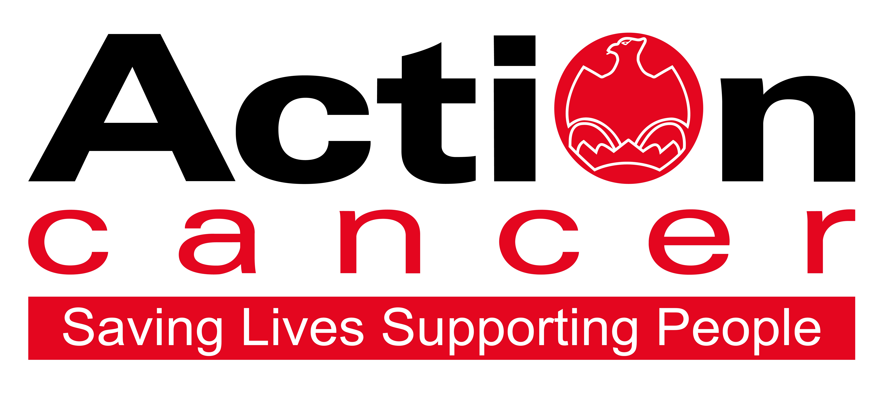
Position: Finance and Administration Assistant

Location: Based in Action Cancer House, Belfast

Salary: NJC scale 5-9: £24,790 - £26,409 (£13.62 - £14.51 per hour)
Pro Rata £14,165 - £15,090

We also offer:
- 20 days leave increasing to 25 days + 11 Public Holidays
- 1 extra leave day at Christmas
- Christmas closure
- Enhanced sickness, maternity, paternity, and adoption leave and pay
- 6% contributory pension scheme
- NHS Top-Up Cash Plan
- Death in Service Plan
- Staff care and support services, including access to Action Cancer services
- Training and development

In addition to a competitive salary, Action Cancer offer a Total Reward Package – see Appendix - which focuses on what our staff value, and includes a flexible mix of rewards designed to meet staff needs, their lifestyle, and their stage in life, including a time-off-in-lieu accrual system, training, flexible family-friendly working arrangements, pension contributions, and excellent professional development opportunities.

Action Cancer is a local Northern Ireland charity - all our money is raised to provide services for local communities. Our dedicated team of staff and volunteers work across the whole of Northern Ireland helping to save lives and support people affected by cancer. To operate our services we must raise circa £4 million every year. We provide early detection and health promotion services, and counselling and support services for cancer patients and their families, thereby making a real difference to people who are affected by or living with cancer.

Action Cancer staff - a mix of highly skilled professionals - are the most valuable asset to our charity. We offer a wide variety of training and development opportunities, and family friendly initiatives to enhance work-life balance, and to value and support individuals and family life. In recognition of this we were awarded Best Learning and Development Organisation in Ireland - Not for Profit Sector, and were winners of The Irish News ‘Best Place to Work’ Award, Employers For Childcare “Childcare Works Award”, Employers For Childcare Family Friendly Employer Award - Social Enterprise/Charity of the Year, and Employer of the Year Award by UTV Business Eye Awards.

We are also very proud to have achieved Investors in People Gold Champion status, Investors in People Health & Wellbeing Good Practice accreditation, and Investors in Volunteers accreditation. These awards are testament to our continued commitment to “have highly valued, trained, enthusiastic, focused and committed people who work together and engage with others to make a positive impact on our community”.

Finance and Administration Assistant – Job Description

Overall Responsibility

To assist the Head of Finance and Administration in the management of the finance and administration function.

Specific Duties:

Finance

Bank Accounts
- Maintain the cashbooks for bank accounts.
- Accurate recording of income and expenses.
- Bank reconciliations.
- Credit card reconciliations.
- Liaise with the Fundraising Department to ensure they are notified about income direct to the finance department.

Purchase Ledger
- Upload/input invoices onto the purchase ledger, ensuring all invoices are correctly authorised, properly coded and accounted for.
- Complete monthly supplier statement reconciliations.
- Prepare supplier and staff payments.

Sales Ledger
- Invoice customers.
- Credit control.

Others
- Supervise volunteers to count cash.
- Prepare regular cash and cheque lodgements for banking.
- Maintain Petty Cash and process payments.
- Audit expense claims.
- Retail gift aid Claims.

Administration
- Ensure that administrative processes and systems are effectively operated.
- Keep proper records and produce regular reports, which assist in the monitoring of systems and procedures.
- Provide administrative service to the Head of Finance and Administration as required.

Management and development of staff
- Act as supervisor for volunteers.

Health and Safety
- Ensure Action Cancer Health and Safety Policy is adhered to.

General
- Undertake any other duties that might reasonably be required by the Head of Finance and Administration.

This job description will be subject to review in the light of changing circumstances and is not intended to be rigid and definitive, but should be regarded as providing guidelines within which the individual works. Other duties of a similar nature and appropriate to the grade may be assigned from time to time. It is important to note that the responsibilities of the post may change to meet the evolving needs of the services that the charity provides.

General Responsibilities

Members of staff are expected at all times to provide the appropriate service and to treat those with whom they come into contact with in a courteous and respectful manner

All staff must comply with Action Cancer’s No Smoking Policy on Action Cancer Premises and also while on duty for the charity.

All duties are carried out in compliance with Action Cancer’s Health and Safety Policy and Statutory requirements.

Action Cancer is an Equal Opportunities Employer. You are required to adhere to Action Cancer’s Equal Opportunities Policy throughout the course of employment.

All staff must comply with Action Cancer Data Protection Policy and Procedures.

To ensure the ongoing confidence of the public in the staff of Action Cancer, staff must ensure they maintain the high standards of personal accountability.

Terms and Conditions of Employment

- 2 satisfactory written references are required direct from a current / previous employer covering the preceding two years of employment.
- Successful applicants must evidence their right to work in the UK (under the Asylum and Immigration Act). This will be evidenced in the first instance by a passport or other forms of ID that will be outlined if no passport is available.
- 6 months probationary period
- Evidence of relevant academic and professional qualifications
- All potential employees may be asked to attend a pre-employment medical

Action Cancer is an Equal Opportunities employer

PERSONNEL SPECIFICATION

Essential Requirements

- 1 years’ experience in a financial / accounting environment.

- Experience of Bank Reconciliations.

- 5 GCSE (Including English and Mathematics) Grade C or above, or equivalent

- Computer literate (databases, spreadsheets, word-processing, e-mail and internet)

- Excellent organisational skills including the ability to prioritise and manage multiple workloads

- Excellent communication skills (written and oral)

- Ability to be flexible and work under pressure in a busy office environment using own initiative as required.

Desirable Requirements

- A financial qualification.

- Knowledge of Sage 50 accounting.

Appendix 1: Action Cancer Total Reward Statement
Training and Development
- Organisation Wide Training Budget
- Paid Tailored Training and Development Support
- Comprehensive In-House Training Courses and External Development Opportunities linked to Role, Strategic Plan, Individual Requests, and Competencies
- Comprehensive Induction Program
- Continued Professional Development Support
- Structured Interim and Annual Performance Reviews
- All Staff and Department Teambuilding Away Days and Events
- Cross Departmental Working Opportunities/ Workplace Shadowing
- Overseas Challenge Opportunities

Work Life Balance
- Standard 35 hour working week
- Flexible Working - hybrid working, compressed hours, staggered start times
- Enhanced paid annual leave - 11 annual statutory days, up to 25 days annual leave (depending on role), Additional Day Paid Leave at Christmas
- Fixed Christmas closure throughout the entire organisation
- Christmas staff and family events
- Time Off In Lieu in compensation of additional hours worked
- Sabbatical, Discretionary and Dependant care leave
- People and Family Friendly Policies
- Enhanced maternity, paternity and adoption leave and pay subject to eligibility.

Social, Physical and Mental Health and Wellbeing
- WPA - NHS Cash Back Plan and Employee Assistance Program.
- Health and Menopause Support Policies and Return to Work programs
- Therapeutic supports – counselling, complementary therapies, acupuncture
- External care and support services – Staffcare & DAS confidential counselling helpline services
- AIG Smart Health - digital GPs, health checks, nutrition consultation, mental health support, myStrength app, 24/7 mental health helpline, legal and financial support.
- External Occupational Health Service, health checks, screening, and vaccinations
- Regular Staff Health and Wellbeing and Awareness and Opinion Surveys, and Staff Wellness Week
- Mediation services
- Staff kitchen facilities, free tea and coffee, and shower facilities
- Christmas family party and subsidised Christmas departmental celebrations
- Staff pool car
- Clear Policies and Procedures
- CSER Team representing staff opinion and arranging events throughout the year.

Financial Reward and Recognition
- Sector competitive salaries
- Action Cancer 6% pension contribution + 3.2% employee contribution + tax relief = 10% contribution to pension pot
- Salary Sacrifice for Annual Leave, Pension, and Bike to Work Schemes
- Work related professional membership fees paid
- Mileage Allowance at the Prevailing HMRC Rate
- Additional Day Paid Leave at 10,15,and 20 Years’ service for staff on NJC payscales
- Free staff uniforms
- Free car parking
- Death-in-service benefit of £50,000 lump sum payable to nominee.

Where such references are unavailable, and in respect of employee(s) joining directly from school or government sponsored youth training schemes, character references will be required.

