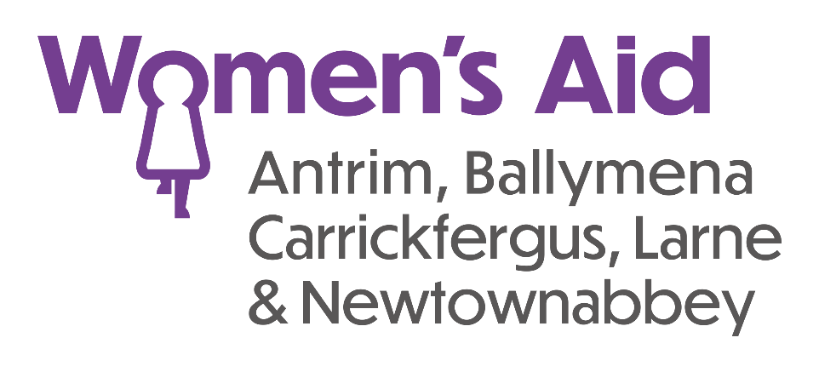

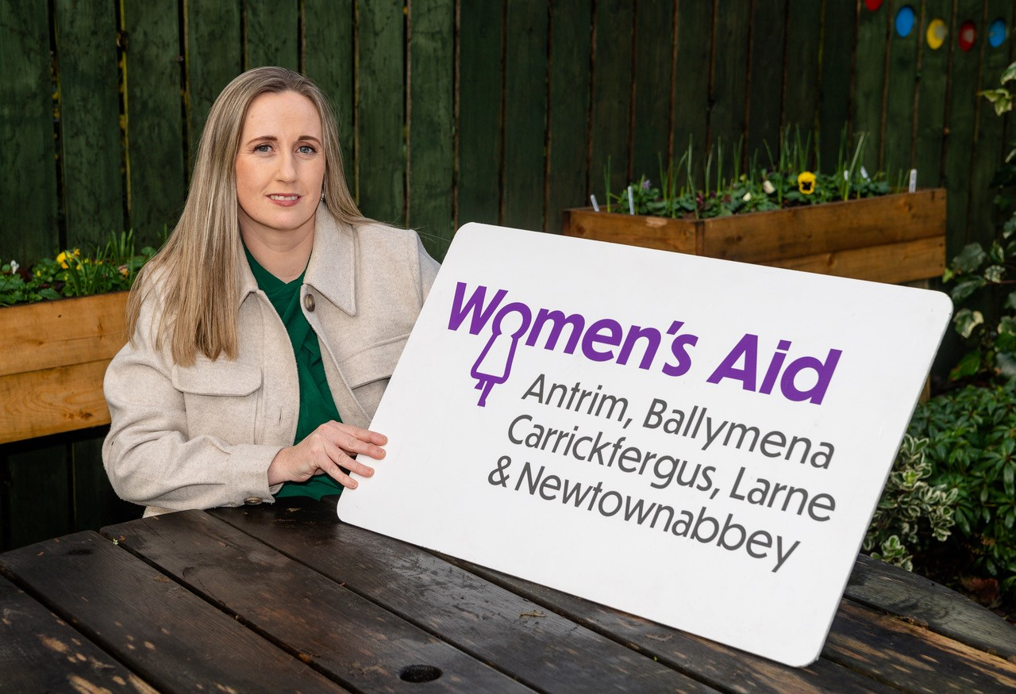

Women’s Aid ABCLN

Recruitment Information Pack

Domestic Abuse Specialists

Together We Are

Working To End Domestic Abuse

Welcome from CEO

Women’s Aid ABCLN is a professional, dynamic and energetic organisation that exists to provide **gold standard** support to women and children experiencing domestic abuse.

We are an organisation of the highest calibre, totally **dedicated** to the needs of women and children who are impacted by domestic abuse. Our work is **purposeful** and **valuable** and the combined skills of our highly trained, expert staff, enables women to create positive change and, in many cases **transform** their lives.

Our staff and volunteers are **specialists** in their field, **professional** across every aspect of their work and **inspirational** in their achievements.

If you feel you can **share our passion** for the work and you have the determination to meet our Gold Standards, I warmly invite you to join us. Your decision to **take this opportunity** to extend your **skills and experience** in an environment that is innovative, meaningful and focussed on success - is one, I know you will never regret.

Gillian Creevy

Chief Executive

  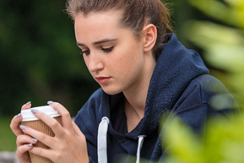

Women’s Aid ABCLN

Women’s Aid ABCLN provides confidential support, information and emergency accommodation for women and children affected by domestic abuse across Antrim, Ballymena, Carrickfergus, Larne and Newtownabbey.

Our work is trauma informed and needs led.

* We provide emergency accommodation for women and children in refuge and self-contained apartments.
* We offer one to one support, practical assistance and group work in the community.
* We provide specialised services and support for children and young people affected by domestic abuse.
* We provide increased awareness and greater protection for older women who have experienced domestic abuse.
* We believe no-one should have to live in fear or threat from abuse

Knowing That Help Is Available

One in four women will experience domestic abuse in their lifetime. PSNI respond to one incident of domestic abuse every 16 minutes. For every incident, we know the impact on women and children can be devastating.

Last year, in 2022-2023, Women’s Aid ABCLN’s Domestic Abuse Specialists supported 1,449 women and 723 children living with domestic abuse in our local community.

Knowing that help is available, that there is a way out of the domestic abuse they have experienced, enables women to transform their lives.

Through early intervention and preventative work, we challenge attitudes and beliefs which lead to male violence against women.

We work with partner organisations and communities to increase understanding and awareness about domestic abuse and equip them to recognise and respond to issues faced.

Together we are working to end domestic abuse.

** **

Domestic Abuse Specialists

Women’s Aid ABCLN Domestic Abuse Specialists provide trauma-informed, high-quality, pro-active, front-line support and services to women and children impacted by domestic abuse.

We listen to what women and children tell us, and recognise and respond to their individual needs. Our work is trauma informed and needs led.

We work with women to develop a support plan focusing on safety planning and protection measures. We provide practical support to enable women to access services including housing, benefits, social services, healthcare and education, financial services, police and legal support.

Women’s Aid ABCLN has made such a difference to my life. I feel like I have crossed a line and proudly, almost unbelievably, I have moved forward in my journey.

We offer emotional support on an individual basis and/or in a group setting. We provide personal development and confidence building groups and courses that enable women and children to discuss issues in a safe and supported environment, and learn through shared experiences.

Our Vision

Women’s Aid ABCLN is working towards a society where domestic abuse will not be tolerated and women and children can live free from the threat of violence.

Our Mission

Women’s Aid ABCLN provides high quality services and support to women and children affected by all forms of domestic abuse.

We are committed to working collaboratively, in partnership with women and children who are victims and survivors of domestic abuse, to provide them with the support to build the skills they have identified as necessary to meet their needs.

We also advocate, lobby, educate and challenge as appropriate on their behalf.  We believe that this contributes to the delivery of effective, co-ordinated, responsive and accessible services for women and their children.

Our Aims

​​

* To provide services and temporary refuge to women and children suffering domestic abuse, be that emotional, physical, financial, verbal or sexual abuse.
* To empower and enable women to determine their own future.
* To recognise, respond and care for the emotional needs of children and young people.
* To offer support and guidance to any woman who asks for it, both in refuge and in her own community.
* To educate, inform and challenge the public, the media, police, courts, social services and other authorities about the prevalence and effects of domestic abuse. We will always be mindful that domestic abuse is a direct result of the general position of women in our society and perpetrators’ decisions to meet their own needs without negotiation because they believe that they are entitled to. Domestic abuse is a breach of human rights.

Ethos & Core Values

We operate within an ethos of empowerment with women, children, staff and volunteers.  This enables women to shape their futures, supporting them to make choices for themselves and their children.

We are guided by a framework of equality and diversity.

Our Values Are

* **R**ealistic and honest with all
* **E**mpathetic and non-judgemental and compassionate
* **S**upportive providing safety and a supported response to all
* **P**ositive have a positive attitude
* **E**arnest in ensuring that everyone is treated as an individual
* **C**lear, honest and respectful with all communication
* **T**rustworthy

What Our Staff Say

When I tell people I worked for Women’s Aid ABCLN I feel myself stand taller and straighter because I am so proud of working for the organisation.

I have been keen to get a job with Women’s Aid ABCLN for over four years, and was excited when the opportunity for the Domestic Abuse Specialist role came up.

I am honoured to work with such great people and proud that women trust us to share their experiences and stories.

I don’t feel I am working because it is such a pleasure to be here where I feel I belong, supporting and enabling other women and children.

I am forever grateful for this opportunity to possibly make a difference.

Human Resources

Women’s Aid ABCLN

Tel: 028 28 632136

Email: [recruitment@womensaidabcln.org](mailto:recruitment@womensaidabcln.org)