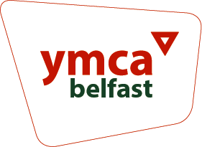

St Judes After School Assistant

Information Pack

## 

## 

## 

## 

## 

## Introduction

**Dear Candidate**

Belfast YMCA has been serving communities and individuals across Belfast for over 170 years and we have a rich legacy of supporting children and young people throughout that time.

A registered charity and company limited by guarantee in our own right, we are also part of a global family of YMCAs which helps keep us openminded and outward-looking for ever better ways to realise our mission.

We are seeking to recruit an experienced After School Assistant; people

who share our passion for children.

The role will be based at St Jude’s Parish Hall on the Ravenhill Road, opposite Cherryvale Park. Where we have a large and bright upstairs hall, garden space and we regularly use Cherryvale Park for outdoor play and activities.

We believe it’s a great place to work and we care about making it an organisation where our staff, volunteers and young people all have the opportunity to thrive.

If you are passionate about enabling children to learn, grow and thrive, and have the

experience of working in an early years setting then we would very much welcome

your application.

**Chris Cupples**CEO

## 

## 

## 

## 

## 

## What we do

**Nursery, Afterschool and holiday clubs**

We provide care for over 200 children each week with a team of over 35 staff working across our childcare and after schools groups.

In our nursery, we have dedicated rooms for babies, toddlers and two nursery aged rooms. We also have a range of indoor and outdoor play areas available for each of the rooms to use. Our afterschool programme provides two separate classrooms for P1- P3 children and P4-P7 children as well as ample outdoor space for play. We have recently completed a new building connecting the two classrooms.

Our newest After School club is based in St Jude’s Parish Hall on the Ravenhill Road. We have a large and bright upstairs hall, garden space and we regularly use Cherryvale Park for outdoor play and activities.

Our nursery and afterschool facilities are inspirational spaces for opportunities and experiences for all age groups that stimulate physical, social, intellectual and emotional development.

We offer great outdoor spaces where children can enjoy free play and a healthy environment.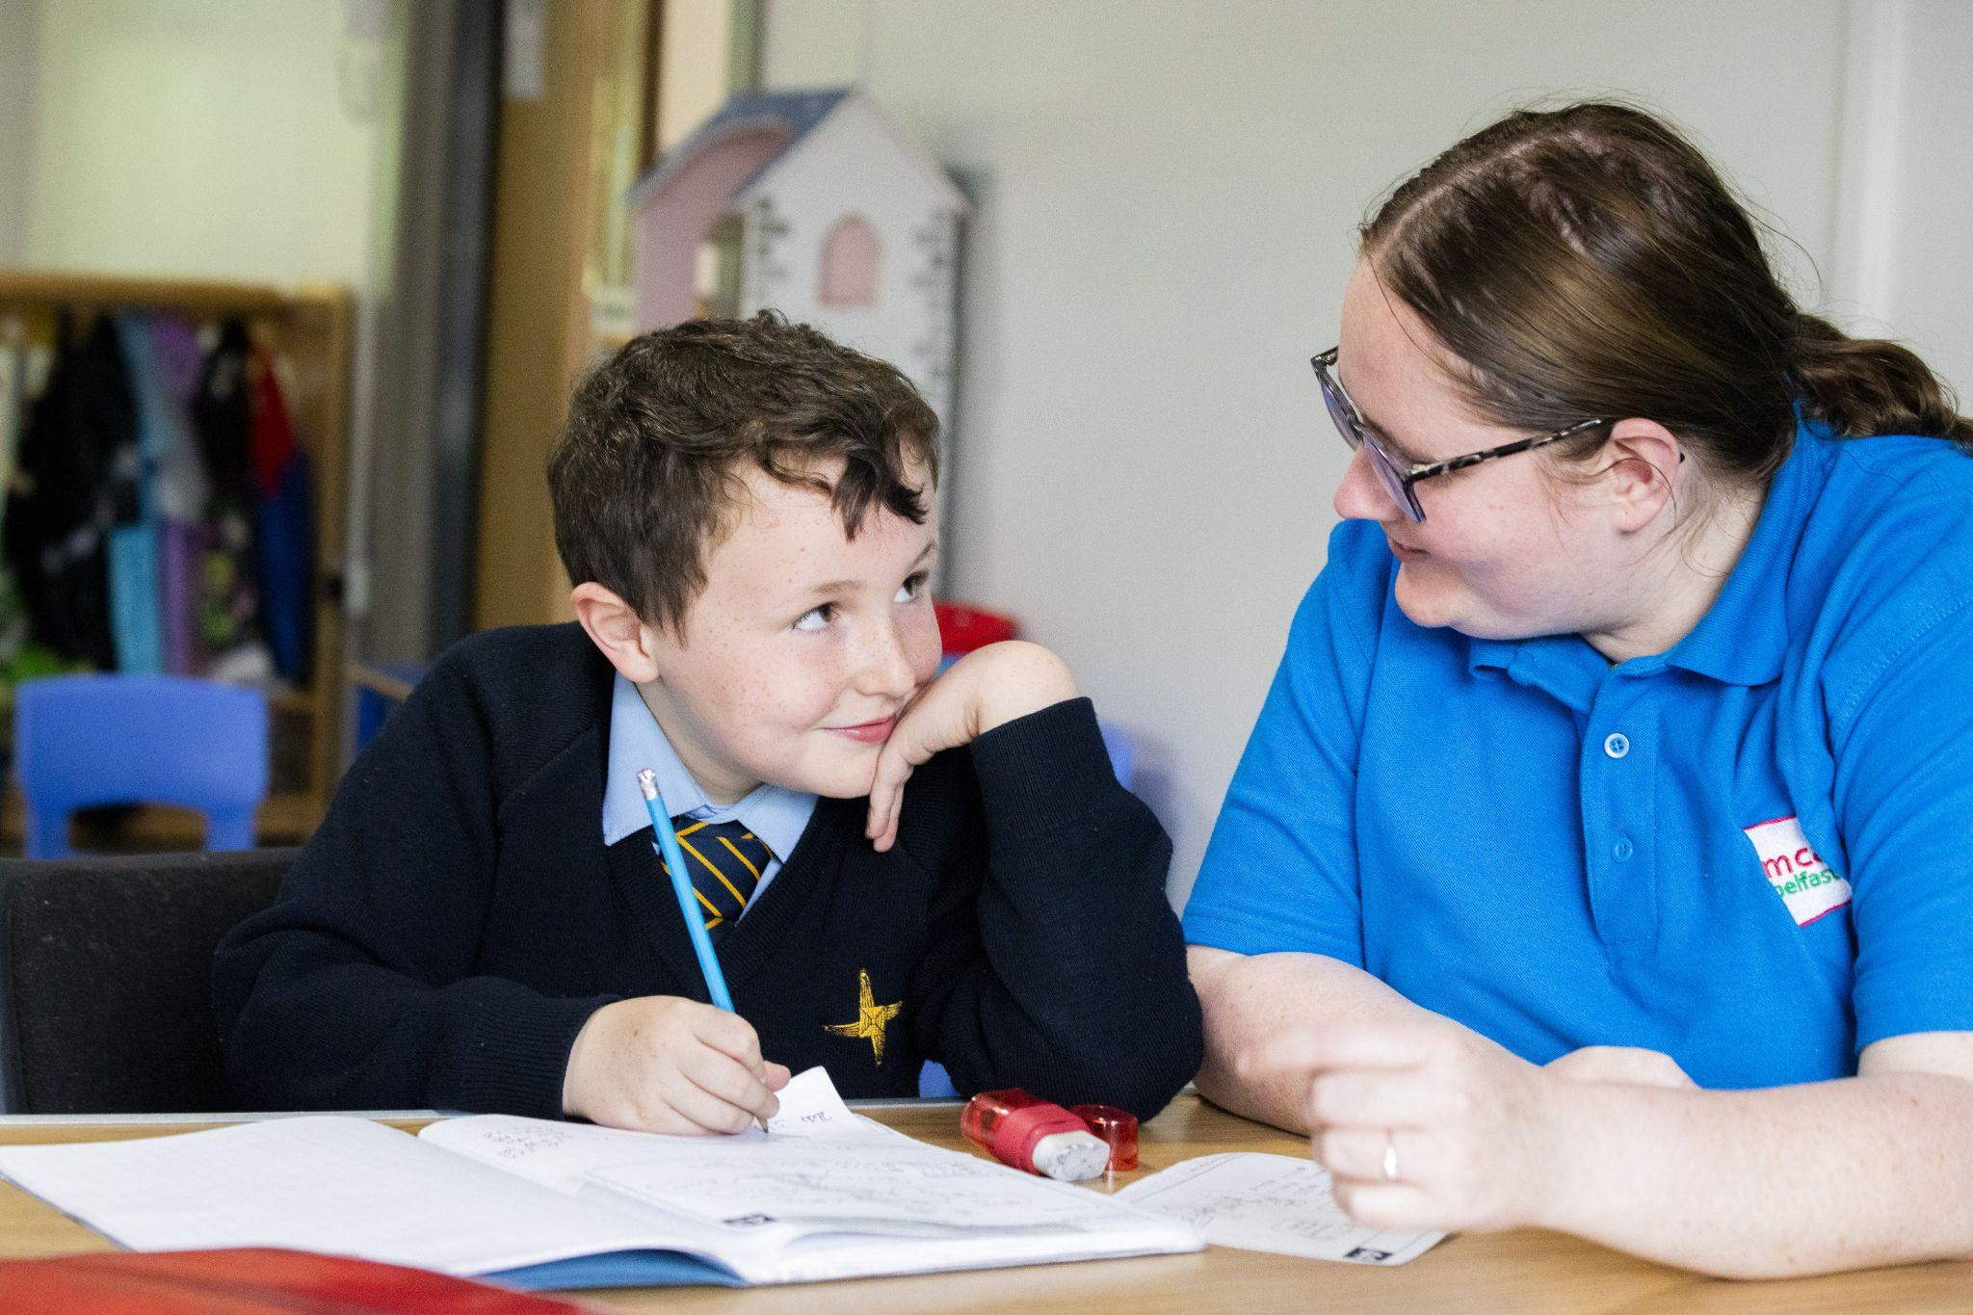

### 

During school holidays we also run clubs for school aged children between 8am-6pm with a programme of play, craft, sport, trips and various outdoor activities.

**Youth and Good Relations Programmes**

Since 2013 our youth team have been delivering our projects in schools throughout East Belfast. Over the course of the academic year we work with over 500 young people in schools across a number of the programmes we offer. The youth team facilitates sessions with pupils in their class groups, usually weekly throughout a term. Our largest programmes focus on good relations.

Ubuntu, our good relations programme uses dialogue and interactive learning to increase awareness of stereotyping, sectarianism and migration.

Our youth team also run a number of other programmes including; Youth in Government, Duke of Edinburgh and summer programmes. We are excited to be launching a brand new Youth Club on our site in 2023 in partnership with CFC South.

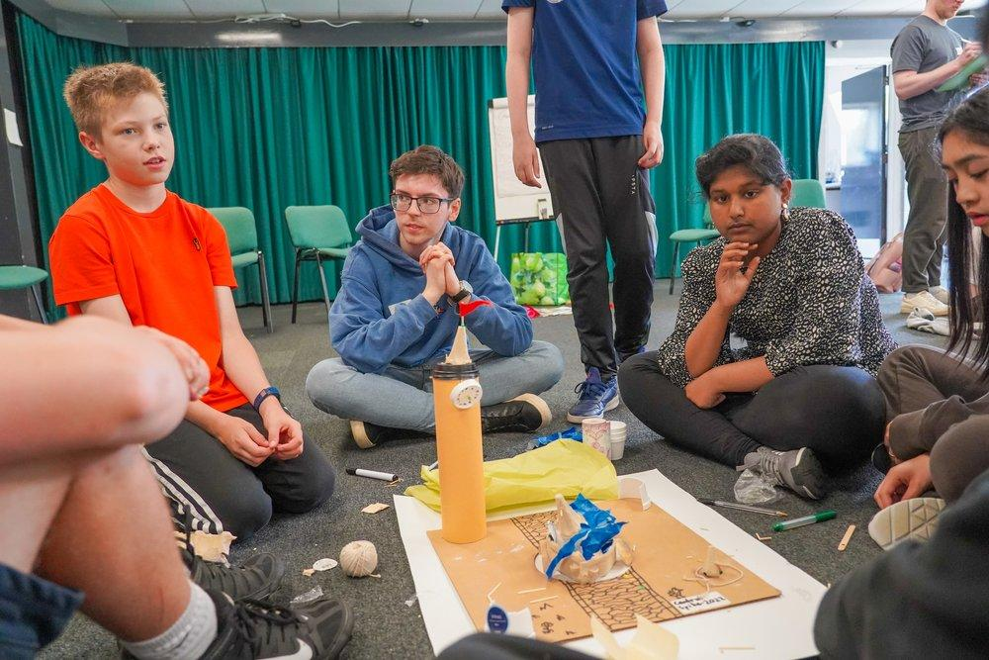 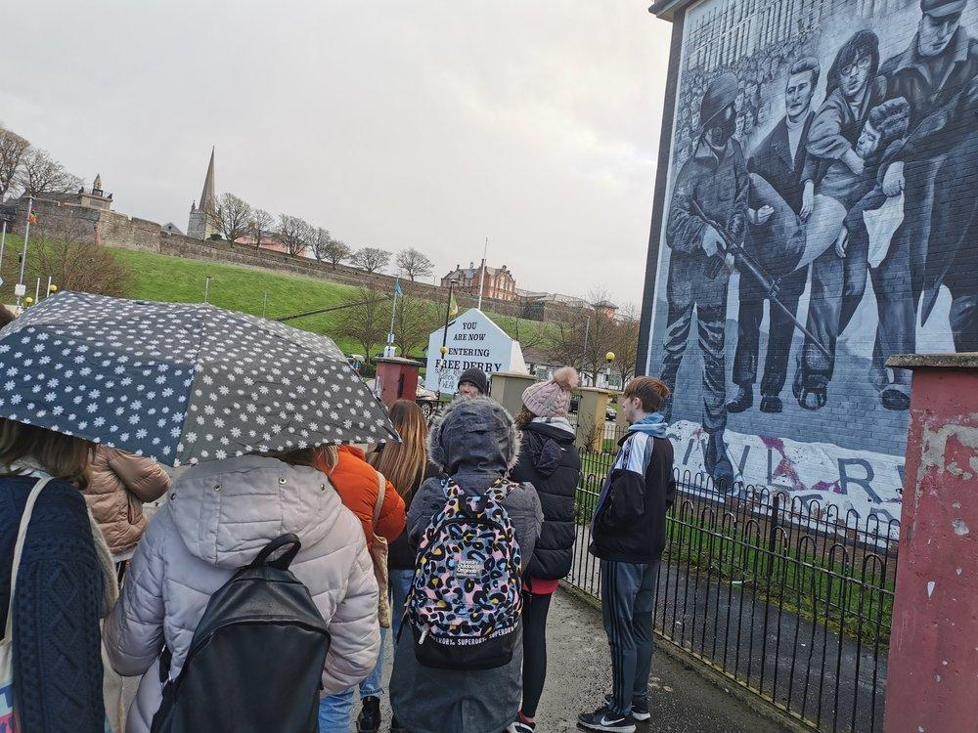

**Partnership Working**

We work closely with community and charity sector partners including:

* **CFC South Belfast** - A local Church that meets on our site each Sunday and throughout the week. Together we run a youth club and various community events in partnership.
* **Ethos Training** - A local fitness community who run the on-site gym and fitness centre
* **Aquinas Football Club** - A local football club that use our sports pitches and in particular run mini-football for children and young people throughout the week and on Saturdays

## 

## Job Description

**Job Title**: Afterschool Assistant

**Responsible to**: Afterschool Manager

**Location**: St Jude’s Hall, 243 Ravenhill Road, Belfast, BT7 2HJBelfast YMCA, 56-58 Knightsbridge Park, Belfast, BT9 5EH

**Salary**: £12.25 - £12.50 (depending on qualification)

**Hours**: 25 hours per week. Monday to Friday: 1pm - 6pm

**Other benefits**: 5% employer pension contribution  
 Employer sick pay scheme   
 Holidays - 31 days per year rising to 37 days per year  
 Death in service insurance  
 Long service awards  
 Staff discount on childcare / St Jude's After Schools

myStrength mental wellbeing app

Bereavement counselling

Probate helpline

Toothfairy - dental app

**Contract:** Permanent

**Probation period**: 6 months

**Vetting -** The role requires vetting from Belfast Health and Social Care Trust and an enhanced Access NI disclosure due to the nature of working within the Nursery.

**Main purpose of the Job:**The appointed after school assistant will work as part of the team to ensure a high level of service for the children in their care. Providing for the children's daily physical needs and ongoing social and emotional development.

**Job Details**

* Assist in maintaining a high level of care within the nursery & afterschool
* Plan, implement and evaluate activities and experiences to promote children’s learning and development through a daily operational programme.
* Support the social and emotional development of the children in the group for which they are directly responsible.
* Care for the physical needs of the children in the group for which they are directly responsible.
* Supervise the children during indoor activities and outdoor play, including break times and meal times.
* Ensure that high standards are set and maintained in relation to health and safety and hygiene.
* Maintain effective working relationships with staff and parents
* Assist with the transportation of the children to and from school using either own or Association vehicle or, where appropriate, by walking the required distance.
* Understand and be supportive of the Christian Ethos of Belfast YMCA

**Please Note:** This is not an exhaustive summary of the responsibilities. The post holder will be expected to undertake any other duties of a similar nature as required for the role.

**Disability**

In accordance with the Disability Discrimination Act a person is disabled if they have, or have had, “a physical or mental impairment which has, or has had, a substantial and long term adverse effect on your ability to carry out normal day to day activities”.

If you consider yourself to have a disability relevant to the position for which you are applying, please contact us so that we can process your application fairly, make any specific arrangements for your interview, and make any necessary reasonable adjustments or adaptations, or provide any aids to assist you in completing the duties of the post if appointed.

**Equal Opportunities**

Belfast YMCA is an equal opportunities employer and will not unlawfully discriminate in its recruitment and selection procedures. In accordance with Article 70 of the Fair Employment & Treatment (NI) Order 1998

**Belfast YMCA**

56-58 Knightsbridge Park, Stranmillis, Belfast BT9 5EH

[Google Maps](https://www.google.com/maps/place/Belfast+YMCA+Limited/@54.5676966,-5.944552,14.58z/data=!4m5!3m4!1s0x486108c14b5e56b9:0x2f3daa1415b1c634!8m2!3d54.5659184!4d-5.9377789)

Tel: 02890684660

Email: jobs@belfast-ymca.org

