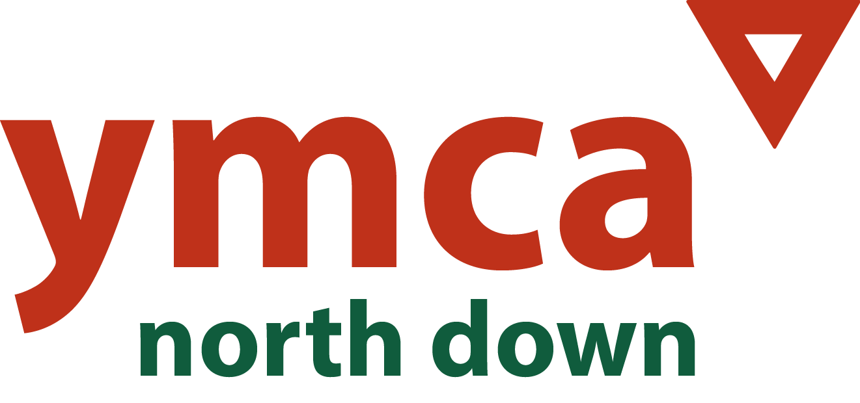

Dear Applicant

Thank you for expressing interest in the position of After School & Play Work Deputy Manager with North Down YMCA. We are seeking to fill a 37.5hr permanent position (Reference Number DPWM 001/25) to assist with the leadership and management of our After School Services and Play Work. The role of Deputy Play Work Manager is a key position within the Team and we are looking for motivated, skilled, experienced and committed candidate.

In advertising position we need to be attentive to the legislative and good practice requirements placed upon us as an employer. Therefore, there are a number of forms to be completed. You must complete the Application Form, Equal Opportunities Form and The Criminal Declaration Section within the application Form or your application will not be considered. The successful candidate will also be required to complete a Health Declaration and undertake vetting in accordance with required standards by Social Services & DE.

Please be very careful to follow the instructions that follow:

Please be careful to download all forms related to this post. **The application should be completed and return to Danielle Nixey North Down YMCA by the deadline of** **12 noon on the 20th January 2025 –** Danielle@northdownymca.org

Interviews are provisionally scheduled for the week commencing 27th January 2025.

The application pack consists of:

* Copy of the job description and Person Specification
* Copy of Application Form
* Declaration & Consent Form for Regulated Activity
* Equal opportunity monitoring form

North Down YMCA is committed to the implementation of its Equal Opportunities Policy in all aspects of its work, including the recruitment of staff and the delivery of service. The monitoring form is, separated from the other documents and processed by the monitoring officer. It is for monitoring purposes only and will not form any part of the short listing or selection process.

In completing your application please ensure you demonstrate how you meet the requirements of the position and the relevant experience.

If you require any further clarification please do not hesitate to contact me. Thank you for your interest in YMCA and wish you every success with your application.

Yours Sincerely

Danielle Nixey

ASC & Play Work Manager