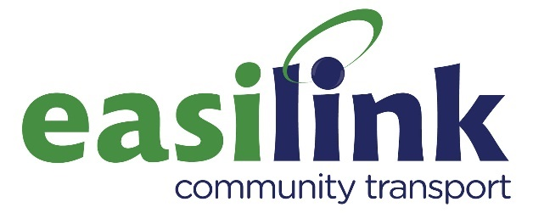

**JOB DESCRIPTION**

# JOB TITLE: Minibus Driver

**RESPONSIBLE TO:** Office Manager

**LOCATION:**  Omagh

**HOURS:** 35 hours per week

**CONTRACT:** Permanent (Subject to Funding)

**SALARY & OTHER BENEFITS:** £12 per hour

Easilink also offer our drivers the following benefits:

* CPC Training
* Time Off In Lieu (To Facilitate CPC Training)
* Medical Assessment & Access NI Disclosure costs for Licence Renewal
* Tachograph Card Fee
* Full Uniform
* Company Mobile Phone for Work Purposes

### **ROLE OF THE ORGANISATION**

Easilink provide a fully accessible transport option to rural dwellers (across the Omagh, Strabane and Foyle areas) who for many reasons have difficulty using or are unable to access public transport.

**PURPOSE OF THE POST:** To undertake driving duties and transport passengers for Easilink Community Transport.

**MAIN RESPONSIBILITIES:**

1. To drive Minibuses operated by Easilink Community Transport.
2. To assist passengers to and from the vehicle when necessary, including the operation of the vehicles in board passenger lift.
3. To input data onto our Drivers’ Mobile App.
4. To carry out daily walk around checks on the vehicles, recording and immediately reporting any irregularities/defects to the appropriate office staff member.
5. To immediately record and report details of any accidents, incidents and near misses, however minor, to the appropriate office staff member.
6. To maintain vehicle cleanliness, both internal and external, on a regular basis.
7. Refuel vehicle as and when required.
8. To be familiar with and maintain all safety equipment and medical supplies fitted to the vehicle and to carry out safety checks as directed.
9. To report any comments or complaints from passengers to the Manager and/or Schedulers.
10. To take part in training and to adhere to agreed quality standards such as the Minibus Driver Awareness Scheme (MiDAS).
11. To work within Easilink’s Health & Safety guidelines.
12. To undertake any other duties as deemed appropriate to the achievement of the purpose and function of this post.

## PERSONAL SPECIFICATION

**ESSENTIAL CRITERIA**

1. A current Category D or D1 PCV Driving License with Drivers CPC.
2. Be aged over 21 years and older (to comply with insurance requirements)
3. Be Flexible to work evenings and weekends if and when required.

**DESIRABLE CRITERIA**

* Previous experience of driving a minibus including using passenger lifts and safety equipment.
* Experience and / or understanding of dealing with people with disabilities.
* Good knowledge of the former Omagh District Council geographical area.
* Hold a valid MiDAS certificate.

**KNOWLEDGE, SKILLS AND PERSONAL QUALITIES**

* The ability to work on own initiative as well as part of a team.
* The ability to communicate effectively.
* Friendly, welcoming personality and a helpful and caring manner.
* Ability to maintain confidentiality.

**General Conditions of Appointment are –**

* Probationary period of 6 months.
* Compliance with Easilink’s Policies and Procedures.
* You will be based at Easilink Omagh; however you may be required to work at the organisation’s other depots and locations.
* To undertake training relevant to your role.
* Successful candidate will be required to undergo an Access NI Enhanced Check and Provide proof of entitlement to work in Northern Ireland.