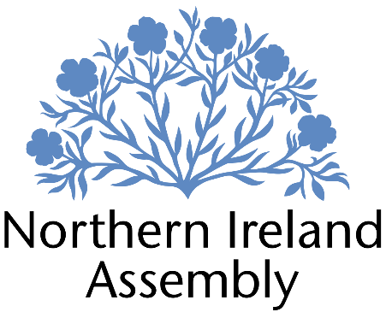

**Kate Nicholl MLA**

*Alliance Party Member of the Northern Ireland Assembly for Belfast South Constituency*

**POLICY AND COMMUNICATIONS MANAGER**

|  |  |
| --- | --- |
| Report to: | Kate Nicholl MLA |
| Office Location: | Primarily Parliament Buildings, Stormont but also, as required, at South Belfast Constituency Office |
| Hours: | 37 hours per week, Monday – Friday. |
| Holidays: | As per determination |
| Salary: | Grade 3 |
| Pension: | A central Assembly-approved pension scheme is provided. If enrolled an amount equivalent to 10% of employees salary will be paid into the pension scheme. |
| Duration: | Fixed Term whilst the member remains a MLA or until legislation is introduced to change Constituency expense provision. Six month probation period shall apply. |
| Closing Date | Noon, Wednesday 18 December 2024 |

# JOB DESCRIPTION

“Responsibility for full range of policy and research support to Kate Nicholl MLA preparing briefings, questions and speeches, monitoring business, developing Motions, Questions and Private Members Bills plus identifying and responding to media and press opportunities”

* Preparing and developing Assembly motions, Assembly Questions and Private Members Bills
* Monitoring business of the Assembly and Committees, and providing detailed prompt briefing for Kate Nicholl MLA
* Drafting speeches, questions and briefing papers for Kate Nicholl MLA
* Reviewing Assembly Committee papers, identifying issues and preparing range of suggested range questions
* Providing rapid, accurate and detailed research on a wide range of policy issues in support of Kate Nicholl MLA’s work
* Develop and deliver Communications Plan for Kate Nicholl MLA’s work
* Identifying and responding to media and press opportunities including replies to queries and the pro-active drafting of statements.
* Engaging and building relationships with various groups, representatives statutory organisations and Non-Governmental Organisations including attending meetings and conferences on behalf of Kate Nicholl
* Responding to correspondence and enquiries from constituents, the media, lobbyists and pressure groups
* Maintaining up to date knowledge or relevant legislation, policy and wider political and industry developments providing relevant regular briefings to Kate Nicholl MLA
* Planning and organising of events as required including physical and virtual
* Assisting the Casework and Constituency Officer with management and processing of standard constituent casework for Kate Nicholl MLA as required.
* Working with constituents directly on individual standard casework cases as required ensuring that casework is logged and dealt with sensitively and confidentially
* Ensuring efficient data and file management to comply with GDPR and data management.
* Attending work related training and networking meetings to develop skills.
* Other duties as required in support of the MLA carrying out their Assembly duties.

**PERSON SPECIFICATION**

|  |  |  |
| --- | --- | --- |
|  | **Essential Criteria** | **Desirable Criteria** |
| **Professional / Technical Qualifications** | * Five GCSE’s / O’ Levels or Equivalent at Grade C or above including both English Language and Mathematics * Third level qualification in Humanities, Social Sciences, Economics or Law * Excellent written skills (Grammar, punctuation and spelling) * Proficiency in the use of   Microsoft Outlook, Word and Excel packages | * 7 GCSEs at Grade C or above including Maths and English Language * Master’s degree in Humanities, Social Sciences, Economics or Law * Professional qualification in management and/or leadership |
| **Experience / Job Knowledge** | * Minimum of one years’ experience in a paid capacity undertaking policy research and analysis in the fields of either Education or Economy * Minimum of one years’ experience working in a paid or voluntary capacity in undertaking research in a political context * Minimum of one years’ experience working in a paid capacity in undertaking research in a political context * Minimum of one years’ experience working in a paid capacity in speech writing * Knowledge of the workings of the Northern Ireland Assembly * Knowledge of Northern Ireland political scene * Minimum of two years’ experience working in a Communications role in a paid capacity * Minimum of two years’ experience of working with the public in a paid capacity | * Minimum of one years’ experience in a paid capacity reading and interpreting financial statements * Knowledge of Northern Ireland Planning System * Experience of dealing with sensitive and confidential information (both verbal and written) in line with the Data Protection Actand GDPR * Ability to update and maintain a database * Experience of working in a small team |
| **Personal Qualities /**  **Skills** | * Good punctuality * Excellent verbal communication skills in person and on the phone * Excellent writing skills * Flexible approach to work duties * Understanding of Alliance Party objectives | * Time management * Ability to multi task |
| **Circumstances** | * Able to work unsupervised and as lone worker in office when required | * May be required to travel to meetings |

Applicants must demonstrate clearly on their application form how they meet the criteria.

December 2024