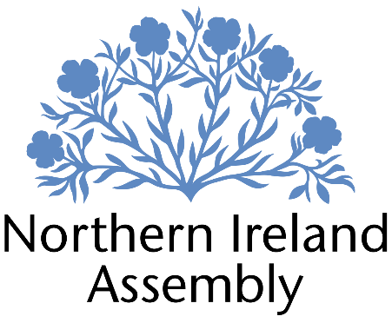

PAULA BRADSHAW MLA

Alliance Party Member of the Northern Ireland Assembly for the
South Belfast Constituency

Internship Placement

Support to: Paula Bradshaw MLA

Report to: Parliamentary Officer

Location: Room 45, Parliament Buildings, Stormont

Contract Type: Internship Placement from 1st January to 31st March 2025

Hours per week: 12 hours per week
Monday & Tuesday, 9AM to 3:30PM, inc. 30 minute lunch-break

Salary: £13.88 per hour

Holidays: 16 hours authorised allowance during this three-month period, plus bank/public holidays. However, flexibility can be shown.

Closing Date: Tuesday 17th December at 5PM

Interviews: Will be conducted via Zoom on Thursday 19th December.
JOB DESCRIPTION

This role requires an organised and hardworking person who will assist in the preparation for the business of the Northern Ireland Assembly for Paula Bradshaw MLA, supporting with preparation for Chamber contributions, Committee meetings, consultation on her Private Member’s Bill and engaging with relevant stakeholders.

Key roles and responsibilities:

- Working alongside the Parliamentary Officer to prepare for contributions in the Assembly Chamber, including Debates, Oral Questions and Ministerial Statements;

- Providing research support for Committee meeting preparation;

- Monitoring Assembly Question responses, with particular reference to The Executive Office – both Written and Oral;

- Responding to queries relating to the consultation process for the Private Member’s Bill survey;

- Creating social media posts to reflect work and contributions in the Chamber and at Committee; and,

- Attending/organising meetings and site visits, as appropriate, and keeping records of actions and key points.

PERSON SPECIFICATION

 | Essential Criteria | Desirable Criteria
Professional / Technical Qualifications | - Five GCSE’s / O’ Levels or Equivalent at Grade C or above including both English Language and Mathematics  - Proficiency in the use of  Microsoft Outlook, Word and Excel packages | - A-level qualifications or equivalent  - Undergraduate qualification in Equality / Human Rights  - Experience of creating content for social media
Experience / Job Knowledge | - Experience working with the public in a paid or voluntary capacity  - Able to demonstrate knowledge of the Northern Ireland political system | - Experience working with online database system  - Experience of working in a team  - Ability to respond to a variety of differing and wide ranging queries
Personal Qualities /  Skills | - Good punctuality  - Excellent verbal communication skills in person and on the phone  - Excellent written skills (grammar, punctuation and spelling)  - Flexible, innovative and enthusiastic approach to work duties  - Time management  - Understanding of Alliance Party aims and objectives | - Experience of working with confidential information  - Able to exercise duties with empathy and compassion  - Ability to multi-task and prioritise workload
Circumstances | - Available for immediate start  - Flexibility to provide lone working, when required

