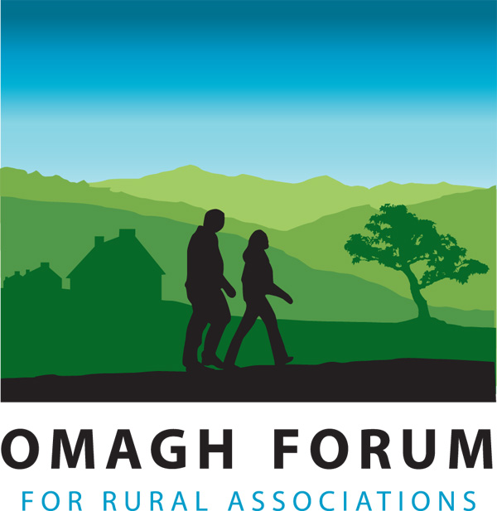
OMAGH FORUM FOR RURAL ASSOCATIONS

Monitoring Questionnaire

We are an Equal Opportunities employer. We do not discriminate on grounds of religious belief or political opinion. We practice equality of opportunity in employment and select the best person for the job. To demonstrate our commitment to equality of opportunity in employment, we need to monitor the community background of our employees, as required by the Fair Employment (NI) Order 1998.

1. Perceived Religious Affiliation

I am a member of the Protestant community □

I am a member of the Roman Catholic community □

I am a member of neither the Protestant nor Roman Catholic community □

2. Gender

Please indicate whether you are: Female □ Male □

3. Marital Status

Please indicate whether you are: Married □ Single □ Other □

4. Disability

In line with the Disability Discrimination Act 1995, a disability is defined as “a physical or mental impairment which has a substantial and long term adverse effect on your ability to carry out normal day to day activities”

Having read this definition, do you consider yourself to have a disability? Yes □ No □

5. Age Band

16 – 20 21 – 30 31 – 40 41 – 50 51 – 60 61 – 65 65+

6. Cultural/Ethnic Origin

Chinese □ Traveller □ Indian □
Pakistani □ White □ Black/African-Caribbean □

Other (please specify) _______________________________________________

7. Do you have dependants, or caring responsibilities for family members or other persons?
A child or children: □
A disabled person or persons: □
An elderly person or persons: □

