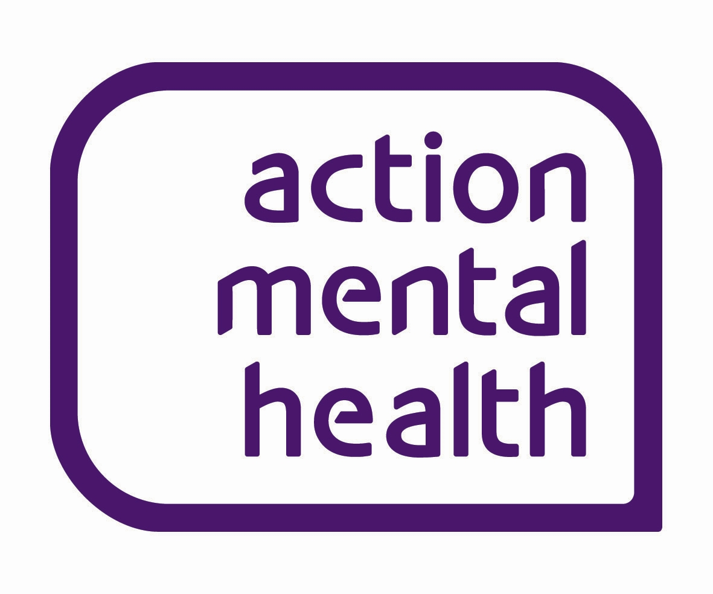

Job Description

Digital Marketing Specialist

Location: Action Mental Health Central Office, Ards

Responsible to: Communications Manager

Accountable to: Head of Communications & Fundraising

Responsible for: Supporting the Communications Manager in raising the profile of Action Mental Health.

Role: As a Digital Marketing Specialist, you will be responsible for all digital marketing activity, aiming to raise the profile of Action Mental Health and its core services. The post holder will provide marketing support to Action Mental Health’s operations and business support teams.

Key Result Areas:

- Digital Marketing

- Content Development

- Administration

- Personal Training, Development and Practice

Key Result Area 1: Digital Marketing

- To contribute to the communications strategy as part of the overall organisational strategy and operational plan.
- Support the development of Action Mental Health’s digital media presence by planning campaigns, scheduling content and monitoring activity on an ongoing basis.
- Support in the development and implementation of the organisation’s CRM system (Salesforce) for digital marketing purposes, in partnership with IT and other internal teams, administer audience contact lists, workflows, review results and integration with the organisation’s website.
- Develop email marketing campaigns and grow audiences organically, maintaining a good relationship with existing audiences and prospects through Salesforce and Marketing Cloud Account Engagement (formerly Pardot).
- Development and implementation of digital marketing campaigns using tools such as Google Ads & Facebook Ads, demonstrating a creative approach to content creation.
- Maintenance, editing and production of content for the organisation’s websites (currently built on WordPress). Contribute to any future developments in this area.
- Measure performance across all digital marketing activity using a variety of web analytics tools such as Google Analytics and social media analytics tools and report to Communications Manager regularly.
- Analyse new and emerging social or digital platforms and their potential to support organisational goals.
- Conduct regular digital benchmarking and identify sector trends to help inform new strategies.
- Contribute to organisation’s SEO and PPC initiatives.
- Management of suppliers to support marketing requirements.

Key Result Area 2: Content Development
- To work with the Communications Manager and internal teams to produce engaging multi-media content, such as blogs, videos, newsletters, podcasts, news articles and landing pages about Action Mental Health’s activities and impact for use on both internal and external communications and to meet funder requirements.
- To proactively collect stories from clients, resources and interviews from all sources including online, social and print media, for use by Action Mental Health in marketing activities.
- To monitor, review and proactively disseminate information relating to coverage of the organisation online.
- Provide regular reports, follow latest trends and make recommendations to help improve the organisations digital profile.

Key Result Area 3: Administration

- Support the maintenance and development of the organisation’s CRM system.
- Prepare written reports, and maintain and update files as required.
- Ensure that the records and statistical information relating to communications work is maintained in an accurate and timely manner, in accordance with the organisation’s requirements.
- To ensure regular and efficient financial administration and reporting on department’s budget, including processing of expenses, invoices and timesheets. Distribute tender documents and manage feedback.
- Ensure all information is maintained and marketing activity is completed in line with both relevant legislation and funder requirements.
- Work in accordance with Action Mental Health’s policies and procedures, including Financial and Health and Safety.

Key Result Area 4: Personal Training, Development and Practice

- To take part in the performance management process and training as identified through Action Mental Health’s Staff Learning and Development Processes
- To take personal responsibility for continuing personal and professional development and maintain a current continuing professional development portfolio.
- To adhere to Action Mental Health’s set of Core Values and Corporate Behaviours

In addition to the above duties the post holder with be expected to be flexible in discharging these duties and any other additional tasks as may be reasonably assigned according to the changing priorities of the organisation.

DIGITAL MARKETING SPECIALIST
PERSONNEL SPECIFICATION

REF | AREA |  |  | ESSENTIAL  ✓ | DESIRABLE  ✓
1 | EDUCATION/ PROFESSIONAL QUALIFICATIONS
 | GCSE Maths and English grades A*-C, or RQF equivalent |  |  | ✓
 | RQF level 4 or equivalent in a relevant subject |  |  | ✓
 | Membership of CIPR or CIM |  |  |  | ✓
2 | EXPERIENCE
 | Experience in working in a Digital Marketing, Communications or other relevant role. |  |  | ✓
 | Proven writing skills for a variety of media and diverse audiences. |  |  | ✓
 | Ability to use IT including Microsoft Word, Outlook and Excel. |  |  | ✓
 | Ability to use the Adobe Creative Suite, Canva or similar package. |  |  | ✓
 | Experience in developing and scheduling digital content. |  |  | ✓
 | Experience of creating and sending segmented email campaigns. |  |  | ✓
 | Experience in the use of CRM platforms for communications purposes. |  |  | ✓
 | Experience in the use of WordPress or similar content management systems. |  |  |  | ✓
 | Experience in reporting on digital analytics. |  |  |  | ✓
 | Experience of SEO or PPC activities. |  |  |  | ✓
 | Experience of working in the voluntary sector. |  |  |  | ✓
3 | SKILLS & QUALITIES
 | Ability to work well with immediate team and other staff and volunteers of the organisation. |  |  | ✓
 | Able to work well under pressure, organised, able to balance priorities and workload to achieve deadlines. |  |  | ✓
 | Ability to network and develop effective relationships with a wide range of contacts. |  |  | ✓
 | Self-motivated and able to work well both as an individual and as part of a team. |  |  | ✓
 | Imaginative and creative. |  |  | ✓
 | Confident and solutions focused. |  |  | ✓
4 | VALUES & BEHAVIOURS
 | Ability to demonstrate alignment with Action Mental Health’s core values and organisational behaviours. |  |  | ✓
5 |  | ADDITIONAL
 |  | A full current driving licence and access to a car is essential. Consideration will be given to alternative travelling proposals in respect of applicants with a disability who cannot hold a licence | ✓
 |  | The successful candidate will be required to undergo a check via the Access(NI) Service before commencement of employment | ✓
 |  | Able to work flexible hours i.e. evenings and weekends if required | ✓
6 |  | SALARY SCALE
 |  | Salary scale £31,130.14-£32,846.08 per annum based on 35 hours per week. Candidates will normally be appointed at the start of the pay scale
7 |  | HOURS OF WORK
35 hours per week: Mon-Thurs 9.00am-5pm, Fri 9.00am-4.00pm
Occasional evening and/or weekend work required within total 35 hours of work.
* AMH’s Core Values and Behaviours can be found in Employee Benefits booklet.

Please note that shortlisting for the post will be based on the above criteria.

