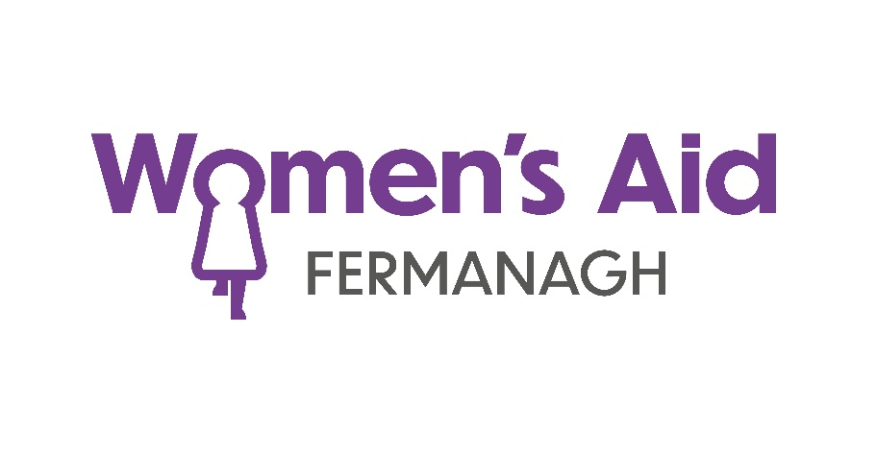

Trustee Information Pack
For a Role on the

Board of Directors
Foreword from our CHAIR

Dear Applicant,
Thank you for expressing your interest in joining the Board of Directors at FWA, an organisation working to improve the lives of women and children living with domestic abuse. We are currently seeking passionate and skilled individuals to guide our organisation as we continue to serve our community and make a meaningful impact.
Becoming a Trustee offers a unique opportunity to:
- Make a Difference: You will have a hand in shaping the future of our organisation, that will make a positive impact on the women and children we support.
- Develop Skills and Experience: You can gain valuable experience in governance, strategic planning, financial management, and leadership. You will enhance your understanding of the charity sector and build skills that can enrich your life.
- Give Back to the Community: Volunteering your time as a Trustee is a meaningful way to give back. Your contributions will help ensure the sustainability and success of FWA for the long term.
Why We Need You…
We are looking for individuals who share our passion for fulfilling Women’s Aid vision for the 21st century to eradicate domestic abuse and bring a range of skills and experiences to help us grow. Whether you have expertise in strategic planning, finance, governance, legal matters, fundraising, have lived experience of domestic abuse, or simply a deep commitment to the cause, we believe you can make a valuable contribution.
Please complete this application and return to sinead@fermanaghwomensaid.com, or feel free to reach out for an informal chat about the role on 028 6632 8898. Upon receipt of your application, we would welcome the chance to meet with you and have a chat about the experiences and skills you can bring to the Board. Thank you for considering this opportunity, and I look forward to hearing from you.
Kind regards,
Angela
Angela McKinney
Chair
___________________________________________________________________________________
Charity No. NIC106084 Registered Company No. NI032846
Address: 19 Darling Street, Enniskillen, Co. Fermanagh, BT74 7DP
Telephone: 028 6632 8898
Website: www.fermanaghwomensaid.com
Women’s Aid Vision and Mission
Our Vision
Our vision for the 21st century is the elimination of domestic abuse.
Our Mission
Women’s Aid exists to challenge attitudes, structures and systems which perpetuate domestic abuse. We seek through our work to enable women, children and young people to live free from violence and abuse. Our mission is to:
• To provide safety and support for women and children who experience domestic abuse.
• To work for and with women and children to ensure their voices are heard and their needs are met.
• To challenge attitudes and beliefs that perpetuate domestic abuse as a form of violence against women.
Our Core Aims
• Engage with women, children and young people, to give them a voice and ensure they inform all aspects of service development and delivery.
• Provide trauma informed specialised services to women, children and young people who have experienced domestic abuse.
• Deliver preventative education programmes in schools and community settings to promote healthy non-abusive relationships and share key safeguarding messages.
• Educate and inform the public, private, voluntary, statutory and community sectors of the context and impact of domestic abuse.
• Monitor, influence and respond to government policy and legislation as a Subject Matter Expert, giving a voice to survivors of domestic abuse.
• Work in partnership, sharing our expertise with all relevant agencies to ensure a joined-up response to domestic abuse
Our Principles
Survivor engagement: Women, children and young people are at the heart of everything we do and we will ensure our work is informed by their voices and experience.
Collaboration: We will work collectively and collaboratively as a Women’s Aid movement, to bring about positive change.
Empowerment: We will encourage women, children and young people to access support which will develop their inherent strengths, helping them to make safe positive choices and determine their own futures.
Equity, diversity and inclusion: We are committed to equity, diversity, and inclusion and will challenge all forms of discrimination.
Trauma informed practice and quality standards: We are committed to quality standards, trauma informed practice, and continuous improvement.
Working with others to influence change: We recognise domestic abuse requires a coordinated response and we are fully committed to working across society, with all individuals and organisations, to end domestic abuse.

Background to the Organisation
Fermanagh Women’s Aid is affiliated with, but as an autonomous entity, to our umbrella organisation Women’s Aid Federation Northern Ireland (WAFNI),and is one of eight Women’s Aid groups in Northern Ireland.
We have been supporting women and children in Co. Fermanagh since 1993 having grown from a small group to 13 dedicated and expert staff with over 20 years of experience, providing a trauma informed environment, that is nurturing and supportive for women and children living with domestic abuse.
Our aim is to work for and with women and children through person centered care, holding a space for them, ensuring that their voices are heard, and needs are addressed. We challenge the attitudes and beliefs that perpetuate domestic abuse as a form of violence against women and children.
Our Domestic Violence Response Team (Adult) provides community-based crisis intervention, guidance, practical and emotional support to women (ages 18+). Support is tailored around meeting their needs: safety planning, risk management, housing, wellbeing, finances, reducing isolation and gaining insights into domestic abuse.
Our Refuge accommodation is an integral part of the service we provide, for women and their children who need to flee their home in an emergency or who are at increased risk of homelessness. It has long been acknowledged that Refuge is a safe and comfortable space for women and children to gain specialist support in order to prevent future abuse and homelessness.
Our Children’s and Young People’s Services provide community-based early intervention support, information and guidance to children and young People (aged 5 – 18) who experience domestic abuse within the home or their own relationships. We deliver person centred support with tailored interventions: Helping Hands, Heading for Healthy Relationships, U Programme and When Mum and Dad Separate.
Our dedicated volunteers engage in Court Support and Administration Support to enhance the service we deliver.

Role Description
Overview:
As a Trustee with FWA, you will play a crucial role in the governance and strategic direction of the organisation. You will work collaboratively with fellow Trustees, our CEO and Finance Manager to oversee the organisation's activities, ensure financial sustainability, and support its mission and values.
The role is a voluntary position, requiring commitment and vision to contribute towards the organisation's success.
Key Responsibilities:
1. Strategic Leadership:
- To contribute to the development and approval of the organisation’s long-term strategic goals and objectives, to guide the direction of the organisation.
- Ensure that the organisation’s mission, vision, and values are upheld in all decisions and actions.
2. Governance:
- Provide oversight to ensure that the organisation operates in compliance with its governing documents, legal obligations, and regulatory requirements.
- Ensure that appropriate policies and procedures are in place for effective governance and risk management.
- Monitor and evaluate the organisation's performance in achieving its strategic goals and objectives.
3. Financial Oversight:
- Review and approve the organisation’s budget, financial statements, and reports to ensure financial sustainability.
- Work with the Finance Manager to monitor the financial health of the organisation.
- Ensure that resources are managed responsibly and that financial risks are effectively mitigated.
4. Collaboration and Support:
- Work collaboratively with the Chair, other Trustees, CEO and Finance Manager to achieve the organisation’s objectives.
- Provide support and guidance to the Senior Management Team, offering expertise and constructive feedback where necessary.
- Participate actively in Board meetings and sub-committees, where required, contributing to a positive and inclusive Board culture.

5. Risk Management:
- Help identify, assess, and manage risks that may impact the organisation’s operations and success.
- Ensure that proper risk management strategies are in place, including safeguarding the organisation’s assets and reputation.
6. Performance Monitoring:
- Evaluate the performance of the organisation against agreed objectives, ensuring continuous improvement and impact.
- Provide input into the performance management of the CEO, ensuring strong and effective leadership.

Person Specification
- Commitment to FWA’s Mission: Passionate about the work of the organisation and committed to advancing its mission and values.
- Strategic Thinking: Able to contribute to the development and implementation of long-term strategies for the organisation’s growth and impact.
- Governance Experience: Understanding of good governance practices, with experience serving on a Board or in senior leadership roles (preferred, but not essential).
- Financial Experience: Comfortable reviewing financial reports, budgets, and understanding financial responsibilities (support from Finance Manager provided).
- Communication and Advocacy: Strong communication skills, and able to advocate on behalf of the organisation.
- Collaboration and Teamwork: Willingness to work as part of a team, contributing constructively to discussions and decision-making.

Term & Commitment:
Term Length: Typically, Trustees serve terms of three years, with the option for re-election for up to 3 terms.
Time Commitment: Approximately 10 - 11 meetings per year, including Board meetings, sub-committee meeting and AGM.
Voluntary Position: This is a voluntary, unpaid role, although reasonable expenses incurred in the course of duties will be reimbursed.
As a Board Member, you will be part of a committed and dynamic team, ensuring the ongoing success and sustainability of the organisation while championing its mission and the communities it serves.

Personal Details
Name:
Address:
Telephone Number:
Mobile Number:
Email Address:

Current Employment Status
Employed |  | Unemployed |  | Student |  | Retired |  | Other (please specify below)
Further comments:

Knowledge, Experience and Skills
Please tell us how your knowledge, experience, and skills (paid or unpaid) would add value to our Board, in any of the following areas:
- Legal Expertise
- Human Resources
- Previous Board Experience (Governance)
- Strategic Planning
- Finance & Fundraising
- Community Engagement and Community Based Support

(Please continue on a separate sheet if necessary)
Why would you like to join the Board of Fermanagh Women’s Aid?

Do you have a direct relationship with any current Trustee, staff member or volunteer at Fermanagh Women’s Aid. If yes, please give details

Have you previously availed of Women’s Aid services or experienced domestic violence? You must not have availed of Women’s Aid services in the last two years and/or, you must have ended a Domestic Violence relationship over 2 years ago

Yes |  | No

References
Please list two Referees, who are familiar with your character, skills and experience. The referee will only be contacted once you have been offered a place on the Board of Directors. Please include your current or last employer if applicable.

 | Referee 1 | Referee 2
Name:

Capacity in which they are known to you:
Organisation:

Address:

Telephone:

Email Address:

All information provided by applicants will be used solely for the purposes for which it is required in this recruitment process and will not be disclosed to others except where we are obliged to do so in accordance with the provisions of the organisation’s Data Protection Policy.

The information given on this form is correct and complete. If successful I agree to abide by the ethos and practice of Fermanagh Women’s Aid.

Signature: ________________________________
Date: ________________________________

FERMANAGH WOMEN’S AID
MONITORING FORM

We are an Equal Opportunities Employer. We do not discriminate on grounds of religious belief or political opinion. We practice equality of opportunity in employment and select the best person for the job. To demonstrate our commitment to equality of opportunity we need to monitor the community background of our applicants and employees, as required by the Fair Employment and treatment (NI) Order 1988. Regardless of the number of times you have completed a questionnaire as a previous applicant, an equal opportunities questionnaire must be completed, in, full, with each application.

TICK BOXES AS APPROPRIATE

1. | GENDER |  |  |  |  |  | FEMALE
2. | DATE OF BIRTH
3. | DISABILITY (Please tick)
Do you consider yourself to have a disability? |  |  |  |  |  |  | YES |  |  | NO
If YES, please indicate the nature of your disability by ticking the appropriate box (es)
Mobility |  |  |  |  | Hearing
Speech |  |  |  |  | Dexterity / Co-ordination
Psychiatric / Mental |  |  |  |  | Learning
Vision |  |  |  |  | Other (please specify below)
Other :
Do any of the disabilities or conditions listed have a substantial and long-term adverse effect on your ability to carry out normal day-to-day activities? |  |  |  |  |  |  | YES |  |  | NO
4. | RACE / ETHNIC ORIGIN
Which of the following groups do you consider you belong to?
White |  |  | Indian |  |  |  |  | Pakistani
Chinese |  |  | Black African |  |  |  |  | Bangladeshi
Irish Traveller |  |  | Black Caribbean |  |  |  |  | Mixed Ethnic
Other (please specify) |  |  | Other :
5. | FAIR EMPLOYMENT MONITORING INFORMATION (Please Tick)
I belong to the Protestant Community
I belong to the Roman Catholic Community
I belong to neither the Protestant nor the Roman Catholic Community

NB. This questionnaire should be returned with the application form and will not be accessible to the assessment panel.
THANK YOU FOR YOUR CO-OPERATION.

