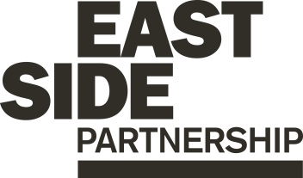 

**Job Description ESP/CPO25**

Project: EastSide Tourism

Job Title: Creative Programme Officer (Templemore Baths)

Location: Templemore Baths, 96 Templemore Avenue, Belfast

Reports to: EastSide Tourism Manager

**Terms and conditions**

**Salary:**

Starting on NJC Point 19, on a scale of points 19–25, currently £31,067 to £35,235 + 7.5% pension

**Contract:** This is a permanent position subject to future funding.

*Job subject to 6 month probation period.*

**Holidays:** 25 days per year plus statutory holidays.

**Hours of work:** 37.5 hours per week. This role will require some flexible working to accommodate community and visitor engagement during evenings and weekends.

*EastSide Partnership is only able to accept applications from those individuals who are currently eligible to work in the UK. We will only interview those applicants who appear, from the information provided, to be the most suitable in terms of the person specification.*

The following gives an indication of the current main duties and responsibilities of the post. The post holder will be expected to work flexibly and carry out any other duties appropriate to the role which may reasonably be required from time to time.

**Main Purpose of Job**

The main purpose of this role is to:

1. Lead on supervising and motivating the onsite activity of casual staff, tour guides and volunteers.

2. Animate the heritage space in Templemore Baths through a programme of leading tours, tour development, workshops and events that will engage the local community, schools and visitors.

**Summary of responsibilities and personal duties**

1. Lead, design and deliver a series of engaging programmes and activities that encourage the local community, schools and visitors to visit Templemore Baths heritage space including;

* Heritage programmes for young people and adults.
* Curriculum-based programmes for school audiences.
* Self-guided tours using multi-media delivery.
* Development and delivery of talks and tours programmes.
* Ensuring a high quality standard of customer service.
* Ensuring that all delivered programmes comply with relevant legislation, health and safety requirements including risk assessment and current best practice.
* Undertaking administrative duties including collating programme information and managing budgets.

*2.* Monitor & evaluate programmes:

* Produce regular funder progress reports.
* Provide regular updates to EastSide Tourism Manager and GLL/BCC.
* Provide data on KPI’s to GLL & BCC as and when required.
* Report against objectives to ensure outcomes are being met.
* Ensure effective monitoring and evaluation is undertaken.

3. Manage Templemore Baths heritage and events space which will include:

* Cash handling, reconciliation and management.
* Management of online ticketing system.
* Ensuring the space is clean and well maintained.
* Manage a venue hire and room booking system ensuring the venue meets client needs, managing logistics and delivering a high standard of customer service.
* Ensure that the animation programme marketed to local and visitor audiences.

4. Lead, motivate and supervise a team of casual staff and volunteers:

* Provide management support to casual staff and volunteers.
* Develop casual staff rotas.
* Develop volunteer schedules and role descriptions.
* Induct staff/ volunteers to the Templemore Baths interpretive and events space.
* Provide support and supervision to staff and volunteers.
* Identify and implement training opportunities to build capacity and learning.

5. Engage with a wide range of stakeholders:

* Identify and manage relationships with relevant stakeholders such as schools, community groups and corporates.
* Work with other members of the EastSide Partnership team to promote heritage activity, events and the events space.
* Develop and maintain partnerships with other local heritage and tourism providers.
* Maintain positive relationships with Templemore Baths delivery partners; GLL, Belfast City Council and project funder National Lottery Heritage Fund.
* Deal with and investigate complaints and queries as they arise providing effective customer service and providing solutions where appropriate.

6. Other general responsibilities:

* Manage relevant and appropriate resources and equipment.
* Act in accordance with EastSide Partnership’s policies and procedures.
* Undertake such other relevant duties as may from time to time be required.

**Person Specification ESP/CPO25**

|  |  |  |
| --- | --- | --- |
|  | **Essential** | **Desirable** |
| **Experience** | - A minimum of 2 years’ experience in:   * Creative programming and managing programmes/ events/ activities * Communicating and engaging effectively with a diverse range of people and stakeholders * Managing volunteers/staff * Experience of managing budgets * Reporting and administration | - Experience of:   * Co-design and partnership working * Working in a heritage or tourism attraction * Audience development and marketing |
| **Attainments/ Education** | - Degree (or equivalent qualification) in a relevant subject e.g. History/Public History, Cultural Heritage, Museum Studies, Tourism, Event Management etc.  **OR**  -A minimum of 3 years’ employment experience in a similar role related to heritage activity, community engagement, programme delivery | - Experience in informal education approaches e.g. Youth Work, Education, Community Development, Cultural Regeneration |
| **Skills** | - Ability to establish and maintain excellent working relationships and partnerships with a broad range of stakeholders, individuals and organisations  - Ability to be creative, innovative and work on own initiative  - Effective organisation skills with the ability to manage and prioritise workload and meet deadlines  - Excellent interpersonal and communication skills including good presentation skills  - Excellent IT skills including Excel, PowerPoint and Word  - Excellent record keeping and reporting | - Ability to design and deliver educational workshops connected to the NI Curriculum. |
| **Knowledge & Values** | - Knowledge of EastSide Tourism and EastSide Partnership  - Commitment to regeneration and a partnership approach |  |
| **Circumstances** | - Willingness to work flexible hours including evenings and weekends  - Willing and able to travel across Belfast for work purposes |  |

**Background Information**



**EastSide Partnership** is a local charity leading the regeneration of east Belfast. Working alongside other community-based organisations, elected representatives, statutory agencies and local businesses, EastSide Partnership delivers a wide variety of projects with a clear mission to create ‘A Thriving, Connected and Welcoming east Belfast’.

We believe our mission is to improve the lives of people across east Belfast and this means working on a range of projects;

* Helping local people to have a say in what happens in their lives and in their local area.
* Supporting people who are most in need to improve their life chances and take opportunities.
* Encouraging everyone in east Belfast to enjoy green space and culture.
* Celebrating the diverse cultures of east Belfast.
* Welcoming new people to visit and live in the area

We were formed in 1995 and founded in 1996. Our work is governed by a parent board through a Chief Executive and a core central team providing shared service support to the following projects:

* **EastSide Arts** - whose aim is to create an east Belfast where the arts are valued, creativity is for everyone, and people are connected with each other and the wider world.
* **EastSide Greenways** - whose aim is to promote the sustainable development, management, improvement and use of open green  spaces and routes, parks and rivers for the benefit of the public.
* **EastSide Learning** – whose aim is to reduce educational underachievement and raise aspirations in east Belfast.  Supporting children, young people and their families to reach their potential, whatever their background.
* **EastSide Property** - whose aim is to contribute to the physical regeneration of east Belfast through the strategic acquisition, development and management of sites and properties.
* **EastSide Tourism** - whose aim is co-ordinate and deliver responsible, sustainable and impactful culture-led neighbourhood regeneration through tourism, putting east Belfast on the map for visitors.
* In addition, we deliver the Neighbourhood Renewal contract with the Department for Communities (DfC) by firstly ensuring that all of the above projects engage with the communities identified within the contract, as well as providing ongoing support to the Inner East & Tullycarnet Neighbourhood Renewal Partnerships.



**EastSide Tourism**, part of EastSide Partnership, aims to coordinate and deliver responsible, sustainable and impactful culture-led regeneration, pushing boundaries to put east Belfast on the map.

EastSide Tourism will fulfil our aim by:

* Positioning EastSide based on our collective strengths and in alignment with the strategic development of tourism in Belfast, Northern Ireland and island of Ireland.
* Empowering EastSide by investing in local people and local businesses to maximise our collective potential and proudly celebrate our rich cultural tapestry and modern-day personality.
* Creating Experiences unique to east Belfast, to enhance our city’s visitor offering and maximise the socio-economic impact of tourism on both people and place.
* Sustaining for the Future through a circular model of regenerative tourism development, adopting an entrepreneurial approach based on social economy principals and maximising partnerships both internally and externally.

**Templemore Baths Heritage Space**

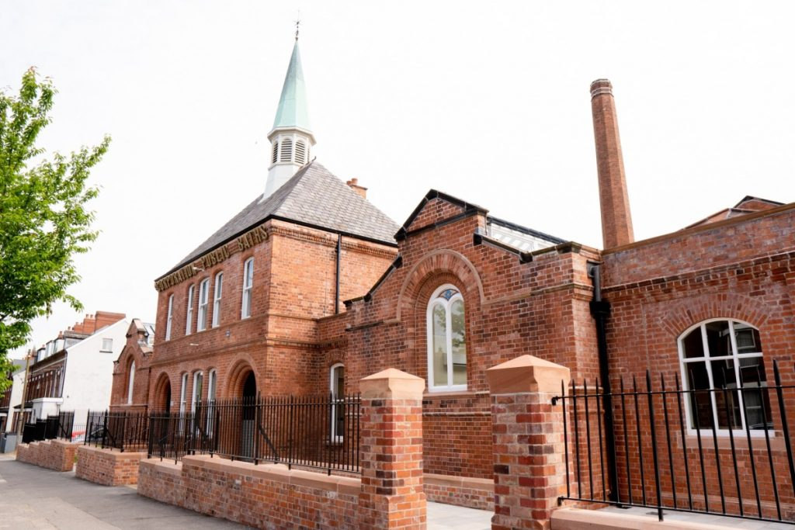

Templemore Baths Heritage Space opened in August 2023. It is a new visitor experience rooted in the Victorian era, bursting with Titanic and Belfast shipyard history. Located on Belfast’s Templemore Avenue, 1mile / 1.6km east of the city centre, Templemore Baths is the only Victorian bathhouse still functioning as a public swimming pool on the Island of Ireland. The Victorian features and ‘slipper baths’ along with the ‘minor pool’ form the core of the exhibition.

Original features have been lovingly restored including the ‘Major Pool’, which is fully operational as a swimming pool. The old slipper baths are part of the heritage exhibition and tour along with the ‘Minor Pool’ which is now an exhibition and event space. The former courtyard has been transformed into an attractive new atrium with a café – Courtyard Cafe at Templemore, offer scones, hot and cold drinks, lunch and snacks daily.

EastSide Tourism staff manage the heritage space in Templemore Baths. A programme of tours, workshops and events runs year-round. The local community, schools and visitors are all warmly welcomed. The restored ‘Minor Pool’ and old boardroom are both available to hire for events, meeting and conferences.

Belfast City Council invested £12 million in the restoration of this iconic building and £5 million was provided by The National Lottery Heritage Fund.

EastSide Tourism manage the heritage space on behalf of social enterprise leisure operator GLL (Better), and in partnership with Belfast City Council.

To find out more about EastSide Partnership/EastSide Tourism visit:

* Website- [www.eastsidepartnership.com](http://www.eastsidepartnership.com); wwwvisiteastside.com
* X - @EastSidePship
* Facebook- facebook.com/EastSidePship; facebook.com/VisitEastSide
* Instagram- EastSidePship