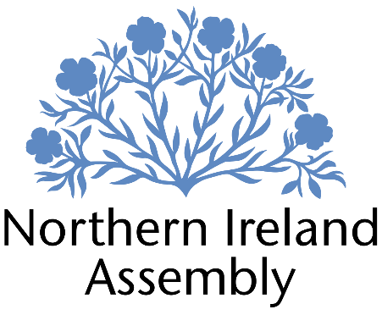

SIAN MULHOLLAND MLA
Alliance Party Member of the Northern Ireland Assembly for the North Antrim Constituency

COMMUNICATIONS AND OUTREACH OFFICER

Support to: Sian Mulholland MLA

Location: 12 Mill Street, Ballymena, BT43 5AE

Hours per week: 16 hours per week, Monday – Friday

Salary: Grade 1, Pay point 1, £25,667 pro rata

Contract Type: Permenant

Employment contingent upon member remaining an MLA or until legislation and / or new determination is introduced to change financial support available to members for support staff costs.

Six-month probation period shall apply.

Closing Date: Friday 24th January 2025 at 4pm

Interviews: It is anticipated that shortlisted candidates will be interviewed on Friday 31st January 2025
JOB DESCRIPTION

This role requires an innovative and creative person who will utilise various techniques and channels in order to improve communications between Sian Mulholland MLA, the constituents of North Antrim and other appropriate stakeholders.

Communications

Liaising with the MLA and other relevant staff members to ensure any websites, social media and other communication channels are updated to ensure the work of Sian Mulholland MLA is appropriately communicated to constituents and relevant stakeholders.
Regularly review Sian Mulholland MLA’s social media presence, providing a strategic plan on how to improve communications with and for constituents.

Create dynamic written, graphic and occasional video content. Take photographs to record Sian Mulholland MLA and constituency office in action for use in various communications whilst ensuring data protection and permissions are sought from any persons depicted or quoted.
Create content that promotes constituent interaction, increases constituent presence on Sian Mulholland MLA’s various platforms and encourages participation by constituents.
﻿﻿Identifying and responding pro-actively to constituency orientated media and press opportunities including replies to queries and the pro-active drafting of statements, ensuring regular press releases are sent to all local outlets.
﻿﻿Developing and maintaining relationships with local press outlets in the constituency and regularly updating them on the work of the MLA
To write, produce and distribute e-newsletters and other material to confirm the activities and work of Sian Mulholland MLA and the constituency office.

Outreach

Working with the Constituency Manager and Constituency Officer in developing an outreach programme for Sian Mulholland MLA and arranging meetings and visits as per outreach engagement programme

Maintaining a database of key stakeholders within the North Antrim constituency including local schools, businesses, community organisations, youth groups and others.

Coordination of constituency surgeries, townhall meetings and other appropriate outreach activities.
PERSON SPECIFICATION

 | Essential Criteria | Desirable Criteria
Professional / Technical Qualifications | - Five GCSE’s / O’ levels / Equivalent, including both English Language and Maths  - Experience of communicating with a diverse range of people via face to face, phone, and email  - Proficient in the use of  Microsoft packages (e.g. Word,  Excel, etc.)  - Experience of design and production of online communications including graphics and clip videos  - Experience of writing press releases and general communication pieces. | - Recognised professional qualification in Marketing or Social Media  - Previous experience of working in politics
Experience / Job Knowledge | - Minimum of one years’ experience working in a paid or voluntary capacity using digital technology skills relevant to the role  - Proven experience of content writing and proof reading  - Experience of developing and implementing a social media strategy  - Ability to set-up up and optimise social media platforms.  - Experience in graphic design for digital/social media platforms | - Experience of dealing with sensitive and confidential information (both verbal and written) in line with the Data Protection Act and GDPR  - Ability to update and maintain a database
Personal Qualities /  Skills | - Punctuality  - Excellent written skills (grammar, punctuation, and spelling)  - Ability to work with a diverse range people from different backgrounds, abilities and cultures with respect and empathy  - Ability to work with little supervision  - Flexible, innovative, and enthusiastic approach  - Understanding of Alliance Party objectives. | - Photography skills  - Ability to work as part of a small team
Circumstances | - Will be required to travel to meetings within the constituency  - May be required to travel to the NI Assembly on occasion | - Use of own transport or public transport for work

If you require the application form in a different format please contact Sian Mulholland MLA via email sian.mulholland@mla.niassembly.gov.uk

Completed applications can be sent to sian.mulholland@mla.niassembly.gov.uk and hard copies can be sent to:
Sian Mulholland MLA
North Antrim Constituency Office
12 Mill Street
Ballymena
BT43 5AE

Deadline for all applications: Friday 24th January at 4pm

We are committed to providing equality of opportunity in employment and welcome applications from all suitably qualified applicants irrespective of gender, marital or family status, religious belief, political opinion, disability, age, race, nationality or sexual orientation. Appointments will be based on merit.

