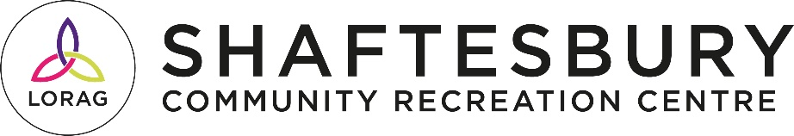

Lower Ormeau Residents Action Group

Background: LORAG (Lower Ormeau Residents Action Group) is a needs led community development organisation, founded in 1987 to support the residents and community of the Lower Ormeau. LORAG have managed Shaftesbury Community and Recreation Centre, a council owned facility since 2000, successfully growing the services delivered from the centre from 20 hours per week to 94 hours, sustaining 26 jobs, serving the needs of the community.
The Lower Ormeau Community Cohesion project was established in 2013 to assist and support the long-term indigenous and newcomer community with the various challenges faced as an Inner-City growing communities.
LORAG has successfully undertook the redevelopment of the John Murray Lockhouse as a Healthy Living Hub, Community Garden, Shed, Boat Store and River access point, at a cost of £2.8 million good relations / animating the towpath and river project. The project is currently under construction and set for completion in 2025.
The successful candidate will be to the forefront of nurturing good relations and community cohesion within the area.

Job Description

JOB TITLE: Community Outreach Cohesion Coordinator
BASED AT: Shaftesbury Community and Recreation Centre
RESPONSIBLE TO: Senior Youth and Community Development Worker

Salary: £33,366 - £35,235 per annum NJC SO1 pt 23
Contract: Initially for 12 months (subject to performance review)
Holidays: 25 days per year plus statutory holidays.
Hours of Work: 37 hours per week
Willingness to work flexible hours essential (with time off in lieu arrangements)

Purpose: The Project Outreach Cohesion Coordinator will be a member of Lower Ormeau Residents Action Group staff and will assist with the development, co-ordination and implementation of a good relation community cohesion project within the Botanic, Shaftesbury wards of South Belfast. S/he will play a significant role in shaping the policy and strategic direction of community cohesion work within Lower Ormeau and Botanic.
Range of Responsibilities: The role involves working in partnership with a wide range of people from within the voluntary/community, public and private sectors towards promoting community cohesion and cultural diversity, reducing racism and developing an inclusive society by:Offering support, development and co-ordination to existing and new race relations work with a focus on community cohesion, challenging racism and facilitating inter-cultural relationship building.
- Liaising with inter-cultural community groups to build cohesion and capacity and developing support for anti-racist practice including raising awareness within schools and working with children/youth/community workers to deliver learning and leadership programmes
- Mapping existing race relations work, identifying good practice and support mechanisms and compiling and promoting a handbook/toolkit of same, compiling statistics and producing reports
- Developing local frames/strategies
- Helping to articulate the needs and cultures of indigenous and minority ethnic groups to eliminate discrimination
- Dealing with conflict, racial harassment and attacks through established three local frameworks/strategies:
  - Emergency Responses
  - Housing
  - Engagement & Early Intervention
- Assisting with the devising and delivery of the LOB (Lower Ormeau and Botanic) Network Communication Strategy
- Bringing a race relations perspective in regard to the development of strategic planning and proposals, and supporting groups to access and deliver training to promote good race relations
- Organising conferences, seminars and workshops with groups to foster debate about race relations work and its development and practice in the community
- Representing LOB Network externally at certain public events, including seminars and conferences
- Reporting progress to the employer, Network and project Advisory Sub-Group
- Carrying out any reasonable duties required by LORAG.
Canvassing
Canvassing staff or Board members involved in the recruitment process directly or indirectly will result in disqualification.
Please note: the onus is on candidates to provide sufficient detailed information on their application forms in order to demonstrate how they meet each of the criteria outlined in the attached Person Specification. Failure to do so may result in a candidate not being shortlisted since Selection Panels cannot make assumptions in the absence of essential information.

Closing Date for application: Friday 24th January 2.00pm 2025

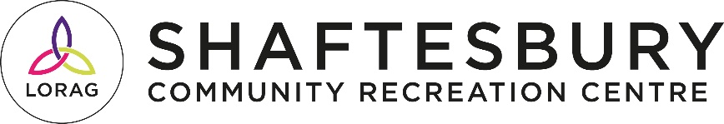

Community Cohesion Coordinator Job Spec

JOB TITLE: Community Outreach Cohesion Coordinator
BASED AT: Shaftesbury Community & Recreation Centre
RESPONSIBLE TO: Director of Service

 | Essential | Interview/Application
Qualifications
Hold a professional qualification in Community Development or Race Relations | Essential | Application
Experience
Minimum two years’ paid experience working within Community Development or Race Relations. | Essential | Application
Proven ability to project planning, managing funds and monitoring and evaluation projects | Essential | Application
Demonstrable experience and knowledge of policy in relation to integration and racial equality and an understanding of the NI context on cohesion. | Essential | Application/ Interview
Demonstrable experience of working with both indigenous and migrant communities | Essential | Application/ Interview
Demonstrable experience of with statutory, voluntary and community sector. | Essential | Application
Knowledge & Skills
Experience of liaising with inter-cultural community to build cohesion and capacity | Essential | Application/ Interview
Experience of mapping existing race relations work, identifying best practice and disseminating information to partners | Essential | Application/ Interview
Excellent written and verbal communication skills | Essential | Application/ Interview
Ability to build sustainable relationships with key stakeholders including young people and adults | Essential | Application
Excellent organisational and administrative skills | Essential | Application
Experienced in using Microsoft Word, Excel Outlook and PowerPoint to produce/reports/spreadsheets/presentations | Essential | Application
Personal Qualities
Strong commitment to partnership working | Essential | Application/ Interview
Leadership/ self-starter/ability to motivate others | Essential | Interview
Willingness to undertake training as and when required | Essential | Interview
Conscientious, flexible and reliable | Essential | Application

