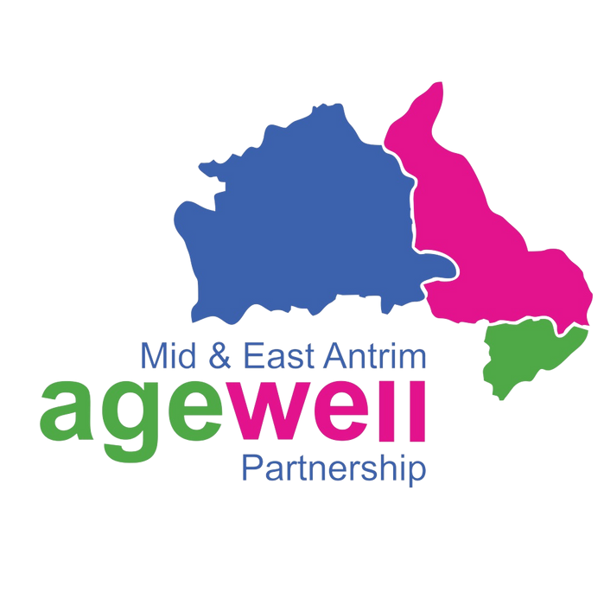

IMPACTAgewell®

**Officer**

Information for Applicants

**November 2024**

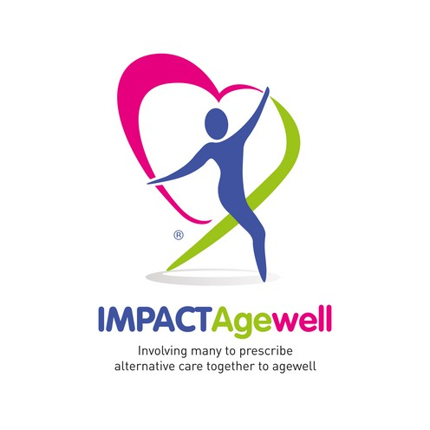Improving the lives of Older People living in the Ballymena, Larne & Carrickfergus areas.

**Contents**

About Agewell 3

Our Programmes 4

Our Work and Impact 5

Our Reward Statement 7

Job Description 8

Person Specification 10

The Recruitment Process 11

Privacy Notice 12

**Who are we?**

**Mid & East Antrim Agewell Partnership (Agewell)** is an inter-agency based partnership aimed at improving the lives of Older People aged 50 years and over, living in the areas of Ballymena, Larne & Carrickfergus.

Since its inception, the charity has grown in strength and now supports a membership of over 75 community groups as well as over 1800 individual Older People from all over Mid and East Antrim through a variety of health and wellbeing services and initiatives.

## Our Vision

**Agewell**’s vision is for “Mid & East Antrim to be a place where everyone can actively ‘agewell’ together, being involved, heard and valued”.

**Agewell** listen to Older People's lived experience to pursue opportunities that will improve health and wellbeing for the ageing population in our community now, and in the future.

### What is IMPACTAgewell® ?

**IMPACTAgewell®** is a innovative model of community led integrated care which uses an asset based community development approach based on the social determinants of health.

**IMPACTAgewell®** has grown from working with six GP Practices in 2017 to a partnership of 22 in 2024.

**IMPACTAgewell®** works with locality hub teams including General Practitioners, Community Pharmacy and Northern Health & Social Care Trust Staff to provide empathetic and sensitive emotional support to older people with long term health conditions via a personalised health and wellbeing action plan when appropriate. We will connect them to internal and external services, supporting independence and improving quality of life.

### Looking Towards the Future

As we continue to expand our services across the Mid & East Antrim area, we are looking for talented and passionate individuals to join our team. We are delighted to present this pack, and now invite applicants to apply for the following position:

**IMPACTAgewell®** **Officer.**

# Our Programmes

**Agewell** run a range of projects including;

**Ageing Well Services -** We work in partnership with Mid & East Antrim Borough Council (MEABC) Community Planning Partnership to support the delivery of the ‘Good Morning’ telephone befriending service in each of the areas, as well an Older Person's Handyman service for small home repairs.

### IMPACTAgewell®,

IMPACTAgewell ® is our innovative, community led, social prescribing programme which has been developed and delivered by a wide range of healthcare practitioners including GPs, Community Pharmacists, Social Work teams and Commissioners, thanks to funding from The Dunhill Medical Trust and The Health & Social Care Board.

### Connect North

We partner with Age NI to deliver the Connect North Service for Mid and East Antrim which is funded by the Northern Health & Social Care Trust. Connect North is a holistic Social Prescribing service for the Northern Trust area which aims to support adults aged 18 years and above and living in or registered with a GP in the NHSCT area who are experiencing social, emotional or practical issues which are affecting their health & wellbeing and require assistance from a Link Worker to determine appropriate supportive services.

### Health and Wellbeing Projects

Agewell also run a variety of small but vital projects relating to the health and wellbeing of Older People in our area. These have included; ‘Healthy Steps to Ageing’ – a Building Community Pharmacy Project designed to support Older People identified as needing support and more recently, in light of the COVID-19 pandemic, we have developed projects which will help Older People gain access and connect to the digital world.

### Community Engagement and Support

As a charity we work extensively with local statutory and voluntary partners in community support. Since the start of the COVID-19 pandemic, work in this area has expanded to include emergency response helplines for those shielding, the co-ordination of volunteers for essential grocery and prescription delivery, meal deliveries to vulnerable people and friendship groups for older people living in their own homes as well as online intergenerational activities for local care home residents.



## IMPACTAgewell Vision

Our vision is to improve the quality of life for older people, now and in the future, by providing them with person-centred services that will put their wellbeing and social needs on a par with their medical needs.

## IMPACTAgewell Aims:

***"Involving many to prescribe alternative care together."***

The aims of IMPACTAgewell® are to:

* Put older people at the heart of what happens.
* Improve health & wellbeing outcomes that matter most to the older person.
* Build knowledge & diversity within health & social care support.
* Develop and sustain integrated, valued & safe partnerships.
* Reduce cost of health & social care support.

### 22 Partnerships 2000 Plus Referrals

**Delivered in Larne,**



**Ballymena and Carrickfergus**

**Evidence Based Join the dots**

**Encouraging work life balance**

37 days paid annual leave (including bank holidays), pro-rata for part-time Increased annual leave entitlement, based on length of employment Smart working options (with the opportunity to work remotely)

Flexible working options

**Caring for you and your family**

* Generous sick pay entitlement
* Opportunity to accrue Time off in Lieu
* Benenden Health cash plan to help offset the cost of health care for you and your family
* Enhanced leave for new parents
* Free access to a confidential independent counselling service
* Additional Mental Health Leave Days
* Special leave options (such as up to 3 days paid leave for domestic or personal emergencies a year)
* New family-friendly benefits, including paid leave: In the event of miscarriage or still birth, to support fertility treatments or adoption process for antenatal appointments for both parents
* Company Maternity and Adoption Pay
* Shared Parental Leave Policy

**Thinking about your finances**

* Auto Enrolment in our Workplace pension with Employer contributions at 3%
* Business Expenses and Mileage

**Enriching your life at work**

* Personalised development plans with a wide range of training courses and opportunities to source additional training options
* New, modern offices that embrace working together both in-person and remotely
* Various opportunities to influence how we internally operate (including surveys, and focus groups)
* Active and supportive internal employee networks for collaboration and peer support
* Two days paid leave a year to volunteer for other local charitable causes

|  |  |
| --- | --- |
| **Job Title** | IMPACTAgewell® Officer |
| **Location** | Broughshane House, 70 Main Street, Broughshane |
| **Hours** | 35 Hours |
| **Salary** | £24,496 |
| **Responsible to** | Executive Director for Health |
| **Annual Leave** | 25 days (plus 12 statutory days) per year Pro Rata |
|  |  |

**Job Purpose**

The IMPACTAgewell® Officers work with IMPACTAgewell® locality hub teams which include General Practitioners, Community Pharmacy and Northern Health & Social Care Trust Staff to provide empathetic and sensitive emotional support to older people with long term health conditions via a personalised health and wellbeing action plan. When appropriate, connect them to internal and external services supporting independence and improving quality of life.

**Key Accountabilities and Responsibilities**

1. To manage a caseload of service users from associated GP surgeries.
2. To visit the service user in their own home and support them in developing a personalised health and wellbeing plans based on the Social Determinants of Health.
3. Ability to hold difficult and emotional conversations with older people experiencing life changes.
4. To connect service users to relevant support networks and community partnerships.
5. To liaise with all the multi-disciplinary members of the IMPACTAgewell® Locality Hub to generate

referrals, manager service user’s cases and to work closely with all members to establish effective working relationships.

1. To chair the IMPACTAgewell® Locality bi-monthly hub meetings with partners attending.
2. To construct and keep case files and databases up to date and be able to provide monitoring information as requested by the Team Leader.
3. To positively promote the service and promote the strategic growth to the public external agencies, community partners, statutory bodies and regional and national conferences through networking and presentations.
4. To maintain records in line with all relevant legislation including GDPR and to adhere to all relevant Agewell policies.
5. To carry out any other reasonable duties required by the Team Leader or Executive Director for Health.

**General**

The key responsibilities above give a broad outline of the functions of the post. However, these duties must be approached in a flexible manner. The post holder will be expected to adapt to changing circumstances and undertake other duties appropriate to the grade of the post as allocated by your line manager as part of working in a small team to deliver for Agewell from time to time.

To adhere to existing work practices, procedures, undertake relevant training and development activities and to respond positively to new and alternative systems

To demonstrate their commitment to Agewell by their regular attendance and the efficient completion of all tasks allocated to them

It will be necessary to work with information technology and associated systems in accordance with Agewell Policies and Procedures

To co-operate with Agewell in complying with relevant health and safety legislation, policies and procedures, in the performance of the duties of the post

To carry out duties and responsibilities of the post in compliance with Agewell’s equal opportunities policies

To maintain confidentiality and observe data protection and associated guidelines where appropriate At Agewell we pride ourselves in being able to offer exciting opportunities and training to staff members to allow them to work on their professional development within the organisation.

The post holder will be subject to an enhanced Access NI check.

### Person Specification:

**Essential Criteria**

**Qualifications and Experience**

 A recognised 3rd level qualification, with 1 years’ experience of working in the field of health and / or community development

 O**R** 3 years’ full time experience of working in the field of health and / or community development.

 Proven experience of working with a client centred context.

 Previous experience of working in a hub environment. Skills and abilities

**Skills and abilities**

 Ability to work sensitively in difficult emotional circumstances with empathy, compassion and understanding.

 A professional approach and ability to work independently, planning and delivering casework expectations to a high level.

 Team working skills with flexible and adaptable ‘can do’ attitude to work.  Ability to manage a diverse caseload on a day to day basis.

 Knowledge of a person-centred approach or innovative models of working with people at times of lifestyle change.

**Circumstances**

 Full driving licence and access to a car for business purposes or access to a form of transport that will meet the travel requirements of the post.

 Ability to work evenings and weekends if required.

**Desirable criteria:**

 Previous experience within a charity.

 Experience of assessing and identifying the health & wellbeing needs of older people.

 Knowledge and understanding of service provision for older people provided by statutory and voluntary agencies including Agewell, local older people groups and health & social primary and secondary care services.

 Knowledge and understanding of care planning and assessment best practice. The post holder will be subject to an enhanced Access NI check.

**Agewell is an equal opportunities employer**

### How to apply

Applications will only be accepted on the official application form.

Attached CV’s will not be considered, either in lieu of the application form or in conjunction with it.

It is the responsibility of the applicant to ensure that they upload the: 1. Application Form and

2. Equal Opportunities Monitoring Form

It is the responsibility of the applicant to ensure that they send their completed application form and Equal Opportunities form to S[eniorHRAdvisor@viablecs.org](mailto:hrofficer@viablecs.org).

The closing date for applications is **noon on 5th December 2024**. **Applications received after this time and date will not be accepted**.

We look forward to hearing from you, and wish you all the best in your application and the process ahead. For any queries please contact [**recruitment@meaap.co.uk**](mailto:recruitment@meaap.co.uk)

Mid & East Antrim Agewell Partnership collects and processes personal data relating to job applicants as part of our recruitment process. We are committed to being transparent about how we collect and use that data and to meeting our data protection obligations.

This notice sets out the basis on which we collect, use and disclose the personal data of our job applicants, as well as your rights in respect of such personal data.

### What information does the company collect and how?

Agewell collects a range of information about you. This includes:

 your name, address and contact details, including email address and telephone number;

 details of your qualifications, skills, experience and employment history;  information from interviews and phone-screenings you may have;

 information about your current level of remuneration, including benefit entitlements;  information about your entitlement to work in the UK; and

 equal opportunities monitoring information, including information about your ethnic origin, sexual orientation, health and religion or belief.

We may collect this information in a variety of ways. For example, data might be contained in application forms (including when these are sent to us as part of speculative applications or queries), obtained from your passport or other identity documents, or collected through interviews or other methods of assessment.

We may also collect personal data about you from third parties, such as references supplied by former employers. We will seek information from third parties only once a job offer has been made to you.

Data will be stored in a range of different places, including on your application record, in our HR management systems and our email system.

### Why does Agewell process personal data?

Agewell collects and processes your data for a number of purposes and where we have a legal basis to do so, as follows.

Agewell has a legitimate interest in processing personal data during the recruitment process and for keeping records of the process.

Processing data from job applicants allows us to manage the recruitment process, assess and confirm a candidate's suitability for employment and decide to whom to offer a job. We may also need to process data from job applicants to respond to and defend against legal claims.

We will not use your data for any purpose other than the recruitment process of which you are a part.

### Who has access to data?

Your information may be shared internally within the company for the purposes of the recruitment process. This includes members of the HR team, interviewers involved in the recruitment process, and managers in the business area with a vacancy.

We will not share your data with third parties, unless your application for employment is successful and an offer of employment is made. We will then share your data with former employers in order to obtain references.

In addition, we may need to share your personal information with a regulator or otherwise to comply with the law.

### How does Agewell protect data?

**Agewell** takes the security of your data seriously. We have internal policies and controls in place to ensure that your data is not lost, accidentally destroyed, misused or disclosed, and is not accessed except by our personnel in the proper performance of their duties.

### For how long does Agewell keep data?

If your application for employment is unsuccessful (including when you have speculatively applied to us in respect of a role which is not available), we will hold your data on file for 6 months. At the end of that period, your data is deleted or destroyed (unless we need to retain it for longer to exercise or defend any legal claims).

If your application for employment is successful, personal data gathered during the recruitment process will be transferred to your personnel file and retained during your employment. The periods for which employee data is held will be provided to you in a separate privacy notice.

### Your Rights

As a data subject, you have a number of rights under data protection law. You can:  access and obtain a copy of your data on request;

 require Agewell to change incorrect or incomplete data;

 require Agewell to delete or stop processing your data, for example where the data is no longer necessary for the purposes of processing;

 object to the processing of your data where Agewell is relying on its legitimate interests as the legal ground for processing; or

 ask us to transfer your data to another organisation.

If you believe that the company has not complied with your data protection rights, you can complain to the Information Commissioner's Office.

### What if you do not provide personal data?

You are under no statutory or contractual obligation to provide data to Agewell during the recruitment process. However, if you do not provide the information, we may not be able to process your application.