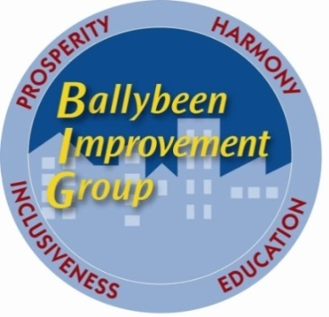
Ballybeen Improvement Group
Unit 7 Enler Complex
Craigleith Drive
Ballybeen
BT16 2QP
Tel: 02890 489990

Community Development Manager, Ballybeen
Person Specification

 | Essential | Desirable
Qualifications | Third level qualification | Relevant 3rd Level qualification in a community development related field.  Community Development Certificate / Management qualifications
Experience and knowledge | Minimum two years’ experience in community development work (three years if no qualification in a community development related field)  Two years’ experience in planning, implementing and developing programmes with various groups and individuals.  Demonstrable experience of strategic and financial planning, budget control, day-to-day management of an organisation or department and monitoring and evaluation of delivery against objectives  Experience in preparing financial statements, tracking income and expenditure, and maintaining accurate accounting records  Excellent working knowledge of funding or developing and managing income generation.  Experience in preparing, writing and presenting reports.  Experience producing newsletters and updating relevant information using social media.  Experience of the community voluntary sector in Northern Ireland  Knowledge of funding opportunities and experience of completing funding application. | Five years’ experience in the essential criteria themes.  Knowledge of Community Development issues in East Belfast  Understanding of policies affecting community development  Understanding of complex needs of a large housing estate
Skills and abilities | Well-developed leadership qualities  Proven negotiation skills  The ability both to work on your own initiative and to accept direction from Line Management appointed by the Board of Directors  The ability to develop good personal relationships with Directors, member groups and stakeholders  Previous experience of IT systems, including Word and Excel  Excellent presentation skills
Others | Willingness to undertake travel outside of Northern Ireland if needed (in exceptional circumstances)  A current full driving license and the use of a vehicle for business purposes  (or)  have access to a form of transport that will enable you to meet the requirements of the post in full.  Access NI clearance

No applicant will be shortlisted for interview unless the application form clearly demonstrates that they meet all the essential criteria. Ballybeen Improvement Group reserves the right to shortlist applicants for interview based on the essential criteria only or on the essential and desirable criteria

