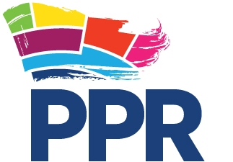

Monitoring Form

The Participation and the Practice of Rights Project seeks to be an equal opportunities employer and to actively promote equality in its recruitment and employment practices. We are obliged by law in Northern Ireland to monitor for community background, but – in conformity with good practice - we have chosen to extend this monitoring to all categories mentioned in section 75 of the Northern Ireland Act. We would therefore greatly appreciate if job applicants assist us monitor our work by completing and returning the form below.

Please return this form separately to info@pprproject.org
This form is confidential and will not be seen by the interviewing panel.

Perceived Religious Affiliation

I am perceived to be a member of the Protestant community

I am perceived to be a member of the Catholic community

I am not perceived to be of either Protestant or Catholic community

Gender

I am MAN WOMAN OTHER

Family Status

Please specify

Disability

Under the Disability Discrimination Act 1995 a person is considered to have a disability if he/she has a physical or mental impairment which has a substantial and long-term effect on his/her ability to carry out normal day-to-day activities.

Do you consider that you meet this definition of disability?

Are there any changes to the organisation’s policies, procedures or practices that would enable you to enjoy equality of opportunity and fair participation in getting a job/working with the Participation and the Practice of Rights Project?

Age Band

Under 30 30-45 over 45

Cultural/Ethnic Origin

Chinese Traveller

Indian/Pakistani African

Asian (other) Afro-Caribbean
(please specify)

White Other (please specify)

Political Opinion

My political opinion is unionist/loyalist

My political opinion is nationalist/republican

Other

Sexual Orientation

My sexual orientation is towards people of my own gender

My sexual orientation is towards people of opposite gender

Both

